

Insight bulletin

September 2025

A large speech mark, outlined in pink.

“When I enter the hospital I have selective mutism. They are not good about this - I've had awful experiences there. To be fair the doctors at A&E have been good and tell me to take my time but the receptionists and other staff are not kind… I feel stupid enough as it is. They treat me like I am making it up and it makes me feel really anxious.”



**If you would like a paper copy of this document or require it in an alternative format, please get in touch with** **us.**

# This bulletin: at a glance

## Hot topics

In this bulletin we are focussing on 5 key areas:

* Thanks and praise: empathy and efficiency
* Failure to make reasonable adjustments affecting care
* The impact of administrative errors and delays
* Spotlight on: sexual health services for under 25s
* Spotlight on: the emotional impact of financial constraints

## Who have we been hearing from?

Since our last report we’ve heard from **82** people across Surrey, via our Helpdesk or during engagement events in the community.

* **44%** of the feedback relates to hospitals
* **27%** of the feedback relates to GP practices
* The majority of the remaining feedback relates to community, social care and mental health services
* Of those willing to share their age, **67%** were aged over 50.

If you’ve visited us online you might have noticed that we look a little different!

You can still find us at [www.healthwatchsurrey.co.uk](https://gbr01.safelinks.protection.outlook.com/?url=http%3A%2F%2Fwww.healthwatchsurrey.co.uk%2F&data=05%7C02%7CAbby.Rodd%40healthwatchsurrey.co.uk%7C5c627bb617984ff3666908dde18c1d0a%7C80dab1ec97604877b0d434d3f00e7800%7C0%7C0%7C638914714102570511%7CUnknown%7CTWFpbGZsb3d8eyJFbXB0eU1hcGkiOnRydWUsIlYiOiIwLjAuMDAwMCIsIlAiOiJXaW4zMiIsIkFOIjoiTWFpbCIsIldUIjoyfQ%3D%3D%7C0%7C%7C%7C&sdata=jEJA9jbVVY4MxSVoZS0NsATBUNhuIMyNtw6NHNmBW7k%3D&reserved=0) but our brand new website is now up and running. All our reports are still there – just visit the following page to find them <https://www.healthwatchsurrey.co.uk/news-and-reports>.

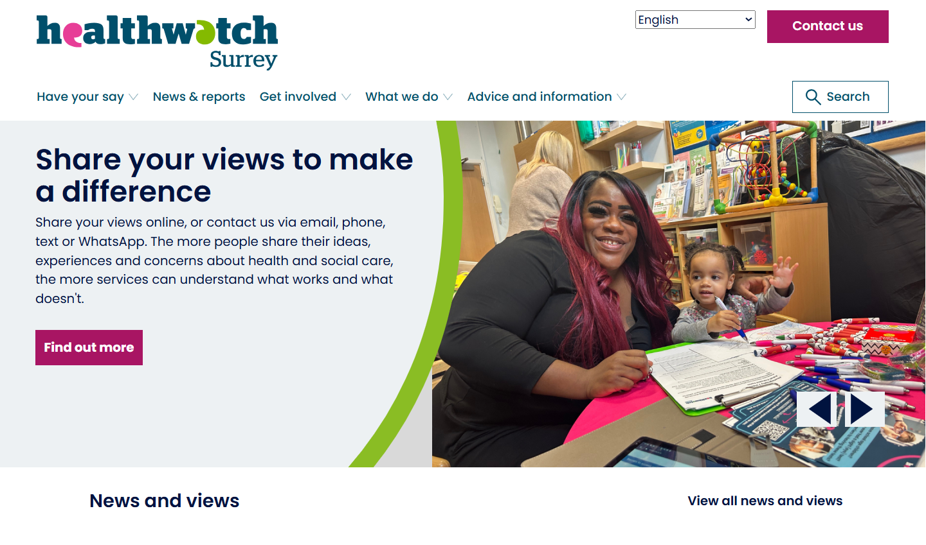

# Thanks and praise: empathy and efficiency

# People often talk to us about the important – and often difficult - balance between empathy and efficiency required from the healthcare system. This month people shared their positive experiences of both.

This resident wanted to share thanks and praise for the ambulance service. Their staff demonstrated real understanding and commitment to service, helping them at what was a very difficult time.

“My wife and I wish to compliment [the ambulance service] on how they treated me as I was in terrible pain. They were very understanding and concerned. They went above and beyond their duty. I wish to say again what a terrific crew you have …and you should be very proud of them.”

230939, Surrey resident

People talk to us about how much they appreciate prompt responses and referrals and a number of people have shared their experiences of these this month.

“I got a reply [from the GP practice] within two hours and an appointment within a day to see a first contact physiotherapist.”

230910, Reigate and Banstead resident

“The [hospital] appointment came very quick to have an MRI done on my liver. The facility was very clean and staffed adequately.”

230909, Surrey resident

# Failure to make reasonable adjustments affecting care

# The Equality Act (2010) states that all organisations, including health and social care such as hospitals and GP surgeries, must take steps to remove the barriers individuals face because of any kind of disability or specific need.

People have reached out to tell us about occasions when reasonable adjustments have not been made, and how this has impacted their experience and health outcomes.

“I have a problem with my foot - I have broken the metatarsal. I have been referred to hospital for an MRI but I am really claustrophobic. I have already been once and couldn't do it - I actually banged my head as I was panicking and asking to come out - I just couldn't cope. I don't know why it has to be a full body MRI when it's only my foot but they've said it has to be.”

230922, Guildford resident

“I am blind and disabled and have been asked to have an abdominal aortic scan as part of a preventative program. They gave me the dates of a local scan but I was unable to go because I rely on social services to support me to attend the scan. I put in a complaint and they became quite aggressive and upset that I wanted to move my appointment.”

230899, Surrey Heath resident

“When I enter the hospital I have selective mutism. They are not good about this - I've had awful experiences there. To be fair the doctors at A&E have been good and tell me to take my time but the receptionists and other staff are not kind… I feel stupid enough as it is. They treat me like I am making it up and it makes me feel really anxious.”

230863, Reigate and Banstead resident

“I also have PTSD about hospitals and sometimes it's hard for them to understand my needs. I have a hospital passport* and sometimes they don't even look at it. Also medical professionals often talk to my support worker and not me.”

230862, Epsom & Ewell resident

“I have had a very bad experience recently when I went for a smear test. Due to the nature of my trauma I asked for reasonable adjustments to make it easier, which they didn’t do. The nurse also began to ask me about my past trauma, which caused me to be triggered and leave crying.”

230857, Guildford resident

Those unable to leave their home are entitled to care delivered to them there, but many people have told us that this can be challenging to access.

“Autistic daughter referred in year 7 [school year] to local CAMHS (Child and Adolescent Mental Health Services)…we received a phone call in late Sept 2023 offering counselling. My daughter is in bed, in her room, and unable to leave the house. We asked for in person mentoring support. This is unavailable. We agree to counselling and ask for online or in person counselling. We had 2 online sessions and my daughter is discharged as she is unable to come into the GP surgery to meet the CAMHS counsellor. The service does not meet the child where the child is. It meets the child where they need the counselling to take place. We have received no mental health or mentoring support since then.”

230939, Surrey resident

* The Hospital Passport is a document to support the care of adults with learning disabilities and autism when going to hospital.

# The impact of administrative errors and delays

**Whilst people often praise the clinical care they receive, we hear from many where issues with administrative processes can have a very real impact on their emotional and physical health.**

In many cases the impact of administration errors is made worse by poor communication.

“Appointments have been cancelled without any notification, causing confusion and delays in care. Despite being a high needs patient, I am rarely prioritised and am often told to attend walk-in centres or A&E. In several cases this delay has worsened my condition and led to emergency care…. when I requested my medical records for a PIP [Personal Independence Payment] application, I was informed that a substantial portion of them had been lost.”

230872, Woking resident

“The admin staff took 4 weeks [to produce a letter which was needed for an employment tribunal] and kept communicating that the matter was in hand and that I would receive the letter, when this was not the case. The GP’s non compliance has put me at risk of breaching the judicial order set by the tribunal which will impact my case.”

230941, Surrey resident

A lack of connectivity between services can often lead to those who are vulnerable either being overlooked by the system or feeling the need to ‘fight’ for their rights.

“I have been housebound for 10 years or more…I need blood tests annually and a nurse comes, I have also had my vaccinations in my home but I have to chase each time and explain about being housebound and they will then say 'I will put you on our list'. Everything is such a fight. I feel [one part of the] system doesn’t know what the other is doing.”

230940, Reigate and Banstead resident

# Spotlight on: sexual health services for under 25s

# The latest Sexual Health Joint Strategic Needs Assessment (JSNA) for Surrey highlights a need to improve engagement and understanding of sexual health & contraception needs in younger people.

We engaged with **9** colleges through in person visits and an online survey; a total of **594** people responded.

We found that **having sexual health outreach in colleges does make a real difference to students’ approach to their sexual health** - students are more aware of and use sexual health services if they attend colleges where there are sexual health outreach sessions.

* **89%** of students from colleges with sexual health outreach sessions knew about services available to them, versus **76%** of students from colleges without such sessions.
* **36%** of students from colleges with outreach had used services versus **14%** of students from colleges without.
* Only **11%** of students from colleges without outreach said they would feel very/fairly comfortable talking to staff about their sexual health needs, increasing to almost half (**47%**) for students at colleges with outreach.

## How could services be improved?

Some of the insights we received were really useful for helping us to suggest how services could be improved

* Pharmacies: people mentioned staff attitudes, cost and locations and times: “I had to purchase the morning after pill and the attitude towards me buying that felt shameful, which it shouldn’t be, I didn’t appreciate feeling small.”
* C-card scheme*: more locations and more information about current locations.
* Face to sexual health clinic appointments: “It is incredibly hard to get an appointment and has to be arranged far in advance which is hard for teens.”
* Full STI home self-testing kit: “For the ones sent in the post, I remember thinking the packaging isn’t very discreet, I would assume this is because of what it contains but can still be awkward walking to the post box with it!”

Read the full report on our website: [Sexual health services for under 25s – July 2025 | Healthwatch Surrey](https://www.healthwatchsurrey.co.uk/report/2025-08-14/sexual-health-services-under-25s-july-2025)

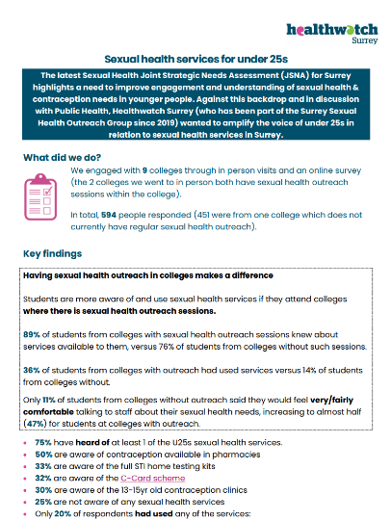

We worked closely with the Public Health team at Surrey County Council – who commission sexual health services in Surrey - in the design and implementation of this research project. They have provided some useful insights in to the services available in Surrey, based on the questions and concerns raised as part of the research, and these can also be found in the report.

There’s more information about sexual health services in Surrey on our website - [Sexual health services | Healthwatch Surrey](https://www.healthwatchsurrey.co.uk/advice-and-information/2025-08-21/sexual-health-services)

* The C-Card Scheme is a free and confidential condom distribution network for young people aged 13 to 24 years old in Surrey. You Can find out more from Healthy Surrey - [Contraception | Healthy Surrey](https://www.healthysurrey.org.uk/sexual-health/contraception)

# Spotlight on: the emotional impact of financial constraints

# Research from the Kings Fund and Healthwatch England have both looked at finance and its impact on health - we wanted to find out the impact financial concerns and constraints have on people’s emotional wellbeing.

**39** Surrey residents answered our online survey and we also visited Leatherhead Community Hub to speak to people face to face. **97%** of people said that financial concerns currently impact their emotional health and wellbeing and mental health; **87%** said that financial restraints do.

“I'm always worrying about money and not having enough to pay bills. I understand why people take their own lives over financial problems. It has a daily impact on me and my mental health.”

Surrey resident

Over two thirds (**68%**) of people said that having a long-term health condition impacted their finances, with people not being able to work (or do as much work) and needing to pay for care and help with everyday living.

“My PIP (Personal Independence Payment) is due for renewal and I’m so worried with all the government changes they will stop/cut my money. It’s starting to make me ill - the panic and anxiety over how I will pay my bills.”

Surrey resident

Read the full report on our website: [The cost of coping: emotional impact of financial constraints - August 2025 | Healthwatch Surrey](https://www.healthwatchsurrey.co.uk/report/2025-08-15/cost-coping-emotional-impact-financial-constraints-august-2025)

# Have your say!

We want to hear from as many people as possible! We therefore have several online surveys to support our face to face engagements out in the community; you can read more about our upcoming engagement events on page 15.

|  |  |
| --- | --- |
| An icon showing a set of double doors with the word entrance above them and a healthcare cross above that. | For our **access to primary care priority** we arecurrentlylooking at online access to GP services.  [Online access to GP services survey](https://www.smartsurvey.co.uk/s/HwSyOnlineAccessGPServices/)  We are also beginning work on a project looking at barriers to access and experience of sight (eye) tests for black and Asian ethnically minoritised communities. Survey will be coming soon! |
| An icon showing 2 people standing together under a roof. | For our **social care priority** we are looking at why there has been a downturn in the numbers of people using day centres and library services.  [Library independence courses and community centre survey](https://www.smartsurvey.co.uk/s/HealthwatchSurreylibraryindependencecoursecommunitycentresurveyQ22025/) |

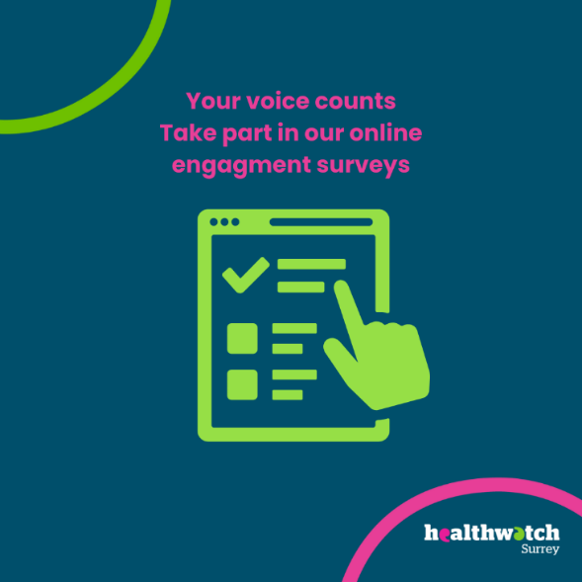

**The more people we hear from, the more impactful our research will be, and the more likely we are to be able to bring about positive change.**

## The NHS 10 Year Health Plan and Healthwatch: your voice matters

In our last [Insight Bulletin](https://www.healthwatchsurrey.co.uk/report/2025-08-12/insight-bulletin-august-2025) we talked about the proposed abolition of Healthwatch England and 152 local Healthwatch, and the transfer of functions ‘in-house’ to local authorities and NHS Integrated Care Boards once legislation has passed.

We strongly believe that the independence of local voices in health and care should be protected. If you agree, please sign our national petition to the government calling on them to review their decision - [Review decision to abolish independent local Healthwatch - Petitions](https://petition.parliament.uk/petitions/732993)

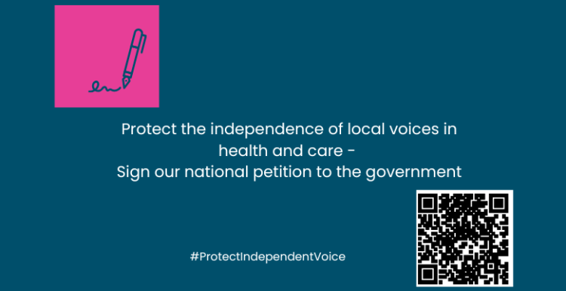

## Join our Luminus vaccine hesitancy fireside chat

## – 17 September

* What are the main barriers to taking up COVID-19 and flu vaccines?
* How do we increase the number of people who have a vaccination?
* What does good look like?

During the last year Luminus have completed 3 research studies about why older people, people from ethnically minoritised communities and care workers are reluctant to take-up a COVID-19 and flu vaccination or booster.

Join our virtual fireside chat to hear the main findings and recommendations, with lots of opportunities to ask your own questions too.

**Cost:** Free

**Date:** Wednesday 17 September 2025

**Time:** 12.30 to 1.30pm

**Audience:** Anyone in charge of vaccine programmes or promotion.

The fireside chat will last for about 20 minutes and the remainder of the time is for questions and answers.

Please email Becki Meakin ([becki.meakin@luminus-cic.uk](mailto:becki.meakin@luminus-cic.uk)) if you want to attend and a Teams invitation will be sent to you. We are keen to make this as accessible as possible, so please state any access requirements you have.

At the top of the image on a slanted purple background are the words vaccine hesitancy and the Luminus logo.
Underneath, on a bright yellow background is the words:
What are the main barriers to taking up COVID-19 and flu vaccines?
How do we increase the number of people who have a vaccination?
What does good look like?
Fireside chat, 17 September 
Each of the questions has a small icon beside it and to the right of the words is an icon of a vaccine syringe and a question mark. Beside the Fireside chat is the image of a 2 people talking in front of a fireplace.

# Sharing our insight and raising concerns

Whilst this bulletin accurately reflects what we hear from the individuals we speak to, we are aware that it may not be representative of everyone’s views of a particular service. Multiple references to a specific service may be due to where our community engagement has recently taken place.

If we hear a case of concern regarding patient safety, we immediately signpost the sharer to the appropriate body and escalate the case with the provider/commissioner. All appropriate information and signposting has already been given.

If you would like more information or examples of what people have shared with us, please get in touch with us.

# Community engagement

Below are details of our upcoming engagement sessions where we visit venues in local communities to listen to what people think about local health and care services, and to ask specific questions related to [our priorities](https://www.healthwatchsurrey.co.uk/about-us/our-priorities/). We also provide information and signposting regarding health and social care. Throughout the year, we also attend events across Surrey to raise awareness of our work.

|  |  |  |  |
| --- | --- | --- | --- |
| Date | Place | Time | Open to |
| 12/09/2025 | Enter and View - Derby House | 10am – 12noon | Private |
| 16/09/2025 | East Surrey College Freshers Fair | 11am – 1pm | Private |
| 16 & 17/09/2025 | NESCOT Freshers Fair | 11am – 1pm | Private |
| 17/09/2025 | Roots at Epsom Methodist Church | 10am – 12noon | Public |
| 25/09/2025 | Ashford Minor Injuries Unit | 10am – 12noon | Public |
| 25/09/2025 | Two Rivers Shopping centre, Staines | 10.30am – 12.30pm | Public |
| 30/09/2025 | Oasis Group – St Paul’s Church | 10 – 11.45am | Public |
| 1/10/2025 | University of Surrey  part time work fair | 11am – 2pm | Private |

**Please note: these dates may be subject to change.**

To share an experience with us, or for information and signposting about health and social care, people can also contact our Helpdesk in the following ways:

Phone: 0303 303 0023

SMS (text only): 07592 787533

WhatsApp: 07592 787533

Email: [enquiries@healthwatchsurrey.co.uk](mailto:enquiries@healthwatchsurrey.co.uk)

Share your feedback via our website: <https://www.healthwatchsurrey.co.uk/feedback-centre/>

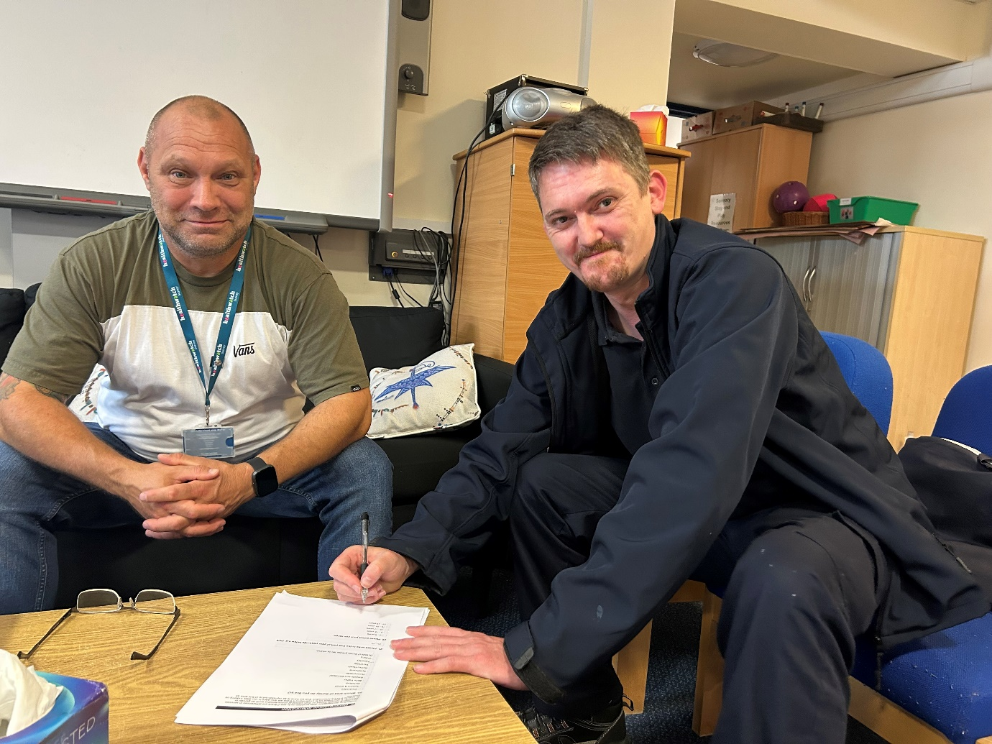

# About Healthwatch Surrey

Healthwatch Surrey champions the voice of local people to shape, improve and get the best from NHS, health and social care services. We are independent and have statutory powers to make sure decision makers listen to the experiences of local people.

We passionately believe that listening and responding to local people's experiences is vital to create health and social care services that meet the needs of people in Surrey. We seek out people’s experiences of health and care services, particularly from people whose voices are seldom heard, who might be at risk of health inequalities and whose needs are not met by current services. We share our findings publicly and with service providers and commissioners to influence and challenge current provision and future plans.

We also provide reliable and trustworthy information and signposting about local health and social care services to help people get the support they need.

# Our distribution list

If you would like to be added to or removed from the distribution list for this Insight bulletin, please contact our Communications Lead [vicky.rushworth@healthwatchsurrey.co.uk](mailto:vicky.rushworth@healthwatchsurrey.co.uk)



We are committed to the quality of our information.

Every three years we perform an audit so that we can be certain of this.



The Healthwatch Surrey service is run by Luminus Insight CIC, known as Luminus.

Registered office: GF21, Astolat, Coniers Way, Burpham, Surrey, GU4 7HL.