


Insight bulletin

  - March 2026


“The complaint response that I have received is insulting and does not answer my questions or address the missed diagnosis which has ultimately led to him [my partner] being terminally ill.”


If you would like a paper copy of this document or require it in an alternative format, please get in touch with us.

This bulletin: at a glance

Hot topics
In this bulletin we are focussing on 5 key areas:
- Thanks and praise for hospital staff: going above and beyond
- Complaints: confusion and dissatisfaction
- Prescription issues and breakdowns in shared care
- Maternity care: capacity issues impacting post natal care
- Research update: Sight on equity
- Research update: the NHS App.

Who have we been hearing from?
Since our last bulletin 130 people have shared their experiences of health and social care across Surrey.

- 48% of feedback relates to hospitals
- 25% of feedback relates to GP practices
- 10% of the feedback relates to mental health services.

Since our last report we’ve had over 50 enquiries to our Helpdesk. People can come to our Helpdesk with questions, concerns or feedback on any aspect of health and social care, so what we’re hearing here can be a good indicator of the main issues that matter to local people. The majority of recent enquires have been about communication and complaints handling (we talked about communication in our February Insight bulletin). People have also been talking to us about issues obtaining prescriptions, and maternity care.

Thanks and praise for hospital staff: going above and beyond

During an engagement event at St Peter’s Hospital we spoke to a number of people who praised staff for small actions which made a big difference to their experience.

In the example below a nervous parent welcomed someone proactively checking in on them as soon as they walked through the door.

“My five year old son had a fainting episode before Christmas - I took him to A&E and they were very thorough - they checked everything. We were seen really quickly and they were very good with him. They didn't find anything but referred us to paediatrics which was reassuring. That's why we're here today and it's been a good experience - the staff are very helpful, someone asked if we knew where we were going as soon as we walked through the door. I really like this hospital and feel confident and happy when I come here.”
230991, Spelthorne resident

In this example a patient was reassured by being given a number to call should she have any concerns between appointments.

“I'm here today for an outpatient appointment with dermatology - they're keeping a check on me and my next appointment will be in 4 months' time. I was here early but didn't have to wait long. The nurse was really lovely and they always have been, very thorough too and get the doctor in when needed. This time she even gave me a card with a number to call if anything changes - it was very reassuring.”
230990, Runnymede resident

Complaints: confusion and dissatisfaction

Everyone has the right to make a complaint about any aspect of NHS care, treatment or service, and this is written in to the NHS Constitution. The NHS actively encourages feedback – positive or negative - because it is used to improve services. However, many people come to us unhappy about the response (or lack of response) to a complaint they’ve made or confused about how to start one.

In this example a resident was concerned about the time it was taking to resolve a complaint- and the lack of communication around it - which were leading to potential safeguarding issues.

“I also wish to formally record my serious concern regarding the current pace of this complaint. I was advised previously that this matter was being looked into and yet substantial time has now passed without a clear outcome or substantive progress update. Given the safeguarding implications and the distress caused to both myself and my son, continued delay is unacceptable.”
231377, Surrey resident

People often tell us that their complaints are not being resolved in a way which feels satisfactory to them.

“We have got a health centre in our village and over the last year there have been lots of problems that have been experienced by many in the village….However, we are finding that some are being answered, and they are admitting that they are at fault, but a lot are going unanswered. We are also finding that when people try to submit a complaint to the practice, they are saying to us that we can just go elsewhere.”
231302, Woking resident

“In February I was in intensive care for 10 days. I complained to the GP…I then complained to the parliamentary Ombudsman, but they said that they can’t do anything without a final decision…I don’t know how to get justice because I have been to the GP twice for the same problem and nothing happened. If somebody can do something to put this right, I would be happy.”
231356, Epsom and Ewell resident

People also express confusion about the process.

“A few months ago I contacted you in regard to my husband’s death. I wrote a message to PALS and they sent me an email back. they told me to write a formal complaint to [the hospital] as it is the right procedure. I am not quite sure how to do it. Do I need a medical solicitor or is it something you could help me with?”
231263, Surrey resident

And many feel unhappy with the response they get.

“The complaint response that I have received is insulting and does not answer my questions or address the missed diagnosis which has ultimately led to him [my partner] being terminally ill.”
231294, Surrey resident

Our ‘Maximising the learning from complaints’ report looks in depth at the Independent Health Complaints Advocacy service and shares our findings to suggest best practice relating to complaints. Published in 2024 there are recommendations in here that we still feel could be embedded further.

There’s more information on advocacy services on our website too.

Prescription issues and breakdowns in shared care

A Shared Care Agreement is a formal arrangement allowing safe,

coordinated management of a patient’s treatment between a

specialist and a GP. Although the aim is to ensure joined up care, several people have talked to us about issues they’ve had obtaining hospital prescriptions via their GP.

“The GP referred me to the hospital for a consultant to help get my symptoms under control. They tried everything that was within the standard guidance, but none of it worked so they ended up altering my prescription. This worked really well, so the consultant discharged me back to my GP practice for ongoing support. However, the GP refuses to prescribe the medication that the consultant has requested and will regularly change it back to the standard dosage. The consultant has written to them twice and requested that they prescribe what they have asked and explained their reasoning, but they don’t listen.”
231333, Woking resident

“Although my pain consultant sees me at [the hospital] and has done so for the past 11 years, the GP questions whether they can issue medication through the NHS. When I receive the practice's reply to say they cannot issue, I send a copy of the initial referral and consultation letters to make clear that I see the consultant through the NHS, regardless of where I'm seen. Although this rectifies the issue for me, it still leaves me without the required medication until it goes through the system, often leaving me in a state of intense pain.”
231339, Elmbridge resident

“Since coming out [of hospital] I have been unable to get GP appointments for pain medication. Have requested an appointment but the surgery pharmacist replied I would not be getting the medication I was on and to take paracetamol and ibuprofen which are not controlling the pain and making it difficult to do exercise. The hospital and physiotherapist say I need stronger medication but the GP will not prescribe it.”
231281, Studholme resident

“I was prescribed a medication for a newly diagnosed condition. I asked the GP to please give me the medication. It took 3 telephone, 2 in person and 3 written requests, including me contacting the hospital again and 10 months later, plus a complaint from me in order to get the medication.”
230941, Woking resident

Maternity care: capacity issues impacting postnatal care

Late last year Healthwatch England invited women to share their experiences of maternity care to feed into an independent investigation into maternity and neonatal services in England. We are thankful to the many women from Surrey who shared their own thoughts on local services. A recurring theme was a perceived lack of sufficient postnatal care and support.

“Pre surgery was good. Post surgery the nurse said ‘just stand up’. This was 7 hours post surgery, with no guidance. Pain medication was starting to be weaned on day 2 with no discussions with me. Internal haematoma was missed resulting in a haemorrhage 10 weeks later. Pain medication was never on time, you had to keep track and chase it up.”
231382, Surrey resident

“After care could have been better; my catheter bag almost burst from being so full overnight, pain medication wasn't regular and I had to ask, my sanitary pad wasn't checked or cleared without being asked. Essentially it felt very short staffed on the ward, but the staff that were there were trying their best. I only stayed 1 night and there were only 3 midwives to 15-20 patients so they were very stretched….”
231385, Surrey resident

“Ratio of midwife to mum/baby on the postnatal ward was crazy, I had a c-section and issues with anaesthetic, couldn’t sit myself up, physically couldn’t get my baby out of the bassinet, she kept throwing up all over herself and crying but I couldn’t get to her to change her or feed her without help. Had to press the emergency bell for help every time, but the midwife was often busy trying to support other mums too, had to leave my baby covered in sick and screaming.”
231358, Surrey resident

Research update: Sight on equity

People with black and Asian heritage are at increased risk of developing conditions such as glaucoma and diabetic retinopathy. Despite this, engagement with preventative eye care is lower among these communities. National research suggests that eye health is often not prioritised due to a lack of cultural sensitivity and relevance. We sought to understand the barriers facing Surrey’s communities specifically, and what could realistically be done locally to improve access.

Over 200 people contributed to this research; 141 people spoke to us at in person focus groups and community engagement events and 98 people completed our survey. The people we spoke to reflected the ethnic, age and geographic diversity of Surrey’s black and Asian communities, with specific sessions tailored to needs identified by individual communities.

We found:
- Clear disparity in how often people from these communities have sight tests and a reliance on opticians to instigate appointment booking.
- There are a number of barriers to people from these communities attending sight tests:
  - Sight tests seen as reactive not preventative
  - Lack of awareness of the link between sight tests, eye health and general health
  - Cost
  - Language
  - Language translation, cultural awareness and reasonable adjustments not met.
- Widespread uncertainty about NHS entitlements
- Uncertainty about lifestyle factors and eye health.

You can read the full report here: Sight on equity: Understanding the barriers faced by black and Asian minoritised communities when accessing sight tests - March 2026

Research update: the NHS App

75 Surrey residents gave us their views on the NHS App, via our survey or at a focus group held with the Merstham Community Champions.

The NHS App is designed to give people a simple and secure way to access a range of NHS services on their smartphone or tablet (or via web browser on the NHS website). But is it really making life simpler? What do people like about it (and what do they not?) and what changes could be made to improve useability and access?

We found:
- Although most people do have the NHS App, less people are actually using it
- For those that aren’t, issues with registration and log in processes (or fear of potential issues) and confusion about how to use it are key barriers; a ‘simplified’ and ‘easier to ‘use’ App would help
- For those that are using it there’s a lack of awareness of the full breadth of what the App can do, and there are some accessibility issues. Could more be done to educate both current and potential new users?

“I’ve tried to help people but often something stops them progressing to full sign up and then they feel deflated and give up.”

You can read the full report here: Loved, liked, or left alone - NHS App and patient feedback - February 2026

You can also read more about people’s views on digital access to GP practices in our Digital Divide report.

Have your say!
We want to hear from as many people as possible which is why we have surveys to accompany our face to face engagements in the community.

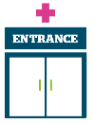 | Access to primary care – we are interested in hearing from anyone about current or recent support received relating to weight management or about support people would like to receive.  Weight management survey closes 31 March 2026.
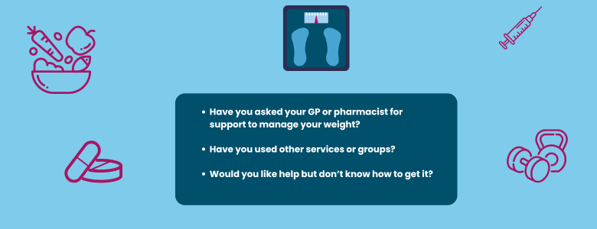

To share an experience with us, or for information and signposting about health and social care, people can also contact our Helpdesk in the following ways:
Phone: 0303 303 0023
SMS (text only)/ WhatsApp: 07592 787533
Email: enquiries@healthwatchsurrey.co.uk
Share your feedback via our website: https://www.healthwatchsurrey.co.uk/share-your-views

Our Luminus organisation is also working with Public Health, to support Surrey residents, wherever they are in their smoking journey, to understand the risks of smoking and get free support to quit. As part of this there is an online survey people can complete: Stopping Smoking - your thoughts which closes on 1 August 2026.

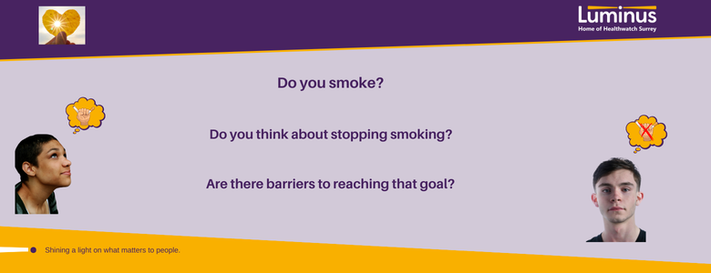
The more people we hear from, the more impactful our research will be, and the more likely we are to be able to bring about positive change.

Clearer Care: Next steps

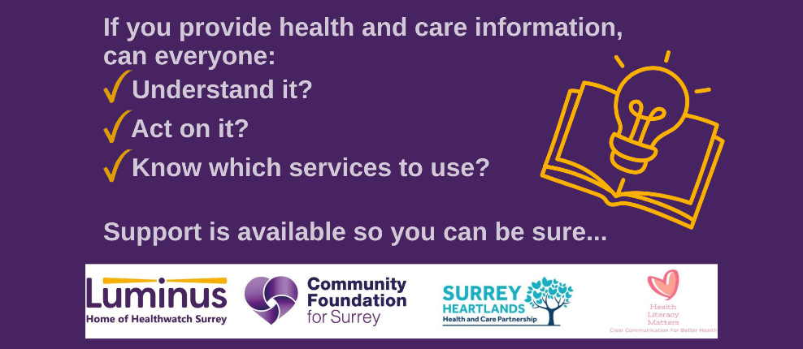

Our Luminus organisation was pleased to welcome over 50 people to find out more about the new Surrey Health Literacy support pilot programme - Clearer Care – which will support Surrey based VCSE, NHS, Local Authority or Public Health organisations to use a health literacy lens to make health communication, information, and services more accessible, inclusive, and equitable.

How can the programme help you and your organisation?
Following an expression of interest and application process, successful organisations will receive:
- Expert health literacy advice and guidance
- Practical support to design and run health literacy pilot projects
Available for VCSE organisations only (in addition to the above):
- Small grants of up to £2,500 are available to deliver pilot projects.

Want to find out more?
Information on next steps is now available on the Community Foundation for Surrey website: Clearer Care — Community Foundation for Surrey

This project is being run by Luminus, Community Foundation for Surrey, Surrey Heartlands Integrated Care Board and Dr Mike Oliver from Health Literacy Matters.

Sharing our insight and raising concerns
Whilst this bulletin accurately reflects what we hear from the individuals we speak to, we are aware that it may not be representative of everyone’s views of a particular service. Multiple references to a specific service may be due to where our community engagement has recently taken place.

If we hear a case of concern regarding patient safety, we immediately signpost the sharer to the appropriate body. All appropriate information and signposting has already been given.

If you would like more information or examples of what people have shared with us, please get in touch with us.

Our distribution list
If you would like to be added to or removed from the distribution list for this insight bulletin, please contact our Communications Lead vicky.rushworth@healthwatchsurrey.co.uk

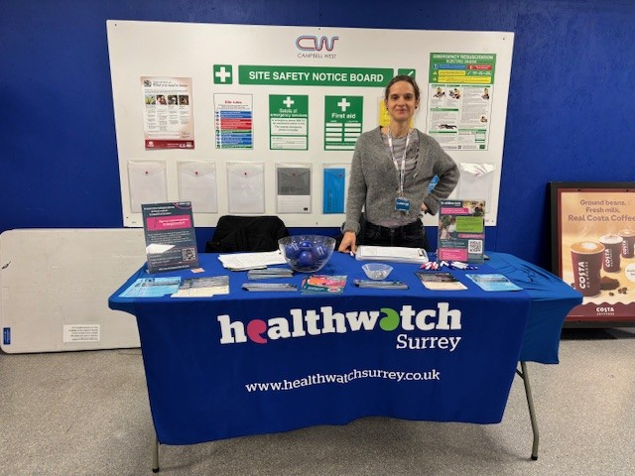

About Healthwatch Surrey
Healthwatch Surrey champions the voice of local people to shape, improve and get the best from NHS, health and social care services. We are independent and have statutory powers to make sure decision makers listen to the experiences of local people.

We passionately believe that listening and responding to local people's experiences is vital to create health and social care services that meet the needs of people in Surrey. We seek out people’s experiences of health and care services, particularly from people whose voices are seldom heard, who might be at risk of health inequalities and whose needs are not met by current services. We share our findings publicly and with service providers and commissioners to influence and challenge current provision and future plans.

We also provide reliable and trustworthy information and signposting about local health and social care services to help people get the support they need.


We are committed to the quality of our information.
Every 3 years we perform an audit so that we can be certain of this.


We are proud to have signed up to the End Poverty Pledge - End Poverty Surrey – Good Company.



The Healthwatch Surrey service is run by Luminus Insight CIC, known as Luminus. Luminus is a Surrey based, independent, community interest company which exists to empower people to have their voices heard. We help organisations provide equity of access and the best services possible, through the inclusive involvement of local people.
Registered office: GF21, Astolat, Coniers Way, Burpham, Surrey, GU4 7HL.

