

Insight bulletin

  - February 2026


“I strongly feel that I have a right to not be excluded from discussions regarding me or my care.”


If you would like a paper copy of this document or require it in an alternative format, please get in touch with us.

This bulletin: at a glance

Hot topics
In this bulletin we are focussing on 6 key areas:
- Thanks and praise for hospital staff: giving an important sense of calm
- Communication: a perceived lack of respect shown from staff
- Mental health and AHDH services: people facing barriers to access
- Research update: community services
- Research update: sight loss

Who have we been hearing from?
Since our last report 201 people have shared their experiences of health and social care across Surrey.

- 36% of feedback relates to hospitals
- 39% of feedback relates to GP practices
- 10% of the feedback relates to mental health services
- The majority of the remaining feedback relates to community and social care services.

Since our last report we’ve had almost 100 (96) enquires to our Helpdesk. People can come to our Helpdesk with questions, concerns or feedback on any aspect of health and social care, so what we’re hearing here can be a good indicator of the main issues that matter to local people. The majority of recent enquires have been about communication and complaints handling (we talked about the confusion around, and mismanagement of, complaints in our November 2025 Insight Bulletin). People have also been talking to us about difficulties accessing mental health services and ADHD medication.

Want to know what impact our work has? Read our latest Impact Report to find out more.

Thanks and praise for hospital staff: giving an important sense of calm

A number of people have shared their positive experience of care in Surrey hospitals, noting in particular the positive impact that the calm professionalism of staff can have at times of heightened stress and anxiety.

“During my day case procedure, I was just so impressed with the kindness and care of all the staff I met. There was a quiet calm about the whole day which really helped me as I was extremely anxious. From the friendly hello of the reception staff, the capable care of the nurses, the kindness of the theatre nurse, the skill of the doctors. It was very impressive.”
231095, Guildford resident

“The doctor in A&E was absolutely fabulous - she was very cheerful and thorough. Very professional and caring. What a difference it makes when you have a doctor like this especially as I was distressed having been brought in by ambulance.”
231205, Surrey resident

“I had a visit to A&E yesterday which is the first time I’ve been to an emergency room in over a decade. I am petrified of hospitals, I’m from the USA originally and our healthcare system is not ideal. I just wanted to say, despite the stress and the wait times, I had a very pleasant experience with [the] nurse and the doctor. They were fantastic. Especially with my phobia of needles.”
231266, Surrey resident

Communication: a perceived lack of respect shown from staff

Whilst we hear what a difference kindness and reassurance can have, we also hear when communication styles have a negative impact.

“The nurse I spoke to after was very patronising and she didn’t listen to me and she was being sarcastic with me.”
231260, Surrey Resident

The impact of being made to feel patronised or dismissed can be huge, with people feeling incredibly uncomfortable and in some cases disassociated from their own care.

“The staff involved in my treatment at times blatantly discussed me (displaying rather overt hand gestures towards me and sometimes looking directly at me) while switching to a non-English language. This made me feel incredibly uncomfortable, and I strongly feel that I have a right to not be excluded from discussions regarding me or my care.”
231298, Surrey resident

“From the second the call handler answered the phone she sounded annoyed and abrupt. She spoke some words that were difficult to understand as were said too quickly and the phone line wasn’t great and then got annoyed that I didn’t understand her. She was rude and abrupt that she didn’t understand the situation I was explaining to her, even though I was obviously upset about the health of my 9 week old baby and became defensive when I asked her to please stop being rude to me.”
231131, Surrey resident

Mental health services: people facing barriers to access

In December 2025 the Government launched an independent review in to the rising demand for mental health, ADHD (Attention deficit hyperactivity disorder) and autism services. Here in Surrey people tell us that this demand is not being met.

People tell us that they are not receiving the care they need or that what is offered is not appropriate.

“I was very low. I phoned 111. Someone was meant to call me back with not a long wait. I had to spend time while distressed ringing round possible services after a long wait and it was not clear who was meant to be calling me back. I never got the help. At the doctors’ surgery the next day (for something else) I expressed my concerns and how I had been. No one phoned me to check anything. It was all very casual and like 'you can phone (the surgery) if you want'. I also feel adequate notes are not often made and you are not listened to. There is also poor communication between mental health agencies and/or in slightly different areas. They sometimes don't know why you are calling.”
231288, Surrey resident

“My sister has struggled with her mental health for over 40 years. My sister has approached many GPs and mental health care agencies to gain access to a more long term continuity of care. In January my sister had a GP appointment to discuss the ongoing issue, only to feel rushed out the door and advised to seek 6 sessions of CBT, my sister has previously engaged in 6 sessions of CBT but to no avail. I hope you can empathise that my sister's 40 years of issues cannot be unpicked in 6 weeks via 6 sessions.”
231286, Surrey resident

You can read more about the mental health support available in Surrey on our website.
ADHD: Confusion remains
People are sharing concerns about difficulties accessing ADHD assessments and medicine for young people specifically, and confusion about processes and pathways is also causing undue stress for many.

“About 6 years ago my son was diagnosed via the NHS with ASD [autism spectrum disorder] and ADHD. For the ASD diagnosis we had a useful report and conversation, however, for ADHD they just confirmed the diagnosis and asked if we wanted to consider medication. At the time we didn't but…we now want to consider medication but have no idea where to start. There is so much chat around this subject I don't know what's true and what isn't.”
231274, Epsom and Ewell resident

In this example, communication between different providers led to one child without proper help and monitoring.

“Can someone help me please? My daughter was diagnosed with ADHD in 2021 privately and shared care was agreed by the GP and the GP agreed to refer her to [the provider] for ongoing consultant overview in 2022. We continued to get repeat prescriptions but no checkups so when she started having adverse side effects, she stopped taking the meds. When I asked the GP for re-titration it became apparent that the [provider] referral had not taken effect and we were told that she would need to be referred as a new case. She needs ADHD medication to be able to access education. Can anyone explain to me how I can get her re-titrated before this turns out to be disastrous for her GCSE prospects?”
231250, Surrey resident

You can read more about the impact of long waits for ADHD assessments in our one page report. You can also find information on the Right to Choose who delivers your care .

Research update: community services

Surrey County Council (SCC) run a free 8 week course to teach skills that support independence. The aim is that participants leave feeling more connected to their community and other residents, and more informed about the support available to them, ultimately helping to combat loneliness. But uptake is low. SCC also told us that there has been a downturn in community centre attendance.

We wanted to understand the barriers to uptake and attendance so undertook a series of engagements and ran a survey to gauge the thoughts of Surrey residents.

Library independence courses
We found that there is a cohort of people who would be interested in the library independence course, but we need to find new ways to reach them and promote it.

“I will be referring my mum to the course as she is very vulnerable to financial scams.”
Reigate and Banstead resident

Some people shared concerns about getting there, the location and the 8 week time commitment.

Community centres
How easy a venue is to get to is important. Almost half of our respondents said that they walk to the social groups that they do attend, with only a third driving themselves. Others took the bus or got a lift. No one used community transport or private taxis. More needs to be done to ensure that community centres are accessible and to raise awareness of community transport options.

You can read our full report and recommendations here - Left on the shelf - October 2025 | Healthwatch Surrey.

Research update: sight loss

As part of our work on access to primary care, we wanted to speak to Surrey residents with low vision about their experiences of specialist eye care services, as well as the information and support they receive between appointments and following discharge.

We spoke to residents at 3 Macular Society meetings and a VisionZone event - our findings will support the work of the Local Optical Committee (LOC) as they try to ensure that all Surrey residents with low vision receive the support they need.

- We heard from some that there was a lack of “personal touch”, with appointments changing and little consistency in who people saw. The experience was described as like “being on a conveyor belt” with short, routine appointments lasting only a few minutes, despite long waits to be seen.
- We heard concerns about gaps in the information being provided following consultations.
- Others felt they were not given any information about their condition or how to manage it and had to rely on their own research.
- Some people talked about not being given access to the eye care services they needed and finding themselves shuttling between their GP, optometrists and hospital eye care services.

You can read the full report here: Sight loss follows you home - November 2025 | Healthwatch Surrey

You can also find further information on our website – there’s some general information on eye health and optometry as well as a signposting resource about eye tests to support parents, particularly those with children who are neurodiverse. Our Out of Sight out of Mind report explores parents’ understanding of sight tests and the potential barriers faced.

Have your say!
We want to hear from as many people as possible which is why we have surveys to accompany our face to face engagements in the community; you can read more about our upcoming engagement events on page 15.

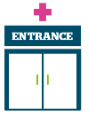 | Access to primary care - we would love to hear your feedback about any support you are currently receiving or have received to help you manage your weight, or any support you’d like to receive.  Weight management survey closes 31 March 2026.
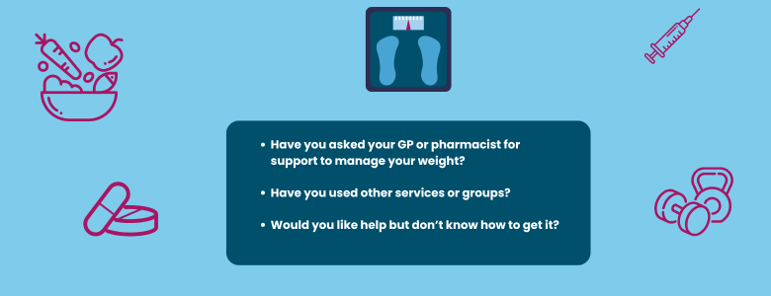

Need a paper copy or want to share your thoughts in your own words?
Please get in touch with our Helpdesk:
Phone: 0303 303 0023
SMS/WhatsApp: 07592 787533

Our Luminus organisation is also working with Public Health, to support Surrey residents, wherever they are in their smoking journey, to understand the risks of smoking and get free support to quit. As part of this there is an online survey people can complete: Stopping Smoking - your thoughts which closes on 1 August 2026.

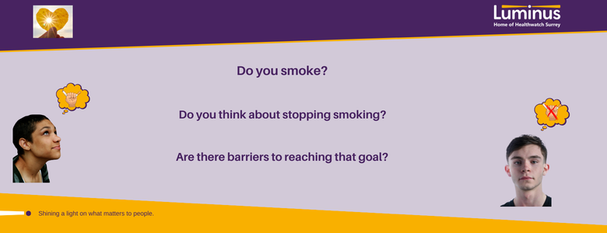
The more people we hear from, the more impactful our research will be, and the more likely we are to be able to bring about positive change.

Clearer Care: a new health literacy programme
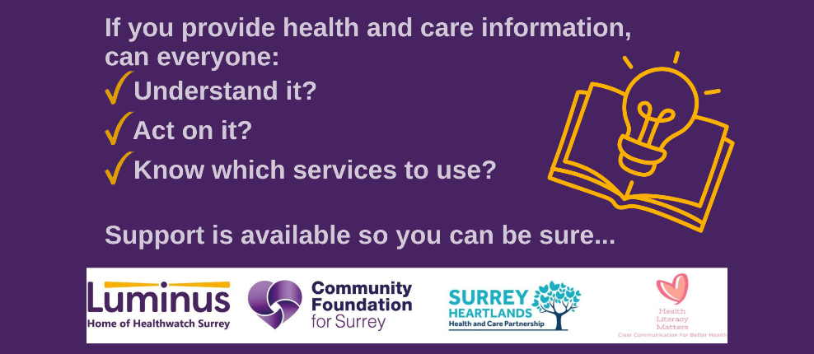

If you are a Surrey based VCSE, NHS, Local Authority or Public Health organisation a new Health Literacy support programme - Clearer Care - can provide support to make health communication, information, and services more accessible, inclusive, and equitable. This project is being run by Luminus, Community Foundation for Surrey, Surrey Heartlands Integrated Care Board and Dr Mike Oliver from Health Literacy Matters.

About health literacy
In England, 42% of working-age adults struggle to understand everyday health information. In Surrey Heartlands around 30% of adults aged 16-64 fall below the health literacy threshold. This means many adults are reading at, or below, the level of an average 9 year old. Low health literacy is associated with missed appointments, poor medication adherence and reduced uptake of preventive services and in increase in the likelihood of experiencing increased hospitalisation or premature death.

How can the programme help?
Following an expression of interest and application process, successful organisations will receive:
- Expert health literacy advice and guidance
- Practical support to design and run health literacy pilot projects
Available for VCSE organisations only (in addition to the above)
- Small grants of up to £2,500 are available to deliver pilot projects.

Want to find out more?
Sign up for our launch webinar on 24 February via Eventbrite: https://launch-webinar-clearer-care-health-literacy-support-programme.eventbrite.com

Sharing our insight and raising concerns
Whilst this bulletin accurately reflects what we hear from the individuals we speak to, we are aware that it may not be representative of everyone’s views of a particular service. Multiple references to a specific service may be due to where our community engagement has recently taken place.

If we hear a case of concern regarding patient safety, we immediately signpost the sharer to the appropriate body. All appropriate information and signposting has already been given.

If you would like more information or examples of what people have shared with us, please get in touch with us.

Community engagement
Below are details of our upcoming engagement sessions where we visit venues in local communities to listen to what people think about local health and care services, and to ask specific questions related to our priorities. We also provide information and signposting regarding health and social care. Throughout the year, we also attend events across Surrey to raise awareness of our work.

Date | Place | Time | Open to
10/02/2026 | Redhill Macular Society | 10.30 – 12noon | Group engagement
25/02/2026 | Slimming World Groups, Reigate and Banstead | 8.30am – 12.30pm | Group engagement
06/03/2026 | Weight watchers meeting | 9.45am | Group engagement
26/03/2026 | Trinity Methodist Church, Woking | 10.30 – 12noon | Group engagement
Please note: these dates may be subject to change.

To share an experience with us, or for information and signposting about health and social care, people can also contact our Helpdesk in the following ways:
Phone: 0303 303 0023
SMS (text only): 07592 787533
WhatsApp: 07592 787533
Email: enquiries@healthwatchsurrey.co.uk
Share your feedback via our website: https://www.healthwatchsurrey.co.uk/share-your-views

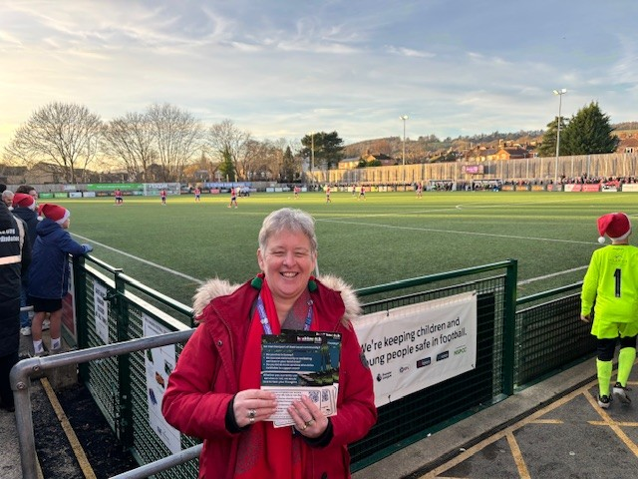

About Healthwatch Surrey

Healthwatch Surrey champions the voice of local people to shape, improve and get the best from NHS, health and social care services. We are independent and have statutory powers to make sure decision makers listen to the experiences of local people.

We passionately believe that listening and responding to local people's experiences is vital to create health and social care services that meet the needs of people in Surrey. We seek out people’s experiences of health and care services, particularly from people whose voices are seldom heard, who might be at risk of health inequalities and whose needs are not met by current services. We share our findings publicly and with service providers and commissioners to influence and challenge current provision and future plans.

We also provide reliable and trustworthy information and signposting about local health and social care services to help people get the support they need.

Our distribution list
If you would like to be added to or removed from the distribution list for this Insight bulletin, please contact our Communications Lead vicky.rushworth@healthwatchsurrey.co.uk


We are committed to the quality of our information.
Every three years we perform an audit so that we can be certain of this.


The Healthwatch Surrey service is run by Luminus Insight CIC, known as Luminus.
Registered office: GF21, Astolat, Coniers Way, Burpham, Surrey, GU4 7HL.

