

Insight bulletin

  - December 2025

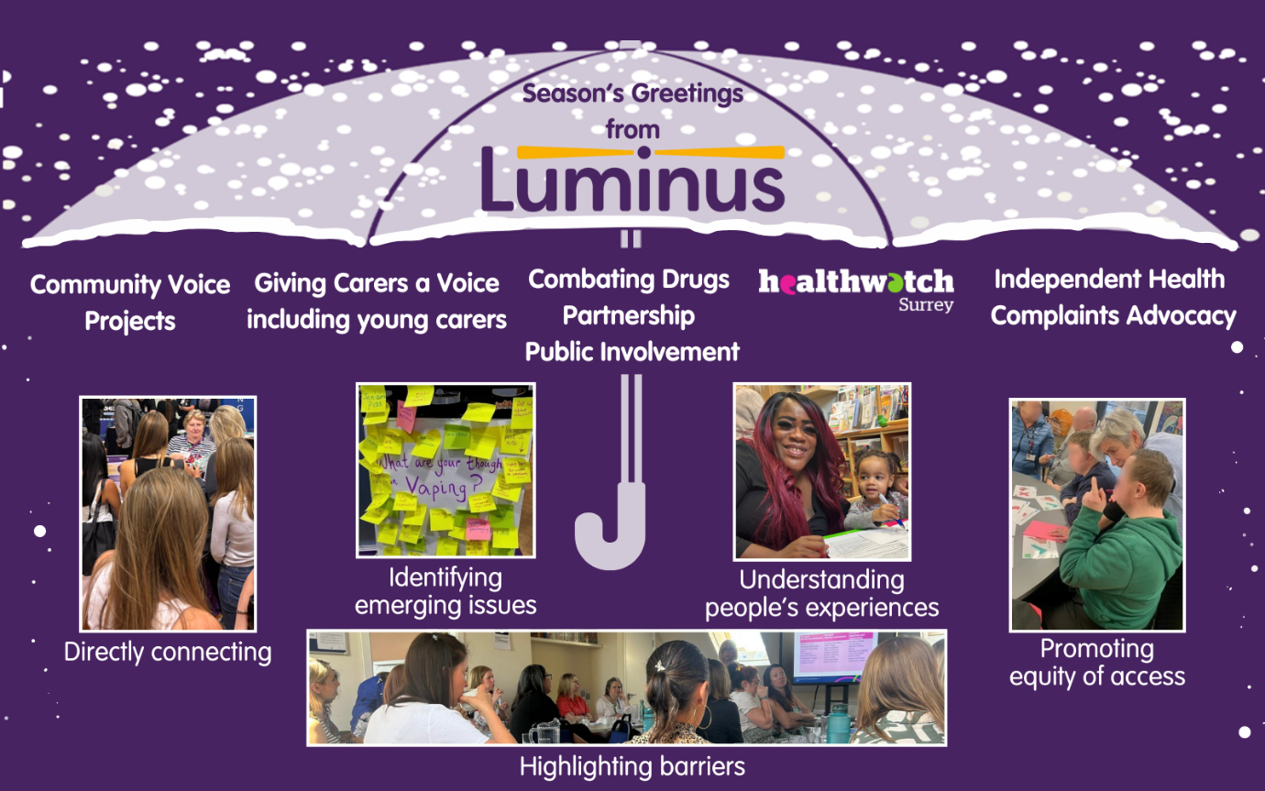

This year has brought its share of challenges and continuing uncertainties, but at Luminus we continue to connect directly with people in the community and those providing or commissioning services. We are proud to amplify people’s experiences to identify emerging issues, promote equity of access and highlight the barriers people face, to help ensure everyone receives the support they need for their wellbeing.

If you would like a paper copy of this document or require it in an alternative format, please get in touch with us.

2025: the year in review
2025 has been a challenging year for Healthwatch Surrey and our colleagues and partners working in the NHS and social care. In March the Government announced plans to abolish NHS England – the body which oversees the budget, planning, delivery and day to day operation of the commissioning side of the NHS in England. In July the 10 Year Health Plan for England set out an ambitious plan aiming to “reinvent” the NHS via shifts from ‘hospital to community’, ‘analogue to digital’ and ‘sickness to prevention’. The plan stated that to achieve this a new “workforce model” was required, a model involving a cost reduction of 50% across Integrated Care Boards (ICBs).

Also included in the NHS 10 Year Health Plan was the decision to abolish the local Healthwatch network with the transfer of our functions ‘in-house’ to local authorities and NHS ICBs once legislation has passed. We have expressed and will continue to express our concern regarding the removal of the only collective, independent and statutory opportunity for the public to hold the NHS and social care system to account. We are challenging this decision (our national petition now has over 10,000 signatures but it’s still vital that people have their say, so please do sign if you agree - Review decision to abolish independent local Healthwatch - Petitions) and will continue our important work to champion the voice of local people until any change in the law comes in to force.

Against this backdrop, local Government reorganisation, intended to streamline structures, will see Surrey reorganising into two unitary councils from April 2027.

Behind all of these plans, strategies, shake ups and reductions are real people, doing real jobs, to help real residents. And what’s striking is that – despite all the change and uncertainty they’re faced with – our partners in the NHS and social care continue to work tirelessly to support the people of Surrey.

This year over 1700 people shared their experiences of health and social care with Healthwatch Surrey, through our Helpdesk, surveys and face to face when out and about in the community. We often focus on areas for improvement as we believe this is an important way to bring about positive change, but we’ve also heard some incredible – inherently positive - stories of care, compassion and dedication. This Insight bulletin is dedicated to those.

Everyone at Healthwatch Surrey wishes you all the best during this festive season,
and a healthy and happy 2026.

January

The shift from analogue to digital – as outlined in the Government’s 10 Year Health Plan – is intended to improve efficiency, accessibility and patient care. Though we often challenge the system on this topic and the potential creation of a ‘digital divide’, for those who understand, and are able to use, the digital system, they are often impressed by its efficiency. Several people spoke to us about this topic at the start of the year, a notoriously busy and challenging time for the NHS.

“Our practice has an excellent email system. You state your problem and who you think might best treat you. They aim to answer within three hours.”
225199, Surrey resident

“My GP is good and when I last made an appointment I did it online but the reception team said if I wanted to be seen earlier I could just call at 8am, but it wasn't an emergency and I got a scan. It was all good and quite quick.”
226150, Runnymede resident

What impact were we having at the start of the year?

In January we submitted written evidence to the parliamentary Health and Social Care Committee who were looking at community mental health services. Our written evidence - based on the experiences of people here in Surrey – was accepted by the enquiry, meaning local residents’ views were heard on the national stage.

February

For those with long term, or recurring, conditions (who are likely to be frequent users of NHS services) compassion and patience are even more important. This is particularly true when it comes to primary care as the ‘front door’ to the NHS. We were delighted to hear this positive experience from a cancer patient back in February.

“I was diagnosed with cancer in 2016 and have had eight procedures since then as it keeps coming back, from my lungs to my liver. At the moment we are very lucky. I always get to talk to a doctor and I always get through quickly. In ten years I couldn't have been treated any better. 10/10 for my practice. I don't think I get any special treatment but I get sent appointments for my blood tests and for my annual flu vaccination.”
225807, Epsom and Ewell resident

How were we helping the community in February?

By February of this year over 800 copies of our ‘What do I need to know about GP practices?’ leaflet and over 100 copies of the Easy Read version had been distributed to various venues across Surrey to support local people. Residents can still find them in all libraries, as well as some Citizens Advice, food banks and churches.

March

We heard more positive experiences about primary care in March, people particularly praising staff who took the time to really listen to them, treat them as people and meet their individual needs.

“Practice staff are fabulous. Really helpful and if they don't know the answer they find out. They've started using a new system and spend time, unrushed, to help go through the form as I couldn't do it for myself. The doctors are all lovely and listen. When I use the dispensary they are really helpful too.”
230729, Surrey resident

“The GP at the surgery is lovely she always checks in with me.”
230668, Guildford resident

“[the practice] are fantastic, they are helping the OAPs by going back to the old ways of booking things.”
230828, Surrey Heath resident

How were we making a difference in March?

In March we were working with the Molebridge GP Practice – offering information and signposting (including a comprehensive Q&A) on a delivery model change – and securing insights around the concerns patients had to help our partners at Surrey Heartlands. We returned in October to see if people had noticed any changes.

April

Community pharmacy is a critical part of primary care in England, making up one of the four pillars along with general practice, optical services and dentistry. It is perhaps most well known as a dispenser and retailer of medicines but, as part of the NHS 10 Year Health Plan, pharmacists will have a more clinically focussed role with less emphasis on dispensing and more on providing advice and other support for patients. We heard some really positive experiences about the support offered in April, with people praising professional, knowledgeable and helpful staff.

“[the pharmacy is excellent]. All prescription requests are managed professionally.”
230678, Runnymede resident

“..the service [at the pharmacy] has been outstanding. I have heard and seen many very positive comments about it and my own experience has been excellent, even my 16 year old granddaughter commented on how lovely the staff are. The online prescriptions are dealt with very quickly, collection is very easy using the QR codes. The staff are always very friendly, pleasant and helpful.”
230999, Surrey resident

“Excellent local pharmacy, staff knowledgeable and helpful.”
230695, Guildford resident

What were we doing in April?

In April we were gathering insights about the EMED non-emergency patient transport service. In total 48 people shared their experience with us and these were provided to our partners at Surrey Heartlands to help improve and shape future EMED non-emergency transport services for Surrey residents.

May

Striking the right balance between efficiency on the one hand, and patience and compassion on the other, is always a challenge for our NHS colleagues who are often working in very difficult circumstances. In April people praised the efficient service they received and told us how much this means to them.

“My local GP service is excellent. I don’t have my ‘family doctor’ anymore but I do get an appointment quickly.”
230681, Surrey resident

“Excellent service when I phoned regarding a mole. Appointment given for almost immediately. All very efficient and thankfully a good outcome.”
230705, Spelthorne resident

How were we effecting change in May?

In May we brought together an influential group of 21 key stakeholders - including system partners, GPs and groups representing domestic abuse survivors - to review the findings of our In Safe Hands? research and to work collaboratively to develop pragmatic and practical solutions to improve access to support and the experience of survivors. During the workshop, attendees identified a number of solutions to the issues identified, and there was a commitment from everyone in the room to implement one change.

June

How were we amplifying the voices of those less well heard in June?

At the start of the summer we attended a Health promotion event at HMP Coldingley to hear about experiences of healthcare in prison. Whilst there, several men told us about the impact which ADHD medication shortages were having on their mental health. In June we were able to share these medication concerns with the Heartlands Provider Quality and Safety Oversight Group, who escalated to the NHS England specialised commissioning team.

We also heard some really positive stories from the men we spoke to, those who felt their health had been well looked after whilst being in prison.

“I'm generally very healthy - my physical health is better than my mental health but that has actually been better since I've been inside. I think being here has made me more resilient as I'm having to deal with new people and new places. I think my health has been well looked after here - I've had Eye Movement Desensitisation and Reprocessing (EMDR) therapy to help me to deal with the crime I committed (death through drink driving).”
230774, HMP Coldingley

“I am not healthy but my health has improved since I have been in prison as I have stopped using drugs…I have access to routine healthcare. They are quite good here, I can go down and speak to them. I have been looked after by the drug services and the COPD [Chronic obstructive pulmonary disease] clinic. They are also investigating my liver issues. I can’t fault them.“
230785, HMP Coldingley

July

There was praise for hospital outpatient services over the summer – people complimenting the care and service they received in several different departments.

“[the] hospital have been fabulous with me, I see them for some cardiac issues, they always call me in for my reviews and scans on time. They have also been amazing with my wife, who has macular degeneration, Alzheimer’s and has recently also had skin cancer. They always call her in for her scans and checks on time.”
230805, Surrey Heath resident

“Cardiology department were helpful friendly and empathetic on 2 recent visits for both myself and my daughter.”
230675, Spelthorne resident

“Excellent experience in Dermatology; consultant was knowledgeable and reassuring; useful information given; very little waiting time.”
230690, Surrey resident

What impact did we have in July?

In July we published a report exploring how access to and experiences of emotional wellbeing and mental health support for people with a learning disability can be improved. 32 parents and carers responded to our survey and we spoke to 70 people with learning disabilities at 5 focus groups. Our partners at Surrey County Council (SCC) and Mindworks are using our findings to bring about real change. You can read more in our Impact Report.

August

The importance of simple kindness can never be underestimated, as people shared with us over the summer.

“I am 97 and live alone as was widowed 18 months ago. I experienced the cancer fast track screening when I had blood in my stools, which was frightening. It worked so well as I was seen within a week and had a colonoscopy. It was not cancer but an infection. I was given antibiotics which did not agree with me - the symptoms were a bad rash and feeling sick. My GP saw me straight away and prescribed new antibiotics. All the staff at the hospital and GP practice were so kind and reassuring which really made me feel they cared.”
231097, Surrey Heath resident

“I took my elderly father to see the GP yesterday. The GP is always so kind to him (and to all of us). She really took her time to look in to his records to resolve a complicated medication query. She had such a kind way with him and was very friendly. My father recently moved to the local area and had been with his previous GP for many years. He was nervous about changing GP practices. The GP has been so kind, efficient and professional. She has really put my father at his ease.”
231106, Mole Valey resident

How were we supporting the people of Surrey in August?

In August we were pleased to launch a new package of information and signposting on Continuing Healthcare (CHC). Following an increase in enquires we met with the CHC team at Surrey Heartlands ICB to discuss further; the result was a new guide on our website, as well as two videos -one for residents and one for providers.

September

There was praise for the urgent and emergency services in September, both their exemplary clinical care and their sensitivity and compassion for people in what are often very stressful situations.

“The paramedics… took extreme care of [my mother, listened to her wishes and took good care of her at home monitoring her carefully and giving us advice on what to do. One of the more recent times they needed an advanced paramedic who arrived and was also extremely competent in a distressing situation.”
231199, Surrey resident

“My wife and I wish to compliment [the paramedics] on how they treated me as I was in terrible pain. They were very understanding and concerned. They went above and beyond their duty. I wish to say again what a terrific crew you have and you should be very proud of them.”
230968, Surrey resident

Who were we talking to in September?

In September we spoke to almost 600 young people about the sensitive topic of sexual health services. Our findings - looking at what students do and don’t know, where they get contraception from, the value of sexual health outreach in colleges and how services could be improved - were shared with the public health team at Surrey County Council (SCC). In response, SCC provided information and signposting to directly address some of the questions, concerns and misconceptions raised.

October

What was keeping us busy in October?

October was the busiest month of the year for our Helpdesk team who dealt with an incredible 56 separate enquiries!

Just as we encourage residents to share their positive feedback – learning from best practice can be as important as learning from mistakes– we also really appreciate it when we hear positive feedback about our own Helpdesk.

“Thank you so much for your help. You are the only people who have sat down with me, talked through everything, looked at the whole picture and given us practical advice.”
231142, Woking resident

We particularly appreciate it when we’re able to help those who feel that they need some independent support.

“I am afraid of the hospital and that if I complain, they won’t give me the surgery. I have a problem with my left knee. I went to hospital and they did some X-rays and told me that I needed a knee replacement. I was due to have the surgery next week, but they have called me and told me that I won’t be having the surgery and they have not told me why. My English isn’t very good, so they spoke to my son, and I think they mentioned something about not being able to attend physio. Can you help?”
230875, Surrey resident

November

Accident and emergency departments can often be busy and chaotic – and by their nature used at a time when people are already feeling distressed. The calm professionalism of staff can make a huge difference to people’s experience.

“I had a stroke. The care at [the] hospital was amazing. I had to sit in A&E for a while, but I was seen really quickly and I am very happy with my care.”
231041, Epsom and Ewell resident

“…the doctor in A&E was absolutely fabulous she was very cheerful and thorough. Very professional and caring. What a difference it makes when you have a doctor like this especially as I was distressed having been brought in by ambulance.”
231205, Surrey resident

What impact were we having in November?

Our report looking at accessible information and reasonable adjustments – developed in response to an increasing number of queries on this subject - was shared with the Learning Disability and Autism Partnership Board, the Reasonable Adjustment Digital Flag (RADF) implementation Board and the national and regional leads for the RADF roll out.

December

Our healthcare system is as complex as the different needs we place on it. Though we often report on how disjointed the system can be, we’re also pleased to celebrate it when different services work well together to the benefit of patients.

“The local practice helped to look after my elderly mum with complex pain issues and were very helpful in getting pain medication prescribed quickly once our mum was put on to the frailty team. They were amazing at helping us as far as they could go, chasing the pain clinic at [the] hospital too. Also involving [the] Hospice…. Once mum was flagged as being housebound the service and attention was even more amazing from the surgery with home visits. They supported us really well.”

Between January and the start of December our incredible volunteers had given us 764 hours of their time. We really couldn’t do what we do without them and were delighted to be able to say thank you – and to celebrate the festive season - with them at a wreath making workshop.

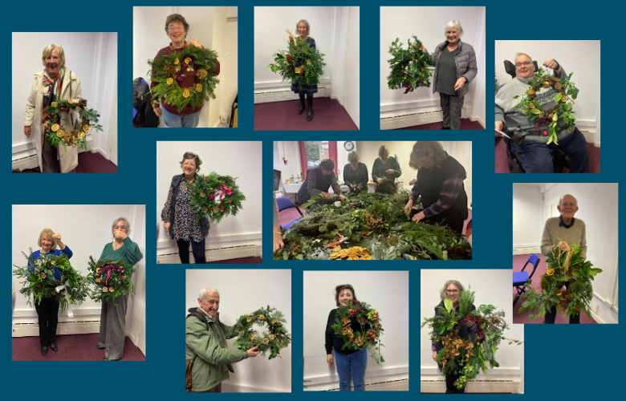

About Healthwatch Surrey
Healthwatch Surrey champions the voice of local people to shape, improve and get the best from NHS, health and social care services. As an independent statutory body, we have the power to make sure decision makers listen to the experiences of local people.

We passionately believe that listening and responding to local people's experiences is vital to create health and social care services that meet the needs of people in Surrey. We seek out people’s experiences of health and care services, particularly from people whose voices are seldom heard, who might be at risk of health inequalities and whose needs are not met by current services. We share our findings publicly and with service providers and commissioners to influence and challenge current provision and future plans.

We also provide reliable and trustworthy information and signposting about local health and social care services to help people get the support they need.

Our distribution list
If you would like to be added to or removed from the distribution list for this Insight bulletin, please contact our Communications Lead vicky.rushworth@healthwatchsurrey.co.uk


The Healthwatch Surrey service is run by Luminus Insight CIC, known as Luminus.
Registered office: GF21, Astolat, Coniers Way, Burpham, Surrey, GU4 7HL.

