

Insight bulletin

  - November 2025


“I felt [the GP] treated me as a person not just a name on her list. She listened without interruption and then became very proactive.”


If you would like a paper copy of this document or require it in an alternative format, please get in touch with us.

This bulletin: at a glance

Hot topics
In this bulletin we are focussing on 6 key areas:
- Thanks and praise for GP practices: the value of kindness and respect
- Complaints handling: confusion and mismanagement
- Spotlight on: accessible information and reasonable adjustments
- Carers: the need for recognition and support
- Spotlight on: the digital divide
- Spotlight on: home based healthcare

Who have we been hearing from?
Since our last report we’ve heard from 152 people across Surrey, via our Helpdesk or during engagement events in the community.

- 36% of feedback relates to hospitals
- 28% of feedback relates to GP practices
- The majority of the remaining feedback relates to community, social care and mental health services.

Our Helpdesk has been particularly busy this month, with almost 100 enquiries since our last report. People can come to us with questions, concerns or feedback on any aspect of health and social care, so what we’re hearing here can be a good indicator of the main issues that matter to local people. The majority of recent enquires have been related to admin and records keeping (we looked at the impact of administrative errors and delays in our September Insight Bulletin), complaints handling, communication and staff attitiudes.

Thanks and praise for GP practices: the value of kindness and respect

'You and Your General Practice' is a new charter introduced as part of the GP contract for 2025-26. It aims to improve transparency and communication between practice teams and the public. This month we’ve had some really positive feedback on Surrey GP practices.

In this example the skill of the GP in tackling a sensitive topic respectfully and delicately was particularly appreciated:

“Amazing ongoing experience for my elderly dad (93) with his local surgery…. Our GP gently and kindly opened the conversation about a DNR (Do Not Resuscitate) which was done so gently and empathetically. Was a masterclass in good conversations about death.”
231084, Surrey resident

People have also praised their GP practices for showing kindness and respect, and have noted the importance of being treated as an individual.

“GP was kind, respectful and very thorough. Took time to explain everything to me. Each appointment lasted 20 mins, despite 10 mins being usual. After the first appointment there was an issue with my medication, the GP receptionist went out of her way to resolve this for me and was also very kind.”
231048, Reigate and Banstead resident

“I felt [the GP] treated me as a person not just a name on her list. She listened without interruption and then became very proactive.”
231043, Surrey resident

“I have complex health issues and have been housebound since December 2024. I need to contact the GP Surgery regularly and am always treated with respect, kindness and care.”
231057, Reigate and Banstead resident
Not everyone in Surrey has had this positive experience. In our report ‘Home is where the care is?’ we found that there is a lack of definition of the term housebound and consequently lack of consistency for people needing care in the home.

“My daughter's agoraphobia started in 2020, when she was 19. She could not leave the house so could not get out for a Covid vaccine - the first response was 'can't you get her to the carpark - we can send a district nurse out to do it there'. She was unable to leave the house at all! It was sorted and the surgery have been very understanding over the years once she was correctly registered as housebound.“
Guildford resident



You can read more about what people are saying about digital access to GPs later in this report.

Complaints handling: confusion and mismanagement

The latest NHS data about written complaints reveals that the number of reported written, formal, complaints in the NHS reached a new high in 2024-25. But does everyone who wants to complain – formally or informally - know how to do it? And are the issues which are being raised being dealt with satisfactorily?

People have come to us confused about NHS and social care complaints processes and, in this case, noting inconsistency in information about it.

“I am writing to escalate my Subject Access Request regarding records from the clinical panel meeting where my son was discussed. [The charity supporting my son] has informed me that they cannot provide the full minutes and that I should direct my request or complaint to the provider. However, this appears to contradict the information published on the provider website… This inconsistency makes it difficult as a parent to know which organisation is the correct data controller for my son’s records.”
231036, Reigate and Banstead resident

Others have shared their frustration at not feeling listened to or taken seriously when they raise an issue.

“[my GP] has so far ignored my three formalised letters - any advice on what I can/should do next to expose to any degree the attitude of this Surgery.”
231022, Surrey resident

“But I really don’t want to keep escalating. I just want engagement.”
231029, Reigate and Banstead resident

“When [the hospital] received our feedback, they decided to process it as a complaint. When we received the complaint response we found it quite insulting. They had not addressed any of our questions…We have an appointment coming up to discuss our complaint with the heads of [the hospital], but we have actively been told by the complaints manager that complaints are not a priority…”
231015, Surrey resident

You can find more information about providing feedback and complaints on the feedback and complaints page of our website. There’s information about advocacy services too (if you find it difficult - for any reason - to have your voice heard about a decision that affects you, an advocate can support and represent you). Residents can also share feedback about health and care services with us. Healthwatch Surrey champions the voice of local people to shape, improve and get the best from NHS, health and social care services. We are independent and have statutory powers to make sure decision makers listen to the experiences of local people.

Spotlight on: accessible information and reasonable adjustments

The Equality Act (2010) states that all organisations, including health and social care such as hospitals and GP surgeries, must take steps to remove the barriers individuals face because of any kind of disability or specific need.

In our last Insight Bulletin we shared examples of people reaching out to tell us about occasions when reasonable adjustments had not been made, and how this had impacted their experience and health outcomes. We were concerned about the increasing number of people sharing these issues with us (42 over the last 6 months) so escalated to our system partners. You can read our What we’re hearing about accessible information and reasonable adjustments report here. In it we recommend that all providers take steps to review whether they're complying with the Accessible Information Standard (AIS) effectively.

People told us that, even when their required reasonable adjustments had been recorded, they were not acted upon by staff.

“I said to the receptionist that I have it on my record that I need reasonable adjustments and the receptionist said, ‘Oh so you expect me to read notes from 2017?”
230941, Surrey Resident

Carers: the need for recognition and support
A Carers UK report published in October found that almost three quarters (74%) of carers feel stressed or anxious. Here in Surrey, against the backdrop of the Carers Partnership Board being put on hold (established in 2022 to promote and champion the agreed Surrey Adult Carer and Young Carers Strategies) and the closure of the Action for Carers Surrey specialised benefits service, we continue to hear from unpaid carers seeking advice and support.

This month we’ve heard from several parent carers concerned about ADHD (Attention Deficit Hyperactivity Disorder) assessments. Parents often come to us when they don’t feel able, or inclined, to reach out to the system directly.

“My daughter was referred for ASD (Autism Spectrum Disorder) and ADHD assessment in March 2022. I keep calling the provider helpline but no one ever answers my calls, and I feel that it’s a total scam. My daughter has been waiting for three years, and I want to know when she will be seen. My daughter is getting worse and needs to be seen as soon as possible. I think it’s disgusting that she has had to wait this long.”
231069, Surrey resident

“My adult son was referred for an ADHD assessment in August 2022 and was told at the time that they were doing assessments for people who had been referred in October 2018. He requested an update this week having been reviewed by a psychiatrist who said it definitely sounded like he had ADHD and was told that they are currently seeing people referred in May 2019. He called and spoke to someone who told him that he could expect to wait about 20 years before they would be able to assess him. He feels that this is really impacting on his life and ability to get on with his career.”
230897, Waverley resident

If you live in England and are an NHS patient you have the right to choose who delivers your care. This includes who can provide your ADHD assessment and support you with starting medication. You can read more on the Right to Choose page of our website.

Championing the voice of carers
Our recent reports Making mental health inclusive: supporting people with learning disabilities and Home is where the care is? championed the voices of those with learning disabilities and those who are unable to leave their home to receive care, as well as their unpaid carers.

The issue of recognition
For many carers a key issue is that they don’t actually recognise themselves as such – this theme is repeatedly reported by our colleagues at Giving Carers a Voice.

“I look after my father who is in his 90s but lives independently… I also look after my [adult] son… I then also look after my sister-in-law who is in her 70s… but lives independently. I don’t think that I’m a carer. Am I? Could they all manage without me. Absolutely not.”
235550, August 202

We work closely with the Giving Carers a Voice team to share carer insights and signpost carers to appropriate sources of support. You can read their latest report on our Luminus website: Giving Carers a Voice: Reports.

Spotlight on: the digital divide

Access to GP services is increasingly through online channels – the NHS App or the GP website – but how accessible is this? The use of AI (artificial intelligence) is also growing, but how do people really feel about the use of this sort of technology to assist them when dealing with their GP?

106 Surrey residents spoke to us at community engagement events or responded to our survey.

We found that:
- Only half of people (51%) found it easy to access healthcare services from their GP practice online.
- Almost two thirds (63%) of people normally make an appointment with their GP practice online, 47% use the phone and 13% do it in person.
- However, when asked if this is how they prefer to make an appointment less than half (47%) chose online. 58% chose the phone and 18% chose in person.
- People reported that they felt pressurised by their GP practice to make an appointment online; some said that they found completing the online form time consuming, saying that there seem to be a lot of questions but that these do not always allow them to say what they felt they needed to. Others said that they knew to use “buzz words” to encourage the triage system to give them an appointment, otherwise they would have to wait weeks.

“I am trying to use the online system but it’s clunky. You have to over exaggerate your symptoms to get an appointment. If you use buzz words like anxiety and depression, you will get an appointment. Getting seen relies on you knowing this which makes the system elitist.”
Mole Valley resident

- When it came to AI, the main concerns were a lack of trust in a relatively new technology, concern about the quality of the data informing AI and the lack of/preference for human interaction.

What would make it easier to access GP services online?

Suggestions included:
- Make the online form available 24/7
- Make more appointments available
- Provide skills tutorials/explanation of how to use the online tools
- Simplify the online form and provide a free text box.

Read the full report on our website: The digital divide - October 2025 | Healthwatch Surrey
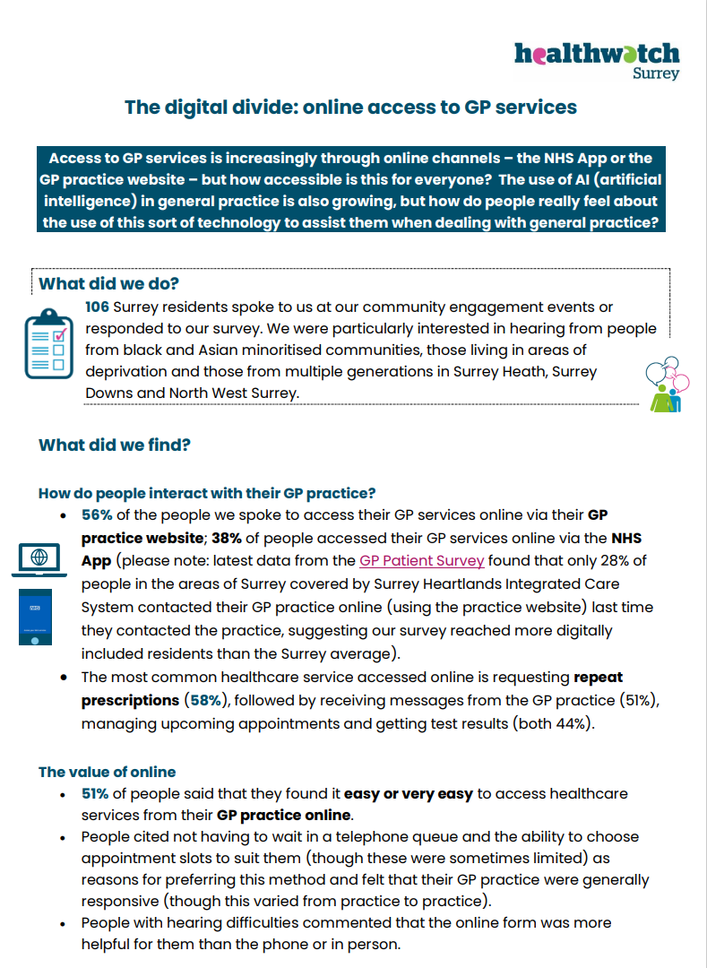

Do you use the NHS App? If yes, what do you like about it (and what could be better?). If not, why not? Either way, we’d love to hear from you.
This simple survey should only take 5 minutes to complete online, or please get in touch with our Helpdesk if you need a paper copy, or would prefer to share your experience in your own words.

Have your say!

We want to hear from as many people as possible! We therefore have several surveys to support our face to face engagements out in the community; you can read more about our upcoming engagement events on page 15.

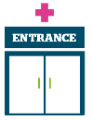 | Access to primary care - we are seeking to understand the barriers that may prevent people from black or Asian minoritised communities from accessing sight (eye) tests.  Eye sight survey closes 28 November 2025.  We’re also looking at the adjustments (changes) a GP practice makes so you can use their services, and if they’re meeting your needs.  Adjustments survey closes 31 December 2025.
     | Public health and adult social care - we are looking at NHS Health Checks. These checks are free for anyone between the ages of 40 and 74 (who doesn’t have one or more of a number of pre-existing conditions), but how much do you know about them? Why are people not taking them up?  Health Checks survey closes 31 December 2025.  Involvement of people – along with a number of other local Healthwatch across the country we are looking for feedback on the NHS App - why you use it, why you don 't, and how it could be improved.  NHS App and feedback survey closes 30 January 2026.  Mental health – we are beginning a new project looking at isolation, loneliness, sense of belonging and community and the impact on men’s emotional wellbeing. Survey coming soon! In the meantime, share your experiences online or with our Helpdesk.
The more people we hear from, the more impactful our research will be, and the more likely we are to be able to bring about positive change.

The NHS 10 Year Health Plan and Healthwatch: your voice matters

In our last Insight Bulletin we talked about the proposed abolition of Healthwatch England and 152 local Healthwatch, and the transfer of functions ‘in-house’ to local authorities and NHS Integrated Care Boards once legislation has passed.

We strongly believe that the independence of local voices in health and care should be protected.

Thank you for your continued support – over 10,000 people have now signed our national petition to the Government calling on them to review their decision. This is an important milestone but it’s still vital that people continue to have their say, so please do sign if you agree - Review decision to abolish independent local Healthwatch - Petitions.

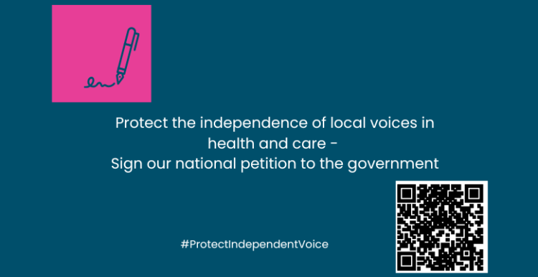

Sharing our insight and raising concerns
Whilst this bulletin accurately reflects what we hear from the individuals we speak to, we are aware that it may not be representative of everyone’s views of a particular service. Multiple references to a specific service may be due to where our community engagement has recently taken place.

If we hear a case of concern regarding patient safety, we immediately signpost the sharer to the appropriate body. All appropriate information and signposting has already been given.

If you would like more information or examples of what people have shared with us, please get in touch with us.

Community engagement
Below are details of our upcoming engagement sessions where we visit venues in local communities to listen to what people think about local health and care services, and to ask specific questions related to our priorities. We also provide information and signposting regarding health and social care. Throughout the year, we also attend events across Surrey to raise awareness of our work.

Date | Place | Time | Open to
8/11/2025 | Heathcot Medical Practice, Community Health and Wellbeing Workshop, Woking | 11am – 4pm | Public
12/11/2025 | Angelic coffee morning, Woking | 10am – 12noon | Group engagement
13/11/2025 | Working Together for Woking | 10am – 2pm | Public
14/11/2025 | Shah Jahan Mosque, Woking | 1 – 4pm | Group engagement
20/11/2025 | Coffee and drop in session, High Cross Church, Camberley | 1.30 – 3.30pm | Group engagement
24/11/2025 | Shifa event, Sheerwater Community Centre, Woking | 12.30 2.30pm | Group engagement
Please note: these dates may be subject to change.
To share an experience with us, or for information and signposting about health and social care, people can also contact our Helpdesk in the following ways:
Phone: 0303 303 0023
SMS (text only): 07592 787533
WhatsApp: 07592 787533
Email: enquiries@healthwatchsurrey.co.uk
Share your feedback via our website: https://www.healthwatchsurrey.co.uk/share-your-views

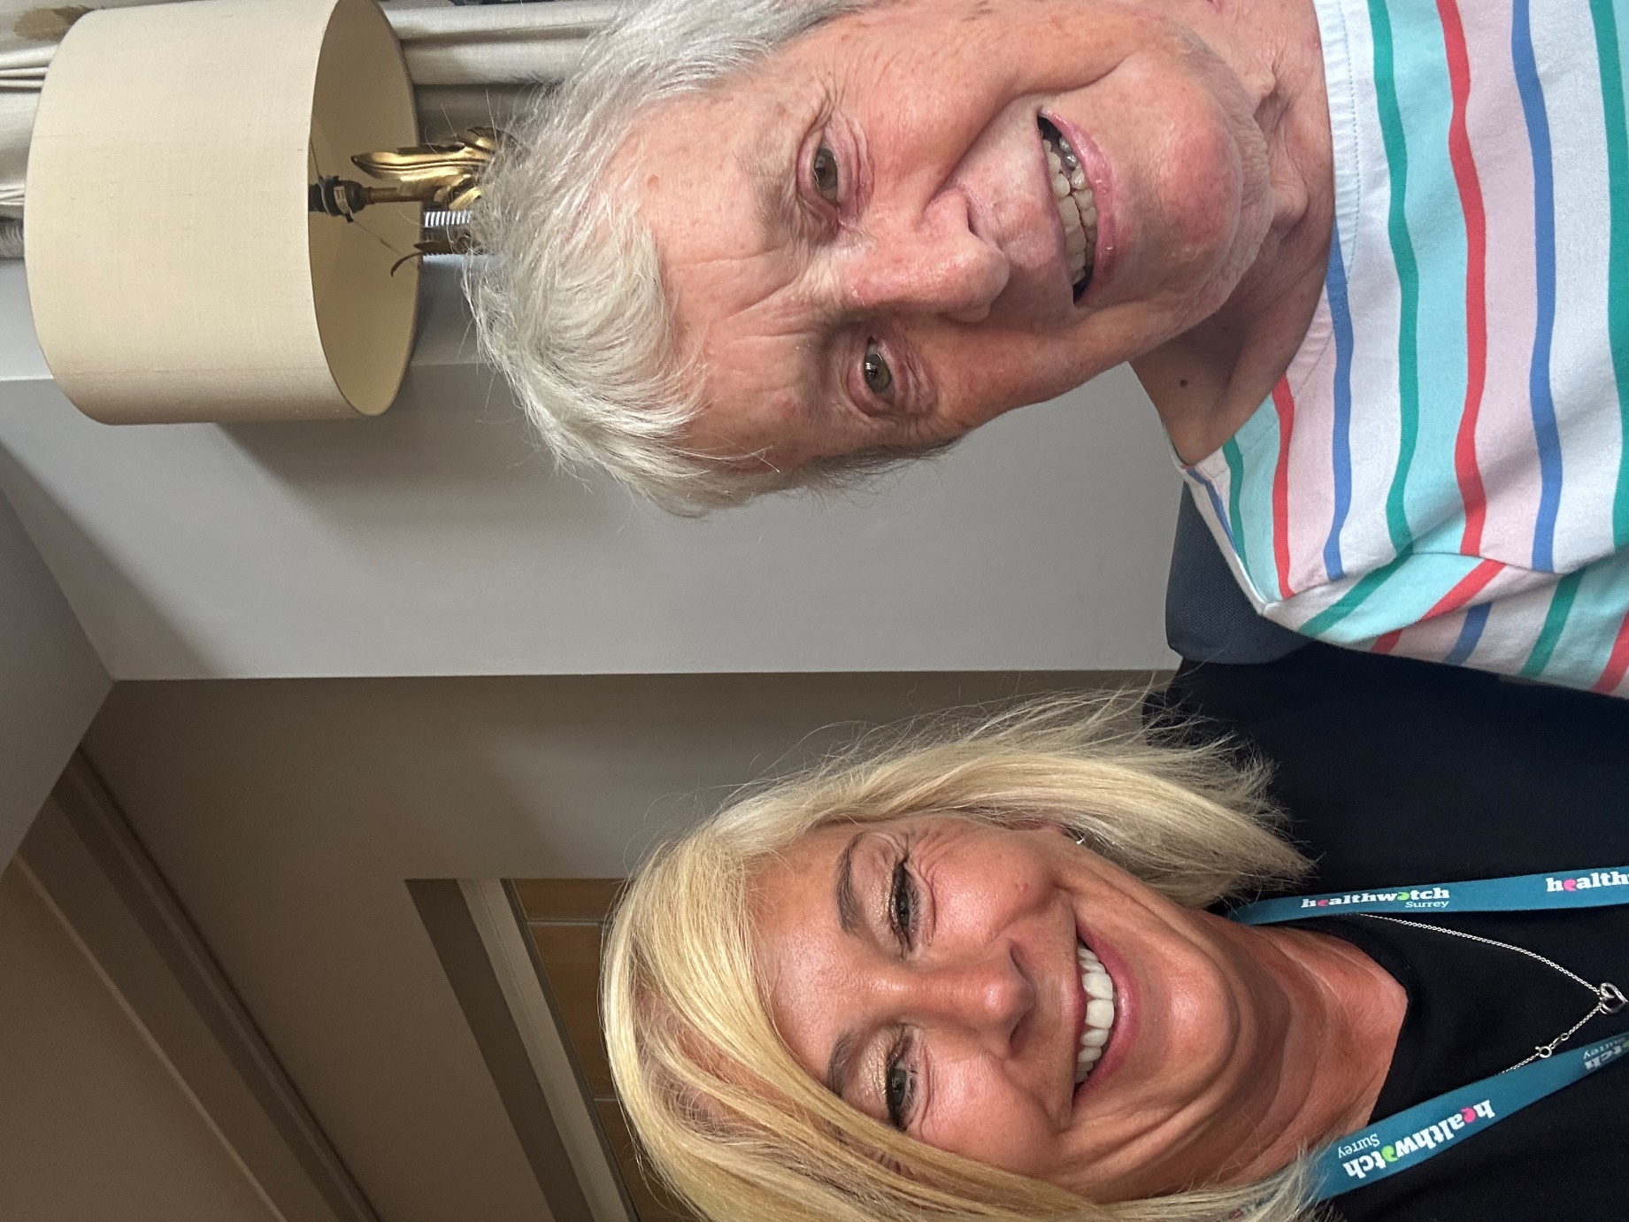

About Healthwatch Surrey

Healthwatch Surrey champions the voice of local people to shape, improve and get the best from NHS, health and social care services. We are independent and have statutory powers to make sure decision makers listen to the experiences of local people.

We passionately believe that listening and responding to local people's experiences is vital to create health and social care services that meet the needs of people in Surrey. We seek out people’s experiences of health and care services, particularly from people whose voices are seldom heard, who might be at risk of health inequalities and whose needs are not met by current services. We share our findings publicly and with service providers and commissioners to influence and challenge current provision and future plans.

We also provide reliable and trustworthy information and signposting about local health and social care services to help people get the support they need.

Our distribution list
If you would like to be added to or removed from the distribution list for this Insight bulletin, please contact our Communications Lead vicky.rushworth@healthwatchsurrey.co.uk


We are committed to the quality of our information.
Every three years we perform an audit so that we can be certain of this.


The Healthwatch Surrey service is run by Luminus Insight CIC, known as Luminus.
Registered office: GF21, Astolat, Coniers Way, Burpham, Surrey, GU4 7HL.

