Healthwatch Surrey logo

**Quarterly Impact Report**

July - September 2024

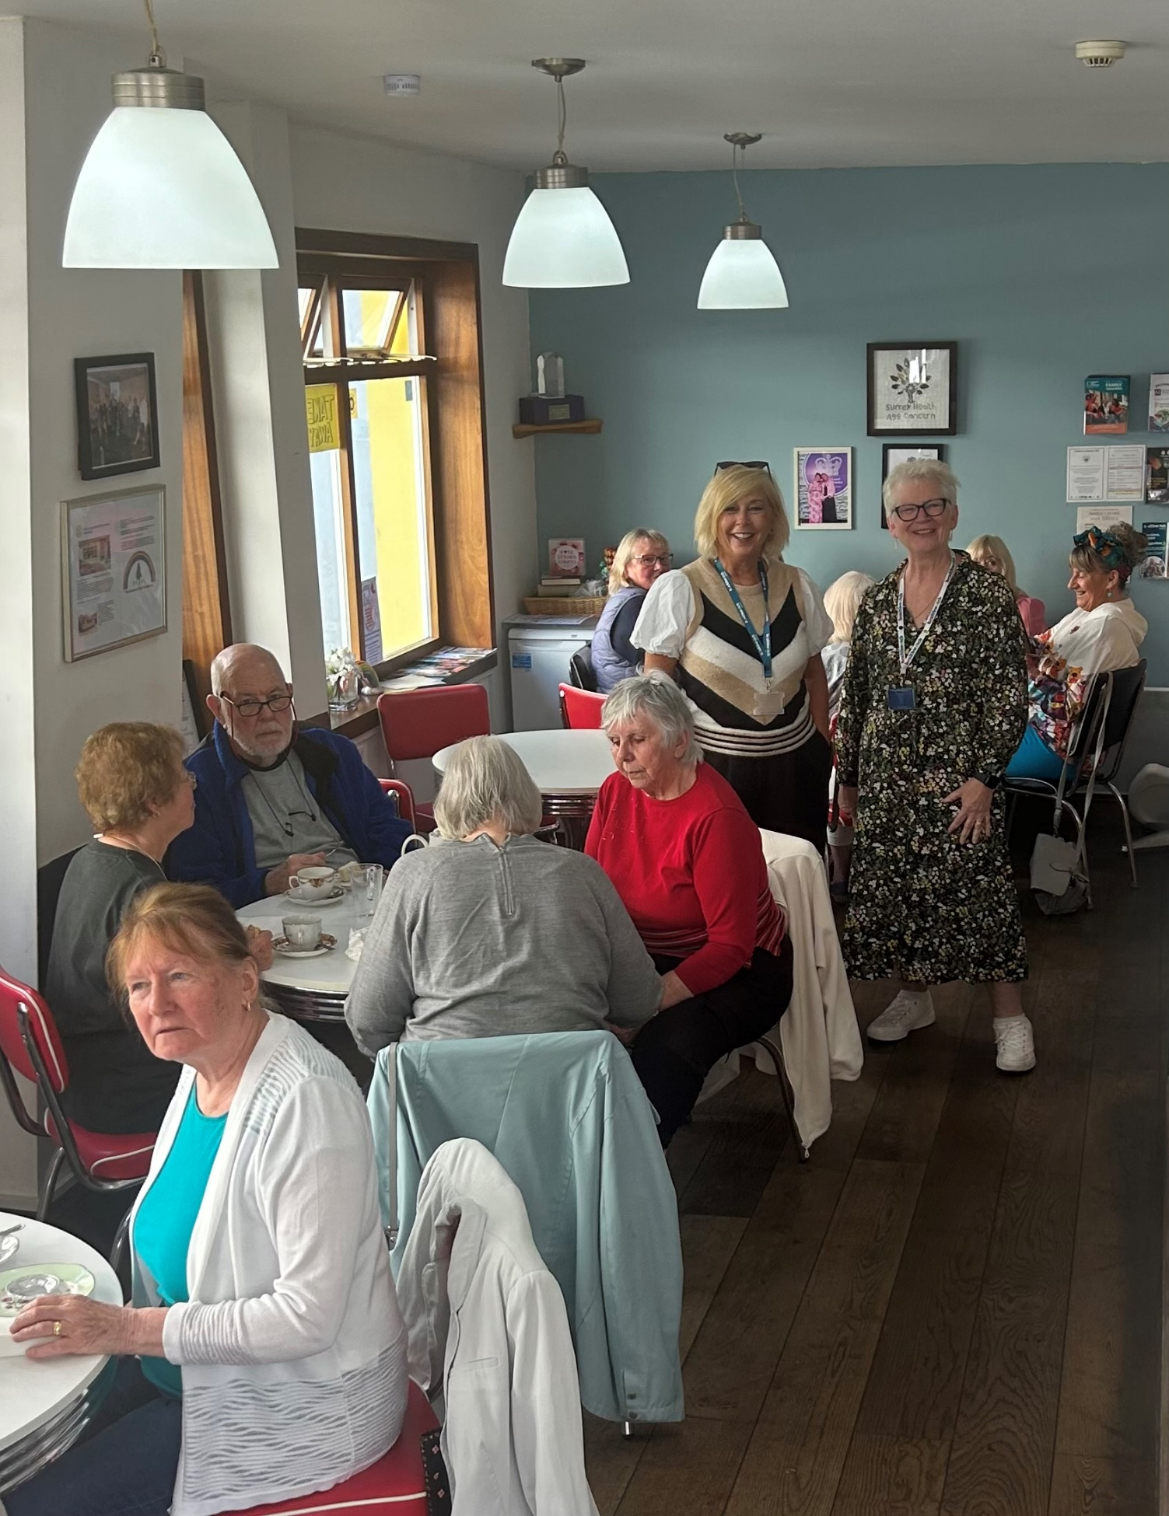

Contents

This quarter in numbers 3

Information and signposting 4

Supporting residents through our Helpdesk 5

Supporting residents in the community 7

Delivering on our thematic priorities 10

Social care 11

Primary care 13

Making a difference at a system level 14

Ensuring the voice of carers are heard 15

Ensuring service users are an integral part of service development 16

Cervical screening: impacting at a local and national level 17

Involving local people in health and social care 18

The Healthwatch Surrey Reading Panel: a vital sounding board for our system partners 19

Adding value to learning disability and autism training 20

Healthwatch Surrey – Contact us 21

If you would like a paper copy of this document or require it in an alternative format, please get in touch with us.

# This quarter in numbers

|  |  |
| --- | --- |
| **Icon of a telephone.** | **118** People supported through our Helpdesk |
| **Icon of a person holding up a sign** | 32 **People supported by our Independent Health Complaints Advocacy service** |
| **Icon of people gathered together and talking** | **30 Community engagement events** |
| **Icon of a group of people** | **815* People helped, supported or engaged with whilst out in the community** |
| **Icon of a report** | **11** [**Reports**](https://www.healthwatchsurrey.co.uk/reports) **published** |
|  | **288 Hours provided by our volunteers, which equates to £10,875 worth of social value\*\*** |

* This quarter we attended three busy Freshers Fairs, which enabled us to engage with large numbers of students in a short space of time.

** Between £35 and £45 per hour for our volunteers, based on level of experience.

# Information and signposting

Healthwatch Surrey offer information and signposting – via our Helpdesk or during engagement in the community - to support people to navigate health and care services across Surrey. We help people to identify the services and support they need and provide advice about what to do when things go wrong. Through our relationships with system partners we can also escalate concerns, providing resolutions to individuals and ensuring an improved experience for others.

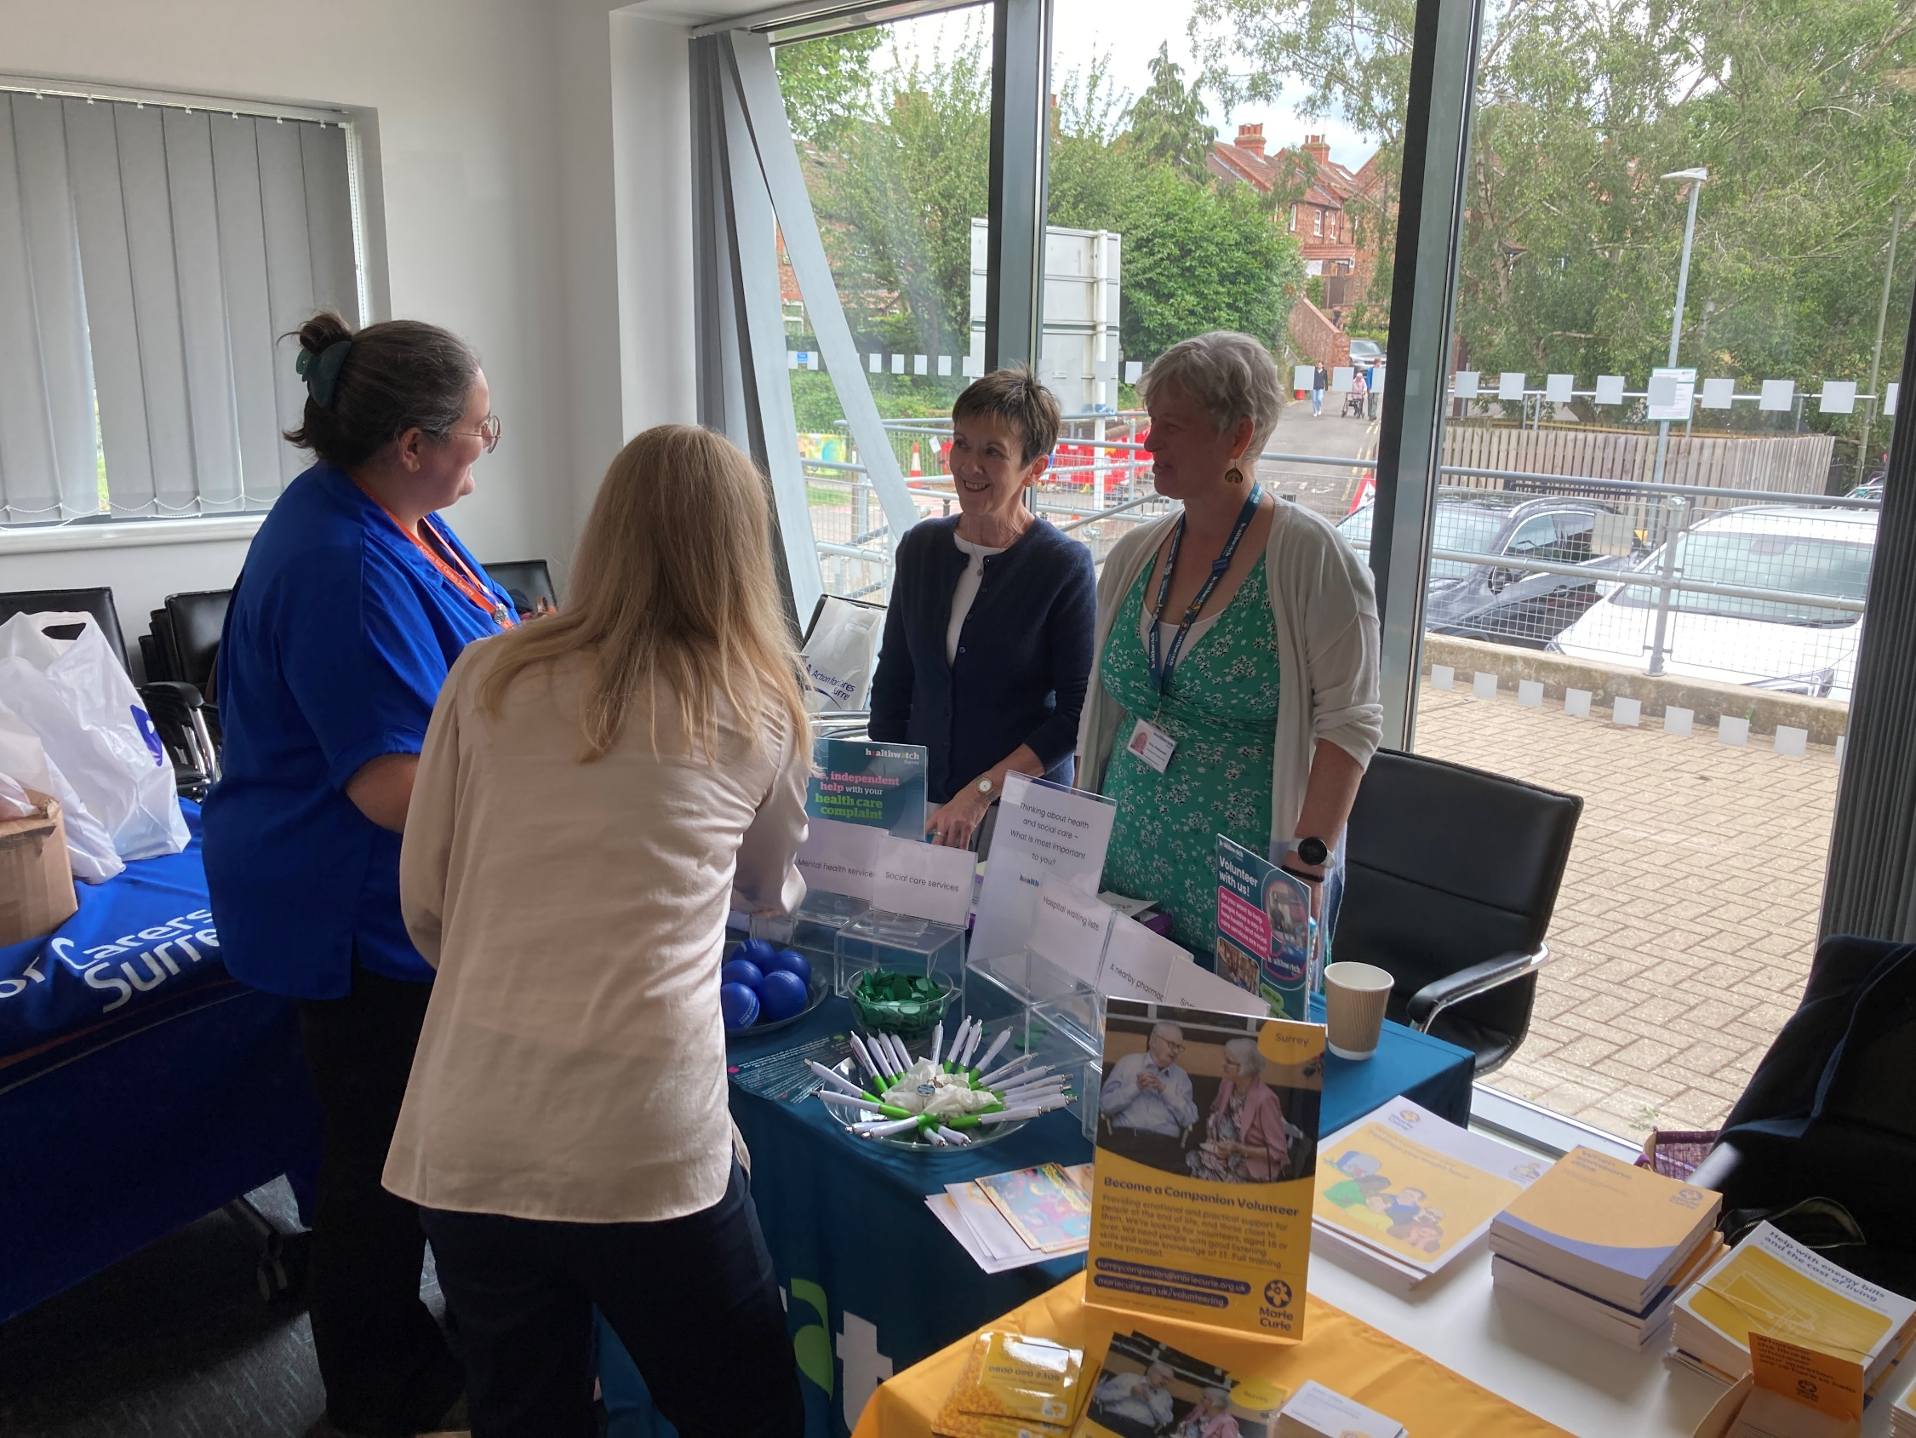

## Supporting residents through our Helpdesk

We helped **118** people navigate health and social care services through our [Helpdesk](https://www.healthwatchsurrey.co.uk/contact/). Of these, almost half (51) had a long-term condition, demonstrating the value of the service to those who have additional health needs.

“Thank you so much for this, it’s amazing. As much as anything it has been enormously beneficial for me to just talk to someone as I feel like I am battling this on my own. Your grasp of it all was phenomenal and I felt like you were really listening and understanding. Thank you.”

Helpdesk user

“After speaking with [Helpdesk advisor] this afternoon, I just wanted to say how impressed I was with her explanation of how your service works, including communicating with service providers, and her perseverance in ensuring that I could understand the whole process.”

Helpdesk user

#### ****Case study: David’s* experience****

We received a call from David who was frustrated by delays to hospital treatment for an issue which hadn’t been dealt with before his recent release from prison. During conversations with our Helpdesk team it became clear that he was actually struggling to access multiple different health and social care services, including a GP, social worker and mental health support.

Our Helpdesk advisor worked with David to develop a plan to help him to obtain the support he needed. They also raised a concern with Surrey Heartlands Integrated Care Board (ICB) about David’s access to primary care and a concern with adult social care.

**Outcome for David**

Theprimary care team at Surrey Heartlands were able to identify the issue and ensure that David was registered with the correct GP practice for his needs. This resulted in David being able to access care for his skin condition, as well as additional referrals to secondary care.

As a result of us raising concerns with adult social care David was re-referred to their service and is now receiving the assistance he needs, including tailored mental health support.

#### ****Case study: Albert’s* Experience****

Albert had a cancerous mole removed but called the Helpdesk very concerned about remaining cells. He had tried to book a GP appointment in person but was turned away and told to use the online form. Albert is elderly and struggled with this as he felt there was a confusing 'category of illness' question that his query did not fit into. Our Helpdesk advisor contacted the Head of Primary Care Commissioning and Development at Surrey Heartlands ICB who reached out to the practice directly to help resolve things.

**Outcome for Albert**

Albert had a phone call from a GP at the practice, reassuring him and helping him to book an appointment.

**Improvement for others**

Training was provided to staff on how all patients who are less digitally able must be supported to ensure they can obtain an appointment how and when they need it, meaning that patients will be better supported to access care they need.

* Names have been changed.

## Supporting residents in the community

We visited **30** venues across Surrey and engaged with **815** people.

“You helped me so much by helping me download the NHS App. It’s made such a difference to my life, I now do all my prescriptions via the app, I can order really easily and they get delivered to my door… I’m so glad you are here today so I can thank you in person. These processes really work for me."

Engagement event attendee

In July our community visits took place in East Surrey, in August, Farnham and in September, Surrey Heath.

The map below shows the venues we visited this quarter.

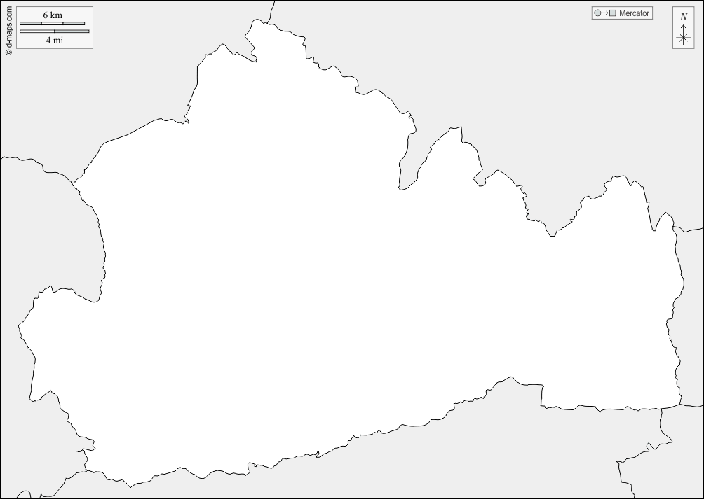

Lightwater GP practice

Lingfield GP practice & parish church

Dorking football club

Fordbridge Centre

Regent House

Farnham library & Hospital

Canalside community fridge

Frimley Baptist church churchchurch

Spires café

St Pauls & Rainbow café & St Martins

Ashford St Peters hospital

Cobham village hall

Christ church

Bourne Hall community centre

Lucan Pavillion

East Surrey hospital

Royal Holloway

Godalming College

East Surrey college

The Hive

The Woodhouse Centre

Next quarter we’ll be focusing our engagement in Guildford and Waverley, Surrey Downs and North West Surrey.

### Community case study: engaging with young people across Surrey

We believe that our influencing should be based on sound knowledge of local issues and the insight and experiences of *all* local people. Young people are less likely to contact us with their views, so this quarter we decided to go to them!

In September, to coincide with the new academic year, we visited 4 Freshers Fairs across Surrey and spoke to **670** students!

Chatting to the young people gave us valuable insights into what matters to them, which in turn will inform what we share with service providers, as well as guiding our strategic priorities. Almost half of those we spoke to stated that mental health services were important, supporting our focus on young people as part of our mental health priority.

**“When it comes to health and social care, what is important to you?”**

A significant number of the students we spoke to expressed an interest in working with us and we’re liaising with them to get them on board as volunteers. We’re delighted to be able to offer young people valuable volunteering experience and support in developing their skills in engaging with their local communities and amplifying their voices.

### Advocacy & complaints

This quarter we supported **32** people to make a complaint through our [Independent Health Complaints Advocacy service](https://www.surreyilc.org.uk/independent-health-complaints-advocacy-service/) (IHCA). Run in partnership with the [Surrey Independent Living Charity](https://www.surreyilc.org.uk/independent-health-complaints-advocacy-service/), IHCA provides free, confidential and independent support.

#### Case study: Emily’s* experience

Emily was referred to the Perinatal Mental Health Community Team following a breakdown. Though initially good, the service from this team deteriorated rapidly, with appointments cancelled and amended –sometimes at the last minute - and the practitioner often arriving late. Emily was seen by a therapist with no understanding of children, bonding or attachment issues, and reporting was inaccurate, leading to extra work for other services to set the record straight and the case being put on hold for several weeks.

The IHCA explained the complaints process to Emily and answered any questions she had. The complaint – including outcomes requested by Emily - was drafted by the IHCA. The IHCA then monitored the response, kept Emily up to date and guided her through the whole process.

**Outcome for Emily**

The Trust accepted their failings regarding appointment changes and communication failings. The practitioner involved was investigated in accordance with their HR process and they have apologised for the staff conduct. They also apologised for the lack of follow up around mental health and well-being. They have implemented training internally for their staff and introduced a more rigorous support framework for patients, their family members and carers, which will be shared Trust wide. Emily was satisfied with the Trust response and will not be taking matters any further.

Emily found the Advocate support invaluable, she felt heard by them, and ultimately heard by the Trust. Without the service Emily doesn’t feel she would have been able to complain, or receive the answers or outcomes that she wanted.

* Names have been changed.

# Delivering on our thematic priorities

Along with our core priorities of agenda free listening, the provision of information and advice and amplifying the VCSE voice, we also have 4 thematic priorities – access to primary care, social care, mental health and the involvement of people.

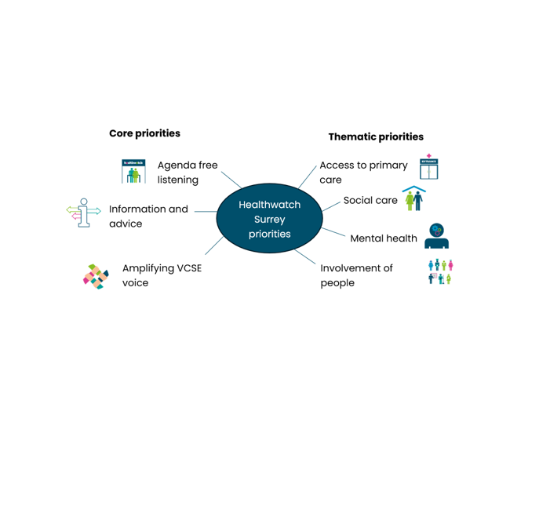

## Social care

**The Surrey residents who talk to us about social care often tell us they struggle to know how to access and understand it. We therefore have a focus on listening to service users and potential service users to help adult social care make things clearer.**

### Self-funders project

#### Background

The life expectancy of Surrey's residents exceeds the national average for both men (81.4 compared to 79.5) and women (84.6 compared to 83.1). The number of older residents in Surrey is predicted to rise dramatically over the next 10 years.

Against this backdrop, Surrey County Council (SCC) approached Healthwatch Surrey to support them with gathering insight into the journey self-funders (people paying for their own care home accommodation) may take to arrive in a residential care home setting.

During visits to care homes, community settings and Age UK Surrey ‘Planning for your future care’ events, and supplemented by a survey, people told us they were not aware of available support or the financial eligibility for social care. As a result, we recommended more information be made readily available and accessible. More information can be found in our report [Who can help me plan for my future as an older person? - June 2024 - Healthwatch Surrey](https://www.healthwatchsurrey.co.uk/report/who-can-help-me-plan-for-my-future-as-an-older-person/).

#### What’s changed?

Surrey County Council (SCC) and Age UK Surrey used our findings to adapt their ‘Planning for Your Future’ campaign materials, so that they now more directly reflect what the public told us they want and need to know. ‘Planning for Your Future’ is an integral part of SCC’s drive to raise awareness of the importance of planning for future care needs, understanding the cost of social care and connecting people to local support.

SCC will also be undertaking specific activities with care providers to ensure that information on what happens when care home residents’ money runs out is consistently provided to residents, carers and families.

In addition, what people told us about their lack of awareness of the costs of care and the wide range of preventative community services available will now be a key focus for SCCs ‘Planning for your Future’ awareness day in 2025. They are also aiming to do some activity with neighbouring authorities to amplify the messages.

Though primarily for the SCC Information, Advice and Engagement team, the report will impact the work and approach of various SCC departments (it has been shared with the SCC Directorate Leadership Team, commissioners from the Older People Commissioning team, Contract & Commissioning Support Service and Brokerage, Financial Assessment and Income Collection Team and senior managers in operations) and has been integral to guiding future engagement focus.

“We are keen to understand more about how people arrived in care homes, where they went for information, did they seek independent financial advice, did they look at other care options, did they understand the costs etc. This focus will be most beneficial to help us act and respond with further actions to plug any information gaps, identify any issues with providers and messages we need to use in our ongoing communications campaigns.”

Siobhán Abernethy, Information, Advice and Engagement Lead, SCC

## Primary care

**In this quarter, over a third (36%) of what people have talked to us about relates to general practice. The vision which guides all our work under this priority is that the population of Surrey know how and when to access primary care services, and for services to work better together to meet the needs of their local populations.**

### Find a GP: Securing a change to the NHS England website

A resident of North West Surrey contacted our Helpdesk because they were unable to find a GP to register with. We usually advise people to use the national [Find a GP](https://www.nhs.uk/service-search/find-a-gp) website hosted by NHS England. However, when this person used this service the first practices that were suggested by the website told them they lived outside the catchment area. We raised the issue with Surrey Heartlands who told us that they were eligible to register with a practice further down the list.

After discussing the information on the NHS website, it became clear that the order in which GP practices appeared was how close to each practice someone lives but wasn’t necessarily reflective of catchment areas. This was raised with the NHS England digital team.

Following our feedback, NHS Digital made a permanent change to the national ‘Find a GP’ web page to make it clearer, meaning people will find it easier to register in future.

# Making a difference at a system level

We ensure that decision-makers in Surrey Heartlands and Frimley Health hear about the insights and experiences residents have shared with us, both positive and negative. We sit on a number of boards and committees and hold regular ‘What we’re hearing meetings’ with Place (the 6 health areas across Surrey). We also proactively challenge system partners over issues identified to us by local residents and share when things have gone well to help to identify best practice.

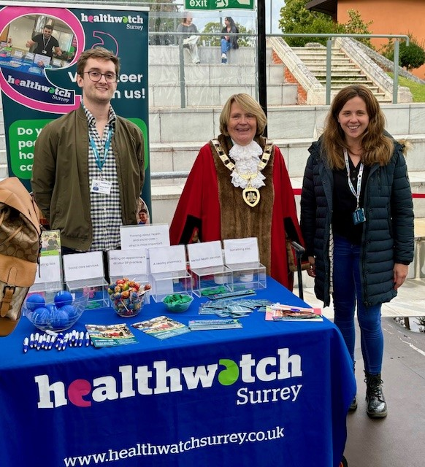

## Ensuring the voices of carers are heard

**This quarter we heard from 196 people who consider themselves to be carers.**

Our influence via the Carers Partnership Group has led to the Joint Carers Team more actively listening to the patient voice when planning and assessing services.

Utilising our influence with the Carers Partnership Group we questioned how the joint carers team measure progress, and whether they use any of the outcomes which carers themselves say are important to them. We are pleased that priorities for 2024/2025 were finalised following carer feedback, including that provided by Healthwatch Surrey, that carers were invited to a co-production and feedback event around the information being developed by the Information and Engagement Team. An annual carers survey is also being planned to enable the team to measure progress against commitments.

Following feedback from Healthwatch Surrey, The Surrey Safeguarding Adults Board (SSAB) website is now more comprehensive and helpful for carers.

We provided SSAB with suggested wording to ensure that their website contains appropriate and sufficient signposting, with vital information for unpaid carers. Videos relating to patient experiences are also now included to aid understanding.

## Ensuring service users are an integral part of service development

Healthwatch Surrey insights and recommendations have re-shaped the approach to co-production within a Trust, ultimately ensuring their services better meet the needs of users.

In 2022 Healthwatch Surrey co-produced and co-authored a [report](https://luminus-cic.uk/wp-content/uploads/2023/06/Who-holds-the-power-Final-17-May-22.pdf) exploring who holds the power at Surrey and Borders Partnership NHS Foundation Trust (SABP). The report aimed to transform the future of co-production at the Trust and provided a series of recommendations to “drive a move away from a culture of ‘power over’ towards ‘power with’ service users and carers.”

On the back of this report – and using the insights and recommendations contained within it - SABP launched their new [co-production framework](https://www.sabp.nhs.uk/aboutus/members-and-governors/how-to-get-involved) in July this year. The framework lays out SABP’s commitment to co production and will guide their approach to ensuring that service users, their carers and their families are a fully integrated part of service development.

“Co-production is a way of working that involves people who use health and care services, carers and communities in equal partnership; and which engages groups of people at the earliest stages of service design, development and evaluation.

Co-production acknowledges that people with ‘lived experience’ of a particular condition are often best placed to advise on what support and services will make a positive difference to their lives.”

SABP



## Cervical screening: impacting at a local and national level



This quarter Healthwatch England published a national [report](https://www.healthwatch.co.uk/report/2024-09-16/cervical-screening-my-way): Cervical screening, my way looking at women’s experiences of cervical screening. The report unpicked why some women are hesitant to go for screening and made recommendations to policymakers on how to improve uptake.

Healthwatch Surrey contributed to this report by interviewing local women with a learning disability and from minoritised ethnic backgrounds, thus ensuring that the voices of marginalised women from Surrey were heard on the national stage.

Locally, the report and its recommendations have been shared with the Learning from lives and deaths - People with a learning disability and autistic people ([LeDeR](https://www.surreyheartlands.org/leder-programme)) programme, the Focus on Women's Health Programme and the Sexual Health Outreach Group. We will also be sharing at the Surrey and Sussex Cancer Alliance Board next month.We look forward to seeing how the report can help to shine a light on the need for accessible information and adjustments to care in women’s health.

# Involving local people in health and social care

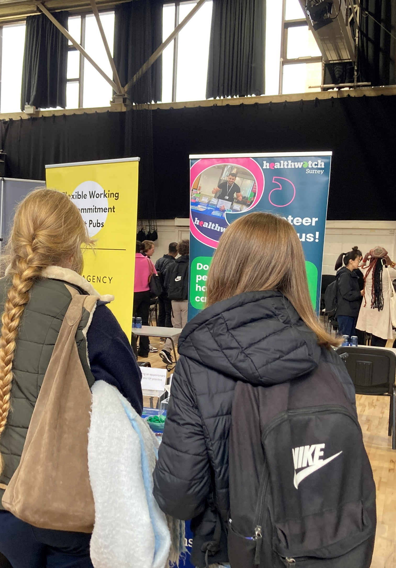Our dedicated team of volunteers help us to ensure that local people have their say, and that we hold decision makers to account.

## The Healthwatch Surrey Reading Panel: a vital sounding board for our system partners

**One of our Healthwatch Surrey priorities is the “Involvement of people”. Under this priority we encourage system leaders and decision makers to ensure local people are involved in health and care services. Our Reading Panel scrutinise reports, strategies and other documents (written to provide details on decisions and services) and suggest changes and improvements to ensure clarity and accessibility.**

### Healthwatch Surrey Information and Advice

We provide reliable and trustworthy information and signposting about local health and social care services to help local residents get the support they need. This quarter we made some updates to the [Information and advice](https://www.healthwatchsurrey.co.uk/information-and-advice/) section of our website, expanding the breadth and depth of the information available and making it as clear and straightforward as possible to navigate. Our Reading Panel played a vital role in this refresh and provided invaluable feedback on our suggested changes.

### Online support for those in a caring role

Surrey Heartlands called on us when they began transforming their hard copy booklet for caring professionals into a digital resource for anyone in a caring role, and to update it with information on supporting people with a learning disability and autism. Our Reading Panel reviewed the copy and made recommendations to ensure it was clear and understandable to a lay audience.

“Thank you so much, the comments the reviewers made are so valuable they make some really good points and I take them on board and will evaluate all the documentation to see how we can capture all the points. This has been such a useful exercise."

Julie Wadham, Transition Safeguarding Advisor, Surrey Heartlands

### SECAmb patient and public survey

Our Reading Panel fed into the South East Coast Ambulance Service Foundation Trust’s (SECAmb) patient and public survey, which will inform their Patient and Public Engagement Strategy for the next five years.

“The reading panel group have been a tremendous help to us with several pieces of work now and provided perspectives that have really helped to shape up final pieces of work in a way and made them digestible and understandable to a wider more diverse audience. They are fantastic!”

Vikki Baldock, Patient Engagement Lead, SECAmb

## Adding value to learning disability and autism training

We also shared best practice and a number of key contacts to help the Ethnic Minority Colleagues Alliance (EMCA) team at Surrey Heartlands to recruit more people with lived experience to deliver the [Oliver McGowan Mandatory Training on Learning Disability and Autism.](https://www.e-lfh.org.uk/programmes/the-oliver-mcgowan-mandatory-training-on-learning-disability-and-autism/) Our support will help to ensure that more people have access to this vital training, and that it is delivered in the most powerful way possible.

We would like to thank everyone who gave their time and shared their experiences with us this quarter.

# 

# A blue background with a green curve going from one side of the page to the other.Healthwatch Surrey – Contact us

Website: [www.healthwatchsurrey.co.uk](http://www.healthwatchsurrey.co.uk)

Phone: 0303 303 0023

Text/SMS: 07592 787533

Email: [enquiries@healthwatchsurrey.co.uk](mailto:enquiries@healthwatchsurrey.co.uk)

Address: Freepost RSYX-ETRE-CXBY, Healthwatch Surrey, Astolat,

Coiners Way, Burpham, Guildford, Surrey, GU4 7HL

Facebook logo [Healthwatch Surrey](https://www.facebook.com/healthwatchsurrey)

 [HW_Surrey](https://twitter.com/HW_Surrey)

Instagram logo [Healthwatch_surrey](https://www.instagram.com/healthwatch_surrey)

LinkedIn logo [Healthwatch Surrey](https://www.linkedin.com/company/healthwatch-surrey/)

The Committed to quality marque - in white there is an icon of a rosette, inside the rosette is a tick. Beside the rosette are the words - Committed to quality.

We are committed to the quality of our information.

Every three years we perform an audit so that we can be certain of this.

The Healthwatch Surrey service is run by Luminus Insight CIC

(known as Luminus)