
Quarterly Impact Report
January -March 2026

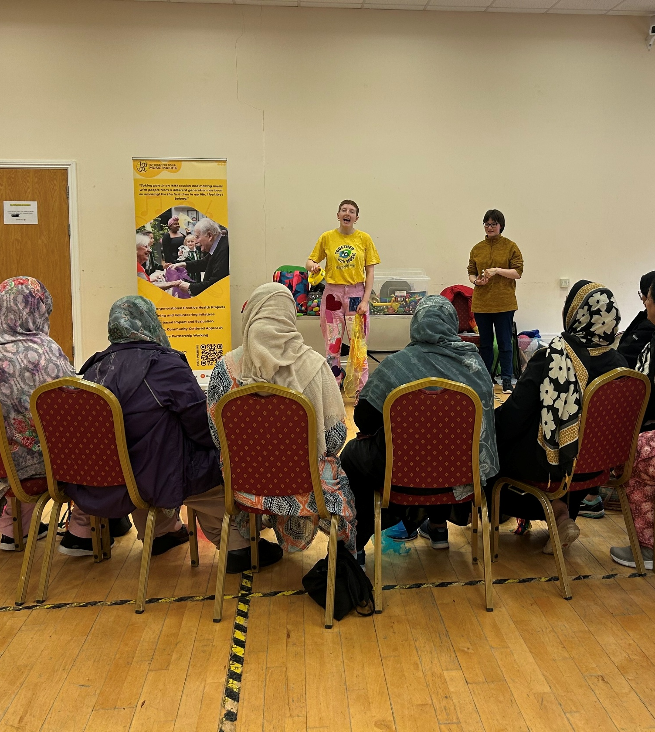

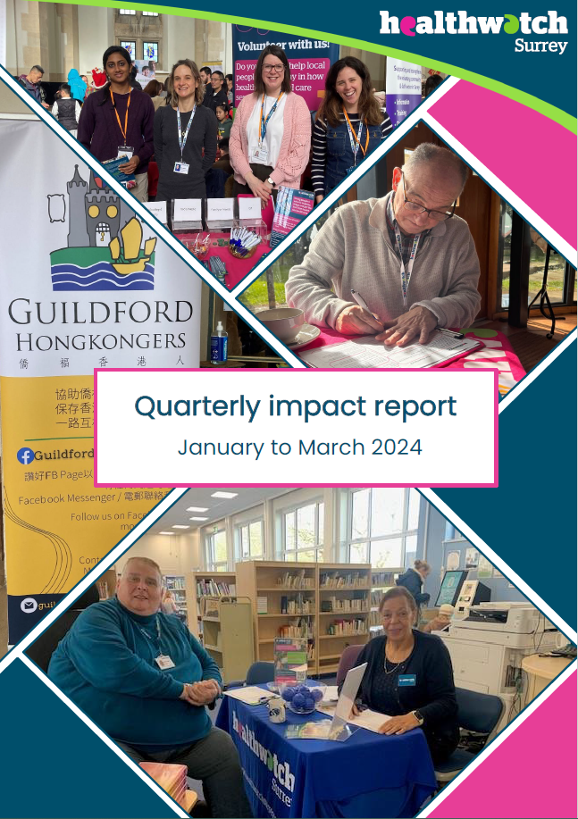

Contents
This quarter in numbers 3
Information and signposting 4
Supporting residents through our Helpdesk 5
Supporting residents in the community 7
NHS Advocacy & complaints 10
Delivering on our thematic priorities 12
Primary care: barriers to access for those from black or Asian minoritised communities 13
Working together to meet the needs of our residents with a hearing impairment 15
Making a difference at a system level 16
Eliciting improvements to non emergency patient transport 17
Ensuring patient experience forms part of PHSO strategy 17
Addressing confusion around audiology pathways 18
Ensuring local insights are heard on the national stage 19
Supporting the consultation on the proposed Online NHS Trust 20
Should the Accessible Information Standard (AIS) be mandatory: ensuring users’ voices are heard 20
Have your say! Ongoing and upcoming projects 22
Contact us 23

If you would like a paper copy of this document or require it in an alternative format, please get in touch with us.

This quarter in numbers
 | 1538 Views of our Information and advice website pages, almost 400 more than the previous quarter
 | 613 People helped, supported or engaged with whilst out in the community
 | 560 Experiences shared with us*
 | 111 People supported by our Helpdesk**
 | 29 People provided with Independent Health Complaints Advocacy support
 | 23 Community engagement events
 | 11 Reports published

* People contacting our Helpdesk for information, advice or to share an experience, via email, telephone, text or WhatsApp, or via our website. Plus sharing their experiences via Smart Survey, our Enter and View visits or some other means including projects and Healthwatch England
** People contacting our Helpdesk for information, advice or to share an experience, via email, telephone, text or WhatsApp, or via our website

Information and signposting
One of our statutory functions is to provide non-clinical information and advice to the public about accessing health and social care services and the options available to them. We help people to identify the services and support they need and provide advice about what to do when things go wrong. Through our relationships with system partners, we can also escalate concerns; providing resolutions to some individuals and ensuring an improved experience for others.


Supporting residents through our Helpdesk

We helped 111 people navigate health and social care services after they contacted our Helpdesk.

Case study: Sally’s* story
Sally called us very concerned about the difficulties she had in getting her prescribed medication. Sally had been referred to her local hospital as she was not responding to the treatment her GP practice could prescribe for her. While under the hospital consultant she found a medication plan that worked and helped manage her symptoms effectively. Sally was then discharged back to the GP and the request was made by the consultant for the GP to take over the prescribing.

However, whenever Sally came to order her medication, her GP would refuse to prescribe it, and Sally was forced to raise it with the Practice Manager. This resulted in her regularly being left without treatment due to amount of time it would take for her to resolve the issues with the practice.

We shared our concerns about Sally specifically, and a wider emerging issue of residents being unable to access medications via a Shared Care Agreement, with Surrey Heartlands Integrated Care Board (ICB).

What impact have we had?

The ICB were able to liaise with both the consultant and the GP to confirm responsibility in relation to fulfilling Sally’s prescription; Sally has confirmed that she now receives her medicine as and when needed. Surrey Heartlands are also working with all providers to try to ensure that Shared Care Agreements are adhered to.

You can read more about what people are telling us about Shared Care Agreements in our Insight Bulletin.

Case study: Peter’s* story
Peter contacted the Helpdesk to request some advice on paying for his mother’s care. Peter’s mother was originally placed in a care home with Fast Track Continuing Healthcare (CHC) funding as she was assessed to be at the end of her life. However, the CHC was removed when she improved, and care was transitioned over to their area social care locality team.

A social worker assessed Peter’s mother and concluded that she could stay in her current care home if a third party paid an additional fee; Peter wanted to know if there was an alternative funding route they could take to cover the cost.

Our Helpdesk team recommended that Peter speak with the social worker and the CHC team to appeal the original decision to remove all CHC funding, and request they assess his mother for standard CHC or funded nursing care to cover the additional costs.

What changed?
Due to Peter’s appeal, prompted by our Helpdesk, the CHC team have agreed to reassess Peter’s mother.

Our Helpdesk team have also been able to provide Peter with information and tips to help him prepare for the assessment.

*Names have been changed

Supporting residents in the community

We visited 23 venues across Surrey and engaged with 613 people. Whilst out and about we have the opportunity to talk to people about the important issues we’re currently exploring (read more information on our thematic priorities later in this report). But we’re also able to listen, without prior agenda, to residents’ thoughts, concerns and questions about any aspect of health and social care and to offer information and signposting wherever we can.

The map below shows the venues we visited this quarter.

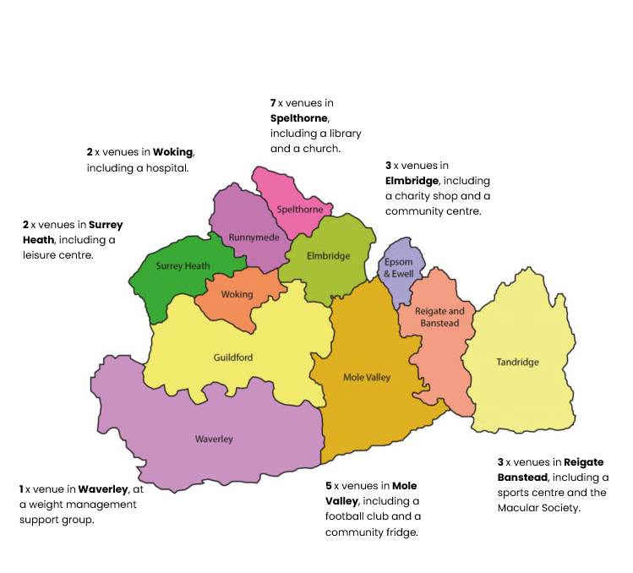

Case study: supporting the prevention agenda
This quarter, we published Living, coping, thriving: exploring the preventative health behaviours of people aged 50-66 in Surrey. Here, we explore the attitudes of people in their 50s and 60s to their own health and wellbeing. As part of this research we spoke to people at events at a variety of venues across Spelthorne and Elmbridge including: warm hubs, community centres, leisure centres, churches, cafes, high street shops, a football club and GP practices. As well as being a great opportunity to hear people’s thoughts, we were also able to offer information and signposting to local sources of support based on people’s individual needs.

One man who told us “I wish there were more things for men to do…Lots of hobby things are for women, or for older people... I would like to join a book club.” was given information on Surrey libraries “Start a reading group” and signposted to Ashford library’s "borrow a bike" scheme. Another lady told us that her husband had recently been diagnosed with early stage dementia and we were able to signpost her to speak to her GP to ask for support from Dementia Navigators.

A number of people we spoke to, told us about the changes they would make after speaking to us and hearing more about prevention, including getting a test for prostate cancer, booking a flu and COVID jab and investigating the shingles vaccine.

We’ll be taking a closer look at the impact of this work in our next report.

Community Cash Fund: helping our community partners
We’re incredibly grateful to all of the local organisations who welcome us through their doors to talk to their members or visitors. This quarter we were delighted to be able to offer something back to many of them in the form of a donation via our Community Cash Fund. This initiative is designed to support local projects and organisations that aim to enhance community wellbeing, promote health, and address social issues. The money donated has already been put to some great uses:

- The Merstham Community Facility Trust used the money to hire a minibus and purchase tickets to Wakehurst Place for volunteers and beneficiaries. This group would otherwise face significant barriers in accessing nature for wellbeing and this provided a valuable opportunity to develop lasting relationships with other beneficiaries of the community centre too.
- The Women’s Centre in Woking put the money towards travel expenses, enabling women to attend groups and 1 to 1s. Travel costs can be a significant barrier to many who have to make choices between vital support, or vital living expenses.
- The Leatherhead Community Hub put the money towards their essential running costs, enabling them to continue their important work, including running: the Community Fridge, Advice Café, ‘Family Feast’ for locals to share a free home cooked meal and ‘Friday Film’, a monthly film night with snacks for young children and their parents.
- St Mary’s Church in Fetcham used the money to purchase a banner which will assist them to raise awareness of their community support initiatives when attending local events.

“We were delighted to welcome Healthwatch Surrey to Fetcham Community Fridge this year. It was a good opportunity for local residents to be able to share their thoughts with members of the team in an informal setting. We look forward to working with the team again in the future.“
Revd Julie Partridge, Associate Minister/Pioneer Community Worker
St Mary's Church, Fetcham

Our commitment to the members of our community in financial hardship: the End Poverty Pledge
As part of Luminus we are proud to have signed up to the End Poverty Pledge. We often hear from people about the impact that finances, or lack of, has on their lives and in turn, the impact this has on their wellbeing (we specifically looked at this as part of a mental health engagement, where we found that only half of the people we spoke to knew where to turn to for financial support).

We support the End Poverty pledge through our everyday work in a variety of ways:
- Ensuring people we speak to are aware of services and benefits available that might help them financially
- Providing information and advice on our website and via our Helpdesk
- Ensuring service providers and decision makers are aware of the impact that financial barriers have when it comes to accessing services.

We also support the pledge as part of our project work. Last quarter we carried out a piece of research in areas classified as deprived to encourage uptake of sight tests for children across Surrey. Findings revealed that many parents believe the cost of sight tests and glasses are prohibitive, so we created a new signposting resource: Sight (eye) tests for children and young people to support parents, particularly those with children who are neurodiverse. You can read more in our previous Impact Report.

We are pleased that our commitment to the End Poverty pledge is being used as a case study on the Good Company website, encouraging others to sign up.



NHS Advocacy & complaints

This quarter 127 people contacted our Independent Health Complaints Advocacy service (IHCA) and were provided with information on how to pursue a complaint. 29 people needed additional advocacy help and were fully supported to submit and pursue their complaint. Run in partnership with the Surrey Independent Living Charity, IHCA provides free, confidential and independent support.

Case study: Jamie’s* story
Jamie contacted the IHCA service as he wanted to make a complaint following his arrest and placement in a mental health hospital (under Section 136 of The Mental Health Act). On arrival at the hospital Jamie informed the doctors that he was taking medication prescribed for epilepsy. The doctors agreed that this medication should continue and should be provided but - due to lack of beds - Jamie was moved to a different hospital. Despite informing the new hospital about his medication needs this was not actioned. After a few days of feeling unwell Jamie had a seizure and was taken to A&E. Jamie believes this could have been avoided if he had been provided with his epilepsy medication as requested.

Jamie lost trust in his doctor at the hospital and experienced further distress, including being excessively restrained resulting in bruising, observing unsafe medication practices and data protection issues. Jamie raised safeguarding concerns at the time but felt that these were not addressed.

The IHCA worked with Jamie to produce a number of drafts of a complaint letter, ensuring Jamie was completely happy with the content, that all aspects of his complaint were covered, and the questions he wanted answers to and the outcomes he was seeking, were clear. Due to Jamie’s mental health he needed a lot of support, which the IHCA advocates were able to provide.

Outcome for Jamie

Despite being specifically asked not to, the provider sent the complaint response directly to Jamie, causing him significant further distress. The IHCA contacted the provider to get a copy of the complaint response and ask them to amend their records to either not contact Jamie, or to remove his email address so this could not happen again in error.

In their response the provider acknowledged that the epilepsy diagnosis and medication should have been actioned - the IHCA spent time going through this complaint response with Jamie to ensure it was fully understood. Due to health reasons Jamie was not in a position to formally respond, which the IHCA were able to communicate on his behalf to ensure no further distress was caused.

* Names have been changed

Delivering on our thematic priorities
Along with our core priorities of agenda free listening, the provision of information and advice and amplifying the VCSE voice, throughout 2025-2026 we have had 4 thematic priorities – Access to primary care, Public health and adult social care, Mental health and Involvement of people – which have been designed based on what residents tell us matters to them.



Primary care: barriers to access to sight tests for those from black or Asian minoritised communities

Background and remit
Those of black and Asian heritage are at increased risk of developing conditions such as glaucoma and diabetic retinopathy. Despite this, engagement with preventative eye care is lower among these communities. National research suggests that eye health is often not prioritised due to a lack of cultural sensitivity and relevance.

Working in partnership with the Surrey Local Optical Committee (LOC), Sight for Surrey, InHealth Diabetic Eye Screening Programme, Surrey Minority Ethnic Forum (SMEF) and Surrey Heartlands ICB we sought to understand what may prevent people from black or Asian minoritised communities from accessing sight (eye) tests.

Over 200 people contributed to the research (141 people spoke to us at in person focus groups and community engagement events, which were supported with a survey completed by almost 100 people). Engagement reflected the ethnic, age and geographic diversity of Surrey’s black and Asian communities, with specific sessions tailored to community identified needs.

Findings and recommendations
We found a lack of consistency in how often people from Surrey’s black and Asian communities have sight tests. These are usually prompted by a deterioration in vision around the age of 40; preventative eye health (and the link between sight tests, eye health and general health) is neither widely understood nor prioritised.

The cost of sight tests, as well as fear of the costs of glasses or contact lenses, was identified as the key barrier preventing people from having a sight test and there was uncertainty around eligibility criteria for NHS entitlements. Language was another significant barrier.

The report concludes that improved awareness could meaningfully increase uptake.
“I think the report is excellent and highlights some areas for improvement and some very achievable action points. Thank you very much to everyone for contributing to this very worthwhile project.”
Jo Lindley, Chair, Surrey LOC

How have we made things better for Surrey residents?

In the course of our engagement we were able to offer real time advice and information on the importance of regular sight tests and to book or signpost where appropriate. In total we helped 19 people to sign up for a sight test and a further 6 people to find specialist help for their specific eye conditions.
Almost a third (29%) of people who completed our survey said that they would go for a sight test as a result of taking part, though some community leaders predicted the actual number to be higher.

The report and recommendations have been shared widely with our system partners, including East Surrey Health Coaches as part of the neighbourhood health pilot, to help to guide their communication with this community and ensure the messages really resonate with them.

Bringing together a number of key stakeholders in the area has led to a commitment from all to do more to improve communication. Work is currently under way to investigate how funding and the involvement of commercial organisations might support this.

“It was a privilege to contribute to this important work. Thank you for bringing partners together to address equity in eye health across Surrey.”
Sana Shahid, SMEF

Working together to meet the needs of Surrey residents with a hearing impairment

Some people who are hard of hearing or hearing impaired had come to us raising concerns about the lack of hearing loops in local pharmacies. Currently it is not a compulsory requirement for pharmacies to have hearing loops but the Accessible Information Standard does state that organisations must ensure people are provided with appropriate communication support and that this can be provided promptly. As more is expected of pharmacies and more people are directed to them for treatment (the Pharmacy First initiative relies on pharmacies to assess patients for suitable treatments for certain conditions), it becomes even more imperative that users of pharmacy services can understand (and respond appropriately to) questions being asked about their conditions, as well as being able to safely understand any treatment and medication they are prescribed.

In collaboration with Surrey Coalition and Sensory Services by Sight for Surrey we submitted a formal request to Surrey MPs and to the Secretary of State for Health and Social Care, asking for the issue to be considered and raised in Parliament.

What impact have we had?

Local MPs have expressed surprise and concern about how those who are hard of hearing or hearing impaired access pharmacies and are raising the issue with the Department of Health and Social Care and the Health Minister, as well as the General Pharmaceutical Council, to try to bring about real change.

Ensuring local insights are heard on the national stage
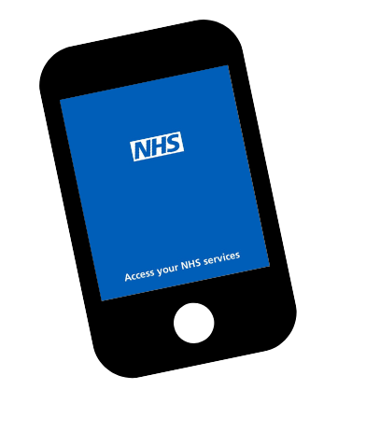
Through our Healthwatch network and our system contacts we are connected to changes, challenges and calls for insights at a national level; we often use what people tell us to ensure the Surrey story is told beyond the county boundaries.

Supporting the national consultation on the proposed NHS Online Trust

The Department of Health and Social Care (DHSC) and NHS England are working to establish a new online service – NHS Online - which will deliver online elective care as part of the NHS.

As part of the planning process DHSC and NHS England consulted with the local Healthwatch network and we were pleased to provide insight.

Why is this important?

Based on what local people tell us and our own knowledge and expertise, we offered insights on people’s use and understanding of digital health services, required communication, access issues and capturing patient feedback, to help to ensure that the new service doesn’t leave anyone behind.

Should the Accessible Information Standard (AIS) be mandatory: ensuring users’ voices are heard

The Accessible Information Standard (AIS) sets out how providers and commissioners of NHS and publicly funded adult social care services should ensure disabled people and people with impairments or sensory loss can:
- Access and understand information about NHS and adult social care services
- Receive the communication support they need to use those services.

Standards not being met (and the impact it has when they aren’t) is something people talk to us about a lot. We’re very grateful to everyone who shared their stories as it enabled us to submit written evidence to NHS England to support their cost / benefit analysis of the impact of making the AIS mandatory.

How did we make an impact?

NHS England have confirmed that our written evidence – What we’re hearing about accessible information and reasonable adjustments - and Closing the gap - has been accepted, meaning the patient voice of Surrey will form part of this important analysis.

The NHS App: working together with our local Healthwatch colleagues to paint a national picture

The NHS App is designed to give people a simple and secure way to access a range of NHS services on their smartphone or tablet (or via web browser on the NHS website). But is it really making life simpler? What do people like about it (and what do they not?) and what changes could be made to improve useability and access? 75 Surrey residents gave us their views on the NHS App, via our survey and at a focus group held with the Merstham Community Champions. Our report- Loved, liked or left alone – NHS App and patient feedback was shared with our system partners across Surrey and also fed in to a collective report led by Healthwatch Wirral, bringing together insights from 1,717 people across 19 Local Healthwatch.

How did we make an impact?

The report – including insights from people here in Surrey - has been presented to the NHS England app design and research team, and by local Healthwatch across the country. The report, revealing a strong preference for in person and non-digital options for many, demonstrates that these accessible options must be maintained whilst digital channels are improved.

We would like to thank everyone who gave their time and shared their experiences with us this quarter.

Have your say! Ongoing and upcoming projects
We’re keen to hear from all Surrey residents about all aspects of health and social care, but we also have some specific subjects we’re interested in hearing about.

 | Involvement of People – we are looking at residents’ experiences of care delivered by Surrey acute hospitals, both in the hospital and the community.  https://www.smartsurvey.co.uk/t/HwSyHospitalExperience2026
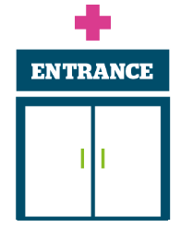 | Access to primary care - we would love to hear your feedback about online access to GP services, how you manage your health care needs with your GP practice using online technology and your views on the use of AI (Artificial Intelligence) within general practice. Survey closes 1 July 2026.  https://www.smartsurvey.co.uk/s/HWSyGPDigital2026/

The more people we hear from, the more impactful our research will be, and the more likely we are to be able to bring about positive change.





Contact us
Website: www.healthwatchsurrey.co.uk
Phone: 0303 303 0023
Text/SMS: 07592 787533
WhatsApp: 07592 787533
Email: enquiries@healthwatchsurrey.co.uk
Address: Freepost RSYX-ETRE-CXBY, Healthwatch Surrey, Astolat, Coniers Way, Burpham, Guildford, Surrey, GU4 7HL.
 healthwatchsurrey
 healthwatch_surrey
 Healthwatch Surrey


The Healthwatch Surrey service is run by Luminus Insight CIC, known as Luminus. Luminus is a Surrey based, independent, community interest company which exists to empower people to have their voices heard. We help organisations provide equity of access and the best services possible, through the inclusive involvement of local people.


We are committed to the quality of our information.
Every 3 years we perform an audit so that we can be certain of this.


We are proud to have signed up to the End Poverty Pledge –
End Poverty Surrey – Good Company.

