Quarterly Impact Report
October -December 2025

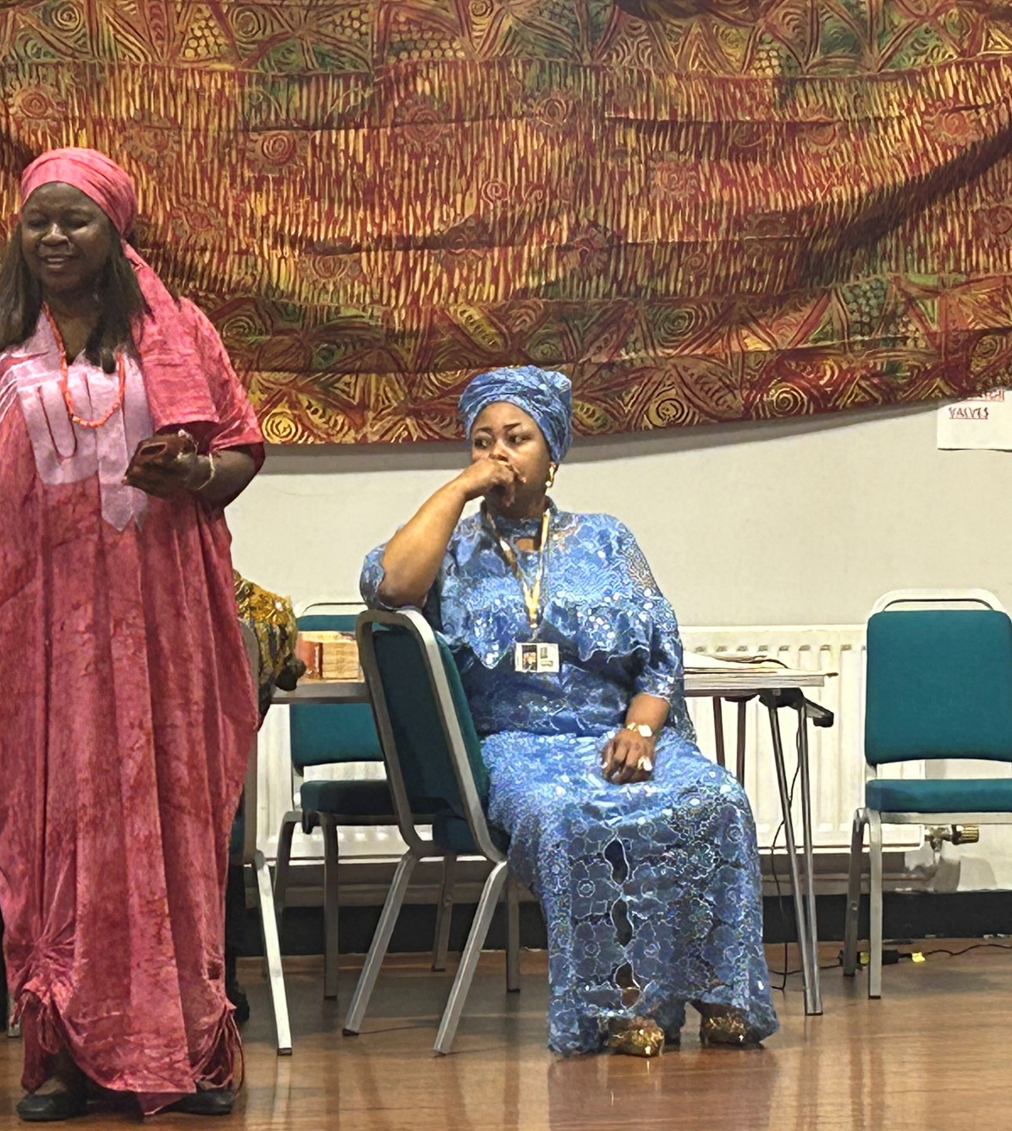

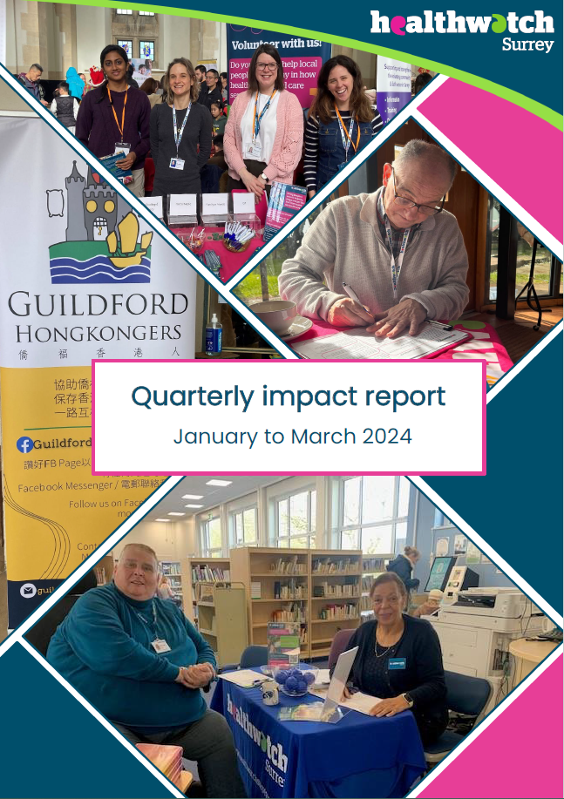

Contents
This quarter in numbers 3
Information and signposting 4
Supporting residents through our Helpdesk 5
Supporting residents in the community 7
NHS Advocacy & complaints 9
Delivering on our thematic priorities 10
Primary care: spotlight on eye care 11
Public health and adult social care 12
Maintaining momentum: checking in on long term impact 13
Making a difference at a system level 15
15
Eliciting improvements to non emergency patient transport 16
Ensuring patient experience forms part of PHSO strategy 16
Addressing confusion around audiology pathways 17
Involving local people in health and social care 18
Supporting the drive for improvements in the care environment: PLACE assessments 19
Supporting our CDPPI colleagues: reviewing the I access website 19
Have your say! Ongoing and upcoming projects 20
Healthwatch Surrey – Contact us 21

If you would like a paper copy of this document or require it in an alternative format, please get in touch with us.

This quarter in numbers
 | 1179 Views of our Information and advice website pages
 | 793 People helped, supported or engaged with whilst out in the community
 | 497 Experiences shared with us*
 | 311 Hours provided by our volunteers
 | 113 People supported by our Helpdesk**
 | 21 People provided with Independent Health Complaints Advocacy support
 | 19 Community engagement events
 | 10 Reports published

* People contacting our Helpdesk for information, advice or to share an experience, via e-mail, telephone, text or WhatsApp, or via our website. Plus sharing their experiences via Smart Survey, our Enter and View visits or some other means including projects and Healthwatch England (internal reference – lines 14, 15, 16).
** People contacting our Helpdesk for information, advice or to share an experience, via e-mail, telephone, text or WhatsApp, or via our website (internal reference – line 8).

Information and signposting
One of our statutory functions is to provide information and advice to the public about accessing health and social care services and the options available to them. We help people to identify the services and support they need and provide advice about what to do when things go wrong. Through our relationships with system partners, we can also escalate concerns; providing resolutions to some individuals and ensuring an improved experience for others.
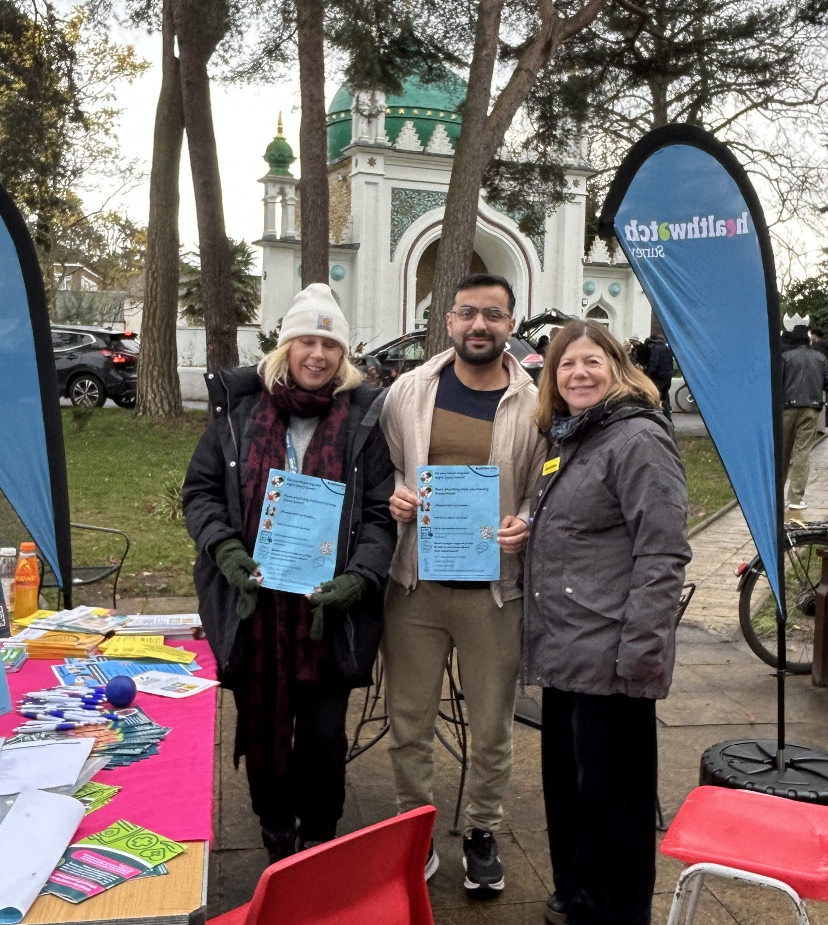

Supporting residents through our Helpdesk

We helped 113 people navigate health and social care services after they contacted our Helpdesk.

“Thanks for this excellent reply. I probably would not have even made the complaint if not for a similarly helpful reply from your colleague to an informal email.… This particular personal example and how you have handled it is exemplary of the high standard which really makes a difference to people's lives.”
Helpdesk user

“Thank you so much for your help. You are the only people who have sat down with me, talked through everything and looked at the whole picture and given us practical advice.”
Helpdesk user

Case study: individual experiences translated into system learnings
Our Helpdesk provides reliable and trustworthy information and signposting about local health and social care services to help people get the support they need. The service is completely confidential but - with the individual’s agreement - we use what people tell us to identify issues and areas for improvement in the system. This way we can help both individuals and the wider community.

Since April 2025 more than 50 Surrey residents have told us they are struggling to have their needs for reasonable adjustments or accessible information met by NHS services. We collated and shared these experiences with service providers and commissioners.

Under the Equality Act 2010 anyone with a disability, impairment or sensory loss has the right to request reasonable adjustments. The Accessible Information Standard (AIS) sets out how providers and commissioners of NHS and publicly funded adult social care services should ensure disabled people and people with impairments or sensory loss can access and understand information about NHS and adult social care services and receive the communication support they need to use those services.

What impact have we had?

Our findings have been shared with the Learning Disability and Autism Partnership Board, the RADF (Reasonable Adjustment Digital Flag*) Implementation Board and regional and national leads for the RADF. We have been pleased to be able to amplify the voices of the people of Surrey to those making decisions about how needs are addressed.

*The RADF is a national record that indicates when reasonable adjustments are required for an individual and, in some cases, includes details of impairments, underlying conditions and key adjustments that should be considered.

Supporting residents in the community

We visited 21 venues across Surrey and engaged with 793 people. Whilst out and about, we have the opportunity to talk to people about the important issues we’re currently exploring (read more information on our thematic priorities later in this report!). But we’re also able to listen, without prior agenda, to residents’ thoughts, concerns and questions about any aspect of health and social care and to offer information and signposting wherever we can.

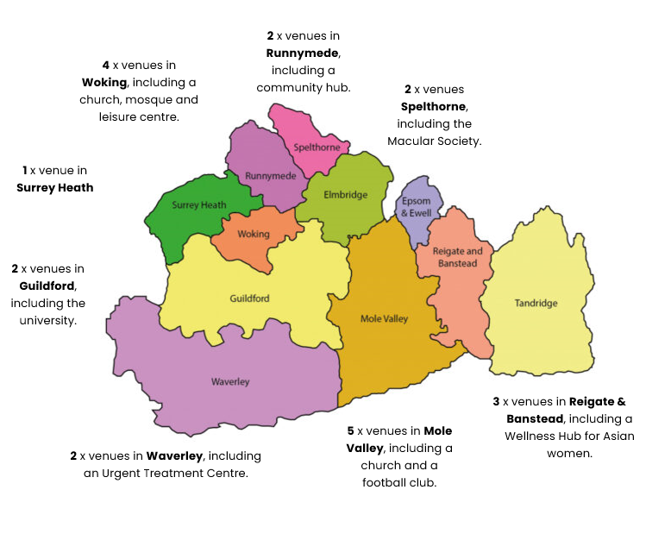
The map below shows the venues we visited this quarter.

Case study: getting to the heart of a community
As part of our latest primary care project seeking to understand the barriers that may prevent people from black or Asian minoritised communities from having sight (eye) tests we’ve held 7 separate engagement events with different groups across Surrey, working with community leaders to ensure the locations, timings and format of the events worked for the people we’re keen to hear from. You can read more about this later in the report!

“I was delighted as Chair of Surrey LOC (Local Optical Committee) to attend a community engagement group on Thursday investigating potential barriers to accessing eye care within [the Nepalese community].

The engagement was invaluable to understand that within this group verbal communication is the primary communication method and that this is predominantly in Nepalese…. Understanding the needs of this particular community group will really assist in providing support in a way that is most effective and help to break down barriers to health care.”
Jo Lindley, Chair, Surrey Local Optical Committee (LOC)

NHS Advocacy & complaints

This quarter 117 people contacted our Independent Health Complaints Advocacy service (IHCA) and were provided with information on how to pursue a complaint. 21 people needed additional advocacy help and were fully supported to submit and pursue their complaint. Run in partnership with the Surrey Independent Living Charity, IHCA provides free, confidential and independent support.

Case study: Lisa’s* story
Lisa had been prescribed a medication which she thought to be a temporary measure. She reported both mental and physical health side effects from the medication to her doctor but felt they weren’t willing to consider alternatives. Lisa contacted the IHCA looking for support to help her to submit a complaint and to get answers to the questions she had about her treatment.

The IHCA service worked on several drafts of a complaint letter with Lisa to ensure she was happy with the content, the complaint was fully explained and the questions she wanted answers to, and outcomes she was seeking, were clear. This was a complex process, with the advocate needing to identify the key information and ensure that the complaint letter was clear and concise and that the Lisa’s views were heard. The advocate also supported Lisa to complete the required consent forms and sent the complaint letter on her behalf.

Outcome for Lisa
Lisa received a thorough response to her complaint which offered a full explanation about why the medication was prescribed, the alternatives that had been previously tried and why her doctor felt that this was the best course of treatment for her and in her best interests, including noting the clinical improvements that had been shown in her condition.

Submitting the complaint allowed Lisa’s concerns to be heard in the short term and facilitated improved communication between her and her care team in the longer term.

* Names have been changed

Delivering on our thematic priorities
Along with our core priorities of agenda free listening, the provision of information and advice and amplifying the VCSE voice, we also have 4 thematic priorities – access to primary care, public health and adult social care, mental health and the involvement of people – which have been designed based on what residents tell us matters to them.

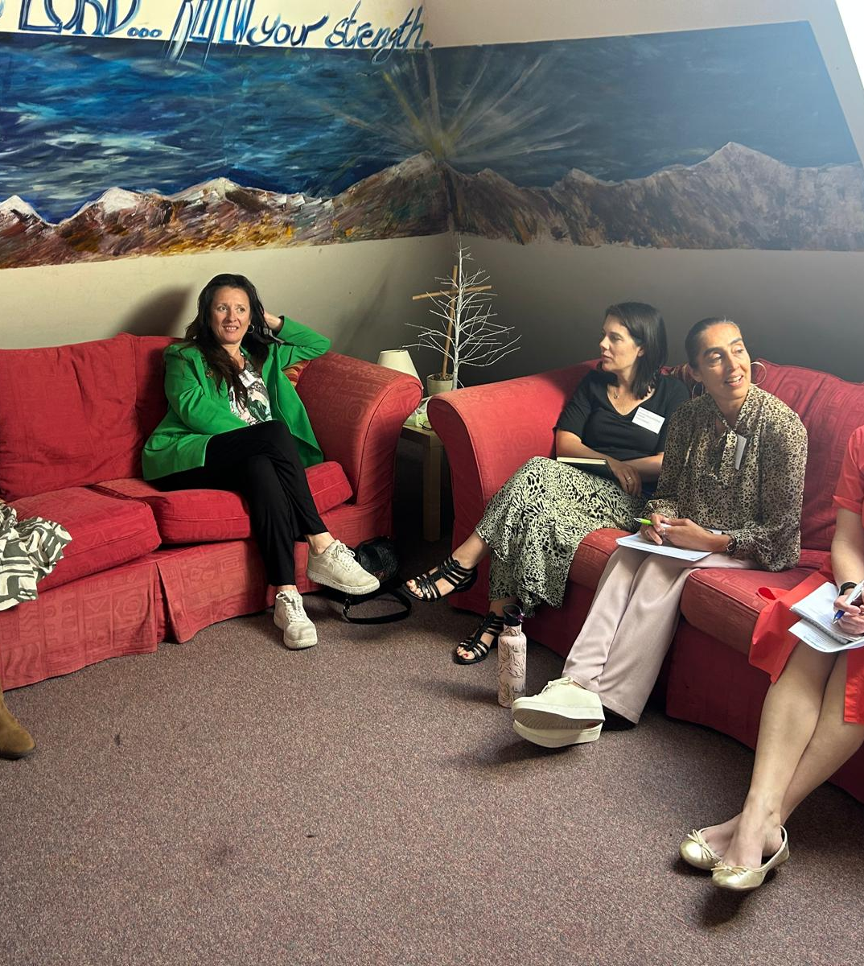

Primary care: spotlight on eye care

Encouraging uptake of sight tests for children across Surrey
In our last Impact report we looked at our work with Surrey Healthy Schools to talk to parents about their understanding of the need for sight tests and to gain a deeper understanding of the barriers.

Our Out of sight, out of mind report was shared with numerous system partners and the knowledge gaps we identified formed the basis of a new signposting resource about eye tests to support parents, particularly those with children who are neurodiverse.

Shining a light on low vision
As part of our commitment to improving access to primary care we wanted to speak to Surrey residents with low vision about their experiences of specialist eye care services, as well as the information and support they receive between appointments and following discharge. We spoke to 30 Surrey residents at 3 Macular Society meetings and a VisionZone event; our findings will support the work of the Local Optical Committee (LOC) as they try to ensure that all Surrey residents with low vision receive the support they need.

“I think the sample comments [from the Macular Society meetings] really showed what we thought they may, which is some parts working well and other parts not, so some patients are falling through the gaps when it comes to support. It is something that I will follow up with in 2026… Thank you very much to Healthwatch Surrey for undertaking the research and sharing the findings and learnings from this vulnerable group of patients.”
Jo Lindley, Chair, Surrey Local Optical Committee (LOC)

Barries to access for those from black or Asian minoritised communities
We’re currently undertaking a piece of work to understand the barriers that may prevent people from black or Asian minoritised communities from accessing sight (eye) tests. At a series of engagement events across Surrey people have shared invaluable insights and we’ve been able to deliver.an educational programme to help debunk various eye care myths and to support people to sign up for eye tests.

What impact have we had?

During our engagement events we’ve helped 19 people to sign up for an eye test and a further 6 people to find specialist help for their specific eye conditions.

We’ll be publishing a report with our findings and recommendations over the next few months.

Public health and adult social care
Surrey County Council (SCC) run a free 8 week course to teach residents skills that support independence. The aim is that participants leave feeling more connected to their community and other residents, and more informed about the support available to them, ultimately helping to combat loneliness. But uptake is low. At the same time there has been a marked downturn in community centre attendance. This quarter we investigated why this is the case – are the right people being informed about the library independence courses? Is the cost to get to community centres prohibitive?

How are we helping?

Our research and recommendations have been shared with adult social care teams to support their communications and planning to increase uptake.

Maintaining momentum and continuing to make an impact

Real, lasting change takes time, which often means the full impact of our work can’t be felt immediately. That’s why we regularly revisit our projects…

Domestic abuse
In quarter 1 of this year we reported on our work exploring whether general practice is meeting the needs of people experiencing domestic abuse within Surrey and what improvements could be made to better meet these needs.

As part of this work, in May 2025, we brought together an influential group of 21 key stakeholders, including system partners, GPs and groups representing survivors. The aim of this workshop was to review our research findings and work collaboratively to develop pragmatic and practical solutions to improve access to support the experience of survivors. During the workshop attendees identified a number of solutions to the issues identified, and there was a commitment from everyone in the room to implement one change each.

We’ve been working closely with all stakeholders since the workshop to monitor and support the improvements being made across the key areas identified in our report.

Barriers to disclosing
The domestic abuse page on GP websites across Surrey Heartlands – which was inconsistent and difficult to find - has been updated to direct people to the Healthy Surrey website which houses all relevant, up to date information. This website can also be masked to protect survivors.

Work is underway to create a GP Domestic Abuse Champion Award, receipt of which will mean a practice has met certain criteria, including specialist domestic abuse knowledge and robust monitoring systems.

Experience following disclosure
The Surrey Domestic Abuse Partnership Service have agreed - dependent on resource - to provide outreach worker time to GP practices, for the purpose of training, with a specific focus on frontline, admin and reception staff.

Signposting and referrals
We are working with the local Integrated Care Board (ICB) to determine if GP practices can have immediate access to the referral forms of local specialist domestic abuse services via their own IT systems. This would ensure survivors are accessing specialist support as quickly and safely as possible.

The Surrey Minority Ethnic Forum (SMEF), who receive a large number of calls regarding domestic abuse, are now working more closely with local GPs and have added a ‘consent to inform GP’ to their referral form so that survivors are being appropriately supported.

Increasing awareness
You can read our full report - In safe hands- Domestic abuse survivors experiences of general practice - July 2025. This report has now been shared with over 20 boards and committees across Surrey, including the Domestic Abuse Commissioner's Office. The commissioner’s office has in turn shared it with NHS England’s domestic abuse and sexual violence team and with Standing Together Against Domestic Abuse (STADA) who host a policy working group on improving the response to domestic abuse within health settings. We also presented the report to over 80 people at the Safeguarding Adults Board.

"I was incredibly impressed by the information you and your team have collated around barriers to reporting and engaging with GP practices….Although clients can feel empowered to tell their stories and can find it very beneficial to feel heard, and more importantly listened to, but the depth of information, ideas and suggestions you were able to get from the women, is truly wonderful. I feel it is a testament to your professionalism, trauma-informed approach and respect towards this client group that they appeared to have felt safe enough to discuss and explore these issues with you.”
Leanne Spiller, Women’s Support Centre, Surrey

Making a difference at a system level
We ensure that decision makers in Surrey Heartlands and Frimley Health hear about the insights and experiences residents have shared with us, both positive and negative. We sit on a number of boards and committees and proactively challenge system partners over issues identified to us by local residents and share when things have gone well to help to identify best practice.
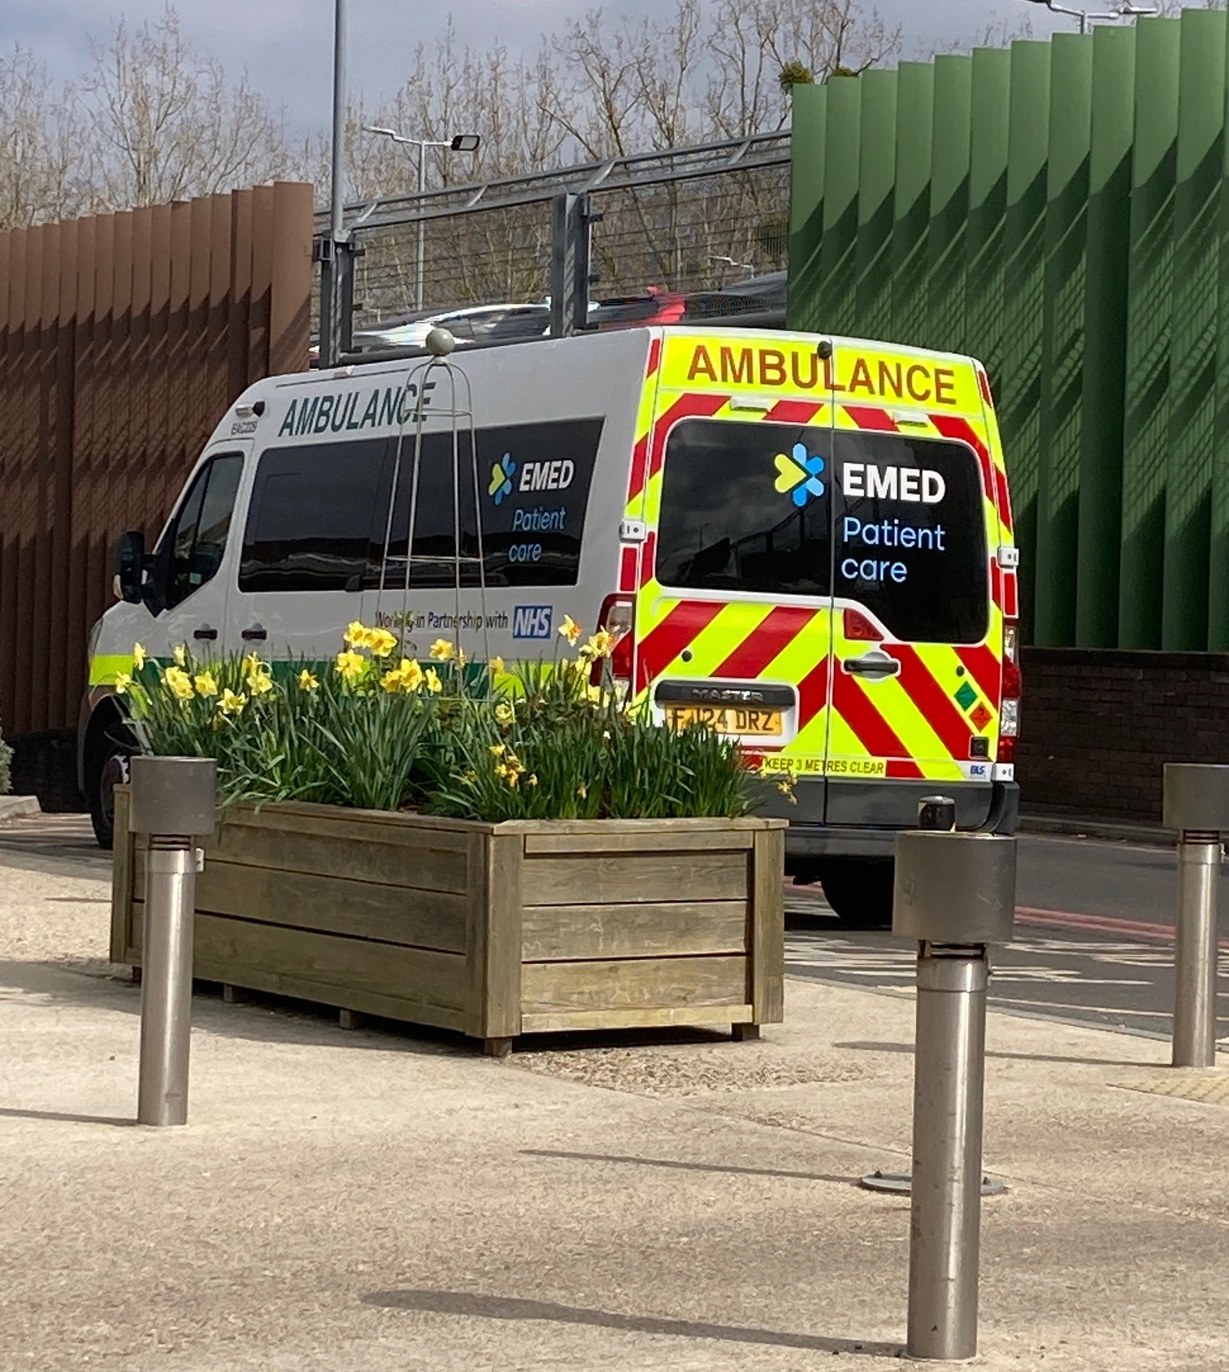

Eliciting improvements to non emergency patient transport
Non-emergency patient transport is a service for patients who are unable to travel safely for medical care by other means. It is a vital service for many Surrey residents with mobility and other medical needs and - back in April 2025 - we worked with Surrey Heartlands Integrated Care Board to gather patient insights about it.

For the remainder of the year people continued to talk to us about extended waiting times and issues with phone lines. We were particularly concerned to hear that phone lines were cutting out, meaning people were unable to complain or provide feedback. We shared these concerns with the provider and commissioner.

How have our actions helped?

Following our feedback the provider and commissioner have committed to monitoring all patient journeys more closely, investigating issues with phone lines and reviewing the complaints information given to patients.

System improvements – individual impact
Our knowledge of services such as the non-emergency patient transport service means we are able to signpost local residents to them. When a mother came to our Helpdesk concerned that her daughter was not accessing appropriate care we were able to direct her to multiple organisations, including the transport service. This proved to be a vital lifeline, with both financial and practical benefits for the woman and her daughter.

Ensuring patient experience forms part of PHSO strategy
The Parliamentary and Health Service Ombudsman (PHSO) investigate complaints about UK government departments, other public organisations and the NHS in England; they can do this once a complaint has been made directly with the provider involved.

We were invited to feed in to the PHSO 5 year plan strategy workshop.

What impact did we have?

By sharing the experiences of Surrey residents who have actually been through the PHSO process, we were able to ensure that lived experience guided their plans and strategies, with the ultimate aim of improving this experience for patients. We were also able to advise on accessibility to support the drive for a more accessible service.

Addressing confusion around audiology pathways
The Royal National Institute for Deaf People (RNID) contacted us concerned about a number of enquiries they’d had through their helpline from people struggling to access an appointment for a hearing test, with some even being told the hospital department is no longer accepting new adult referrals. We liaised with the Surrey Heartlands Integrated Care Board to confirm the situation and passed this information back to RNID.

What’s changed?

Thanks to our intervention (and our connections and understanding of the local NHS landscape) the RNID, a national organisation, could share correct, up to date information with their members to reassure them. Our involvement also contributed to additional communications being sent to GP practices to ensure the correct messaging was reaching patients moving forwards.

Involving local people in health and social care
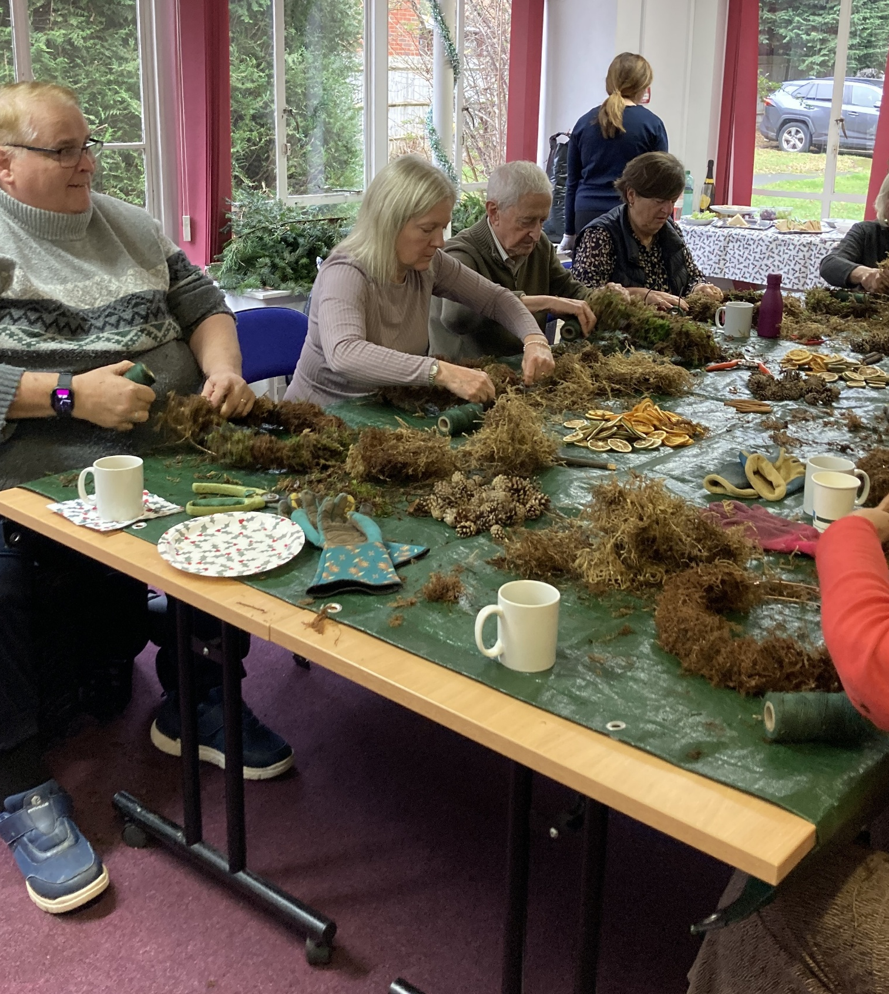
Our dedicated team of volunteers help us to ensure that local people have their say, and that we hold decision makers to account.
Our volunteers gifted us 311 hours of their valuable time this quarter!

Supporting the drive for improvements in the care environment: PLACE assessments
Patient-Led Assessments of the Care Environment (PLACE) involve local people (known as patient assessors) going into hospitals as part of teams to assess how the environment supports the provision of clinical care, assessing such things as privacy and dignity, food, cleanliness and general building maintenance and, more recently, the extent to which the environment is able to support the care of those with dementia or with a disability. The assessments take place every year and results - published annually - show how hospitals are performing both nationally and in relation to other hospitals providing similar services.

This quarter 8 volunteers supported the Healthwatch team as we undertook PLACE at Royal Surrey County Hospital, Milford Hospital, Haslemere Hospital, Woking Hospital and Horton Rehabilitation.

Supporting our CDPPI colleagues: reviewing the i-access website
i-access is Surrey's NHS drug and alcohol support and recovery service, offering confidential advice, treatment and support. Our Luminus team colleagues at Combating Drugs Partnership Public Involvement have been exploring whether people know how to feed back and share concerns or praise about their care and how to make a complaint or where to look for information. One important element of this is the i-access website and we were delighted that our Reading Panel were able to support this piece of work by reviewing the website and offering thoughts on its clarity and accessibility, as well as practical suggestions for improvement.

We would like to thank everyone who gave their time and shared their experiences with us this quarter.

Have your say! Ongoing and upcoming projects

 | Involvement of People - we are looking at the NHS App - why people use it, why they don 't, and how it could be improved. We're also interested to know if residents would use the NHS App to provide feedback on NHS services and how they’d ideally like to provide this feedback. Survey closes 31 January 2026.  https://www.smartsurvey.co.uk/s/HwSyNHSAppandfeedback2025/
 | Mental health - we are exploring whether men feel part of their community - what impact it has if they don’t - and whether they’re aware what services are available to help support their emotional wellbeing. Survey closes 1 February 2026.  https://www.smartsurvey.co.uk/s/HwSyMenCommunityServices/
 | Public health and adult social care – we’re seeking the views and experiences of 50-66 year old Surrey residents about what they do to maintain their own health and wellbeing. The results of this survey will help to shape local NHS and Surrey County Council services. Survey closes 31 January 2026  https://www.smartsurvey.co.uk/s/HWSyhealthwellbeing25-26/
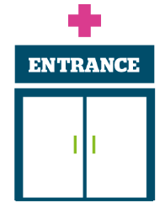 | Access to primary care - we would love to hear your feedback about any support you are currently receiving or have received to help you manage your weight, or any support you’d like to receive. This includes medication, support groups or programmes or general help and advice, obtained independently or from your GP or pharmacist.  Survey closes 31 March 2026.  https://www.smartsurvey.co.uk/s/HwSyWeightManagement2026/

The more people we hear from, the more impactful our research will be, and the more likely we are to be able to bring about positive change.


Healthwatch Surrey – Contact us

Website: www.healthwatchsurrey.co.uk
Phone: 0303 303 0023
Text/SMS: 07592 787533
Email: enquiries@healthwatchsurrey.co.uk
Address: Freepost RSYX-ETRE-CXBY, Healthwatch Surrey, Astolat,
Coiners Way, Burpham, Guildford, Surrey, GU4 7HL

 Healthwatch Surrey
 Healthwatch_surrey
 Healthwatch Surrey



We are committed to the quality of our information.
Every 3 years we perform an audit so that we can be certain of this.

The Healthwatch Surrey service is run by Luminus Insight CIC
(known as Luminus).

