Quarterly Impact Report
July - September 2025



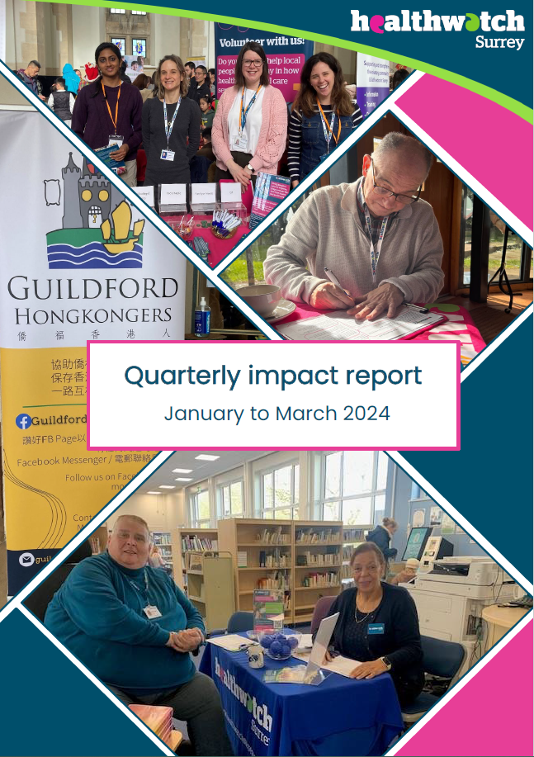

Contents
This quarter in numbers 3
Information and signposting 4
Supporting residents through our Helpdesk 5
Supporting residents in the community 7
NHS Advocacy & complaints 9
Delivering on our thematic priorities 10
Making mental health inclusive: supporting people with learning disabilities 11
Involvement of people: supporting system partners with their information provision 14
Health, wellbeing and adult social care: myth busting sexual health services for the under 25s 15
Primary care: encouraging uptake of sight tests for children across Surrey 16
Making a difference at a system level 18
Recognition from our system partners 19
Maintaining momentum: checking in on long term impact 20
Involving local people in health and social care 22
Shining a light on student mental health 23
Have your say! Upcoming projects 24
Healthwatch Surrey – Contact us 25

If you would like a paper copy of this document or require it in an alternative format, please get in touch with us.

This quarter in numbers
 | 852 Views of our Information and advice website pages
 | 677 People helped, supported or engaged with whilst out in the community
 | 348 Experiences shared with us*
 | 233 Hours provided by our volunteers
 | 96 People supported by our Helpdesk**
 | 24 Community engagement events
 | 19 People provided with Independent Health Complaints Advocacy support
 | 9 Reports published

* People contacting our Helpdesk for information, advice or to share an experience, via email, telephone, text or WhatsApp, or via our website. Plus sharing their experiences via SmartSurvey, our Enter and View visits or some other means including projects and Healthwatch England (internal reference – lines 14, 15, 16).
** People contacting our Helpdesk for information, advice or to share an experience, via email, telephone, text or WhatsApp, or via our website (internal reference – line 8).

Information and signposting
One of our statutory functions is to provide information and advice to the public about accessing health and social care services and the options available to them. We help people to identify the services and support they need and provide advice about what to do when things go wrong. Through our relationships with system partners, we can also escalate concerns; providing resolutions to some individuals and ensuring an improved experience for others.
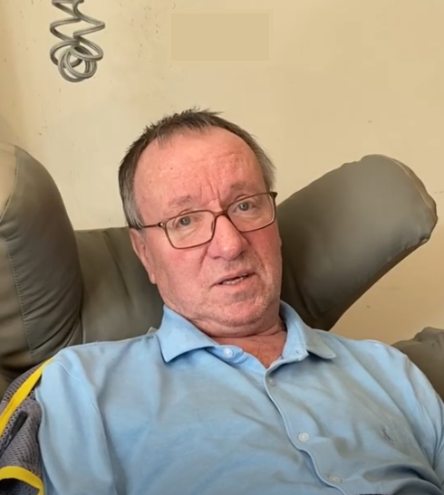

Supporting residents through our Helpdesk

We helped 96 people navigate health and social care services after they contacted our Helpdesk.

“I'm sure your involvement in this had a lot to do with this progression and we are extremely grateful.”
Helpdesk user

“​Thank you…I’ve had more positive interaction with you than all the agencies that have claimed ‘to be there for you’.”
Helpdesk user

“You are the most helpful organisation so far.”
Helpdesk user

Case study: a holistic approach to support
People often contact our Helpdesk with complex needs and questions. Our dedicated team are expert in unravelling these needs and providing bespoke support and signposting to deal with immediate concerns, as well as more holistic information and advice.

Amy’s story*
Following a low-grade skin cancer diagnosis Amy contacted our Helpdesk as she needed some support to access the dermatology service (Amy had been referred to a clinic which was difficult for her to get to as she didn’t drive. In addition, information was provided to Amy in a non-accessible format, meaning she couldn’t access any post diagnosis support or advice).

Our Helpdesk advisor provided Amy with links to national and local support groups, as well as helplines staffed by nurses, so she could get the information she needed quickly. The advisor also completed a referral for the Independent Non-Statutory Discretionary Advocacy service. This meant Amy had someone to work with long-term to get any reasonable adjustments added to her records, and some ongoing support to understand the information given to her in appointments.

Our advisor also gave Amy numbers for her local community transport and Good Neighbour schemes, so she could get to appointments without the additional stress of having to navigate public transport.

Case study: individual enquiries driving support for the wider community
Though our Helpdesk primarily supports individuals, we’re able to use the insights gained from individual enquiries to develop information and signposting to support other people in similar situations.

Continuing Healthcare (CHC)
An increasing number of people have been enquiring about Continuing Healthcare (CHC). This prompted us to meet with the CHC team at Surrey Heartlands ICB to discuss further. We collated this intelligence with more general information relating to the CHC national framework and developed one easy to follow guide for people and carers needing to apply for CHC.

The guide is now on our website and hard copies are available for people when we’re out and about on engagement. It has also been shared with various providers across Surrey - some are considering using it in their communication packs for people and some provided additional content ideas.

We know that there’s nothing quite like hearing from people who’ve actually been through the process, so we’ve also created two new videos – one for Surrey residents and one for our system partners. In them, we meet Maria and David who tell us their stories and offer some practical hints and tips for those who may need to apply for CHC, and some insights in to how the process really feels to help our system partners to make improvements.

* Names have been changed.

Supporting residents in the community

We visited 21 venues across Surrey and engaged with 263 people. Whilst out and about, we have the opportunity to talk to people about the important issues we’re currently exploring (more information on our thematic priorities later!). But we’re also able to listen, without prior agenda, to residents’ thoughts, concerns and questions about any aspect of health and social care and to offer information and signposting wherever we can.
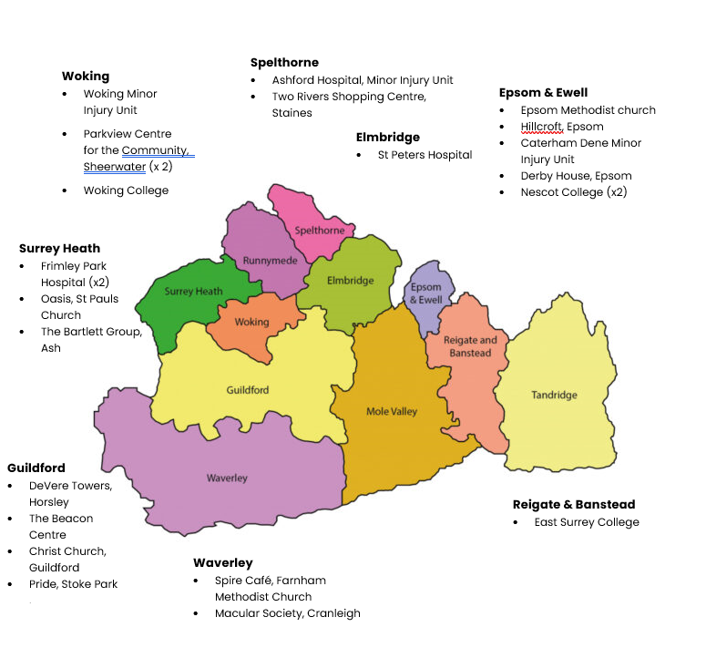
The map below shows the venues we visited.

Community case study: working with colleagues to give something back to the community

We’ve been exploring whether people who are unable to leave their home are having their needs met by community health and care services (you can read our Home is where the care is? Report and personal stories on our website). As part of the research phase of this project we were delighted to join our Giving Carers a Voice (GCAV) team when they visited a Phyllis Tuckwell Hospice carers drop in event at the Beacon Centre in Guildford. Obtaining the unpaid carers’ perspective was vital for this project, and harnessing the expertise of our GCAV colleagues helped to ensure that we were able to give something back in terms of information and signposting to the people who generously shared their insights.



NHS Advocacy & complaints

This quarter 134 people contacted our Independent Health Complaints Advocacy service (IHCA) and were provided with information on how to pursue a complaint. 19 people needed additional advocacy help and were fully supported to submit and pursue their complaint. Run in partnership with the Surrey Independent Living Charity, IHCA provides free, confidential and independent support.

Case study: Sheila’s* Experience
Sheila had concerns about the hospital discharge planning which had been put in place for her husband. She felt that departments within the hospital were not communicating with each other and that incorrect information was being given to both patients and carers. Sheila had initially contacted the Patient Advice and Liaison Service (PALS) but had had no response to her calls and messages. She had then submitted a formal complaint but was unhappy with the written response.

One of our advocates contacted the Trust directly – the Trust were asked to reopen the case and reminded of their responsibilities within the formal complaints process regarding communicating with a complainant. The advocate then worked with the client to identify and clarify all the issues, develop a meeting agenda and identify which professionals would be best placed to respond to the outstanding concerns.

Outcome for Sheila, and wider outcomes
At a meeting between Trust senior management and clinicians, Sheila and the advocate, the Trust acknowledged that there were failings in their discharge process and apologised for the lack of information and support offered by their staff. The Trust accepted that the process needed to change and a level of accountability needed to be brought in for each stage.

The Trust asked if the complainant would be willing to be a part of the improvement process and offered her another meeting to discuss the implementation of new processes. Sheila accepted this meeting offer and the apologies made by the Trust; she felt assured that she and her husband had been heard and considered the complaint to have been resolved.

* Names have been changed

Delivering on our thematic priorities
Along with our core priorities of agenda free listening, the provision of information and advice and amplifying the VCSE voice, we also have 4 thematic priorities: access to primary care; Social care and public health; mental health and the involvement of people – which have been designed based on what residents tell us matters to them.

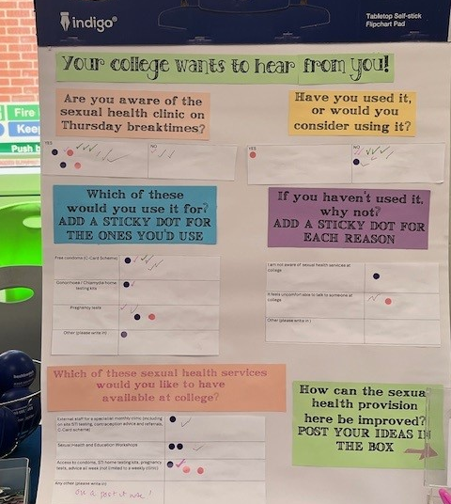

Making mental health inclusive: supporting people with learning disabilities
We work with the healthcare system to share people’s experiences of mental health services - as well as the impact that wider determinants of health and health inequalities can have on mental health - in order to improve mental health services for local people. We’re particularly passionate about amplifying the voices of people who face barriers to accessing support, and those at risk of health inequalities.

Background
Figures show that people with learning disabilities are twice as likely to have mental health issues as those without. Information on Mencap’s website shows that in 2017/18 severe mental illness was 8.4 times more common in people with learning disabilities than in those without, and that 13% of people with learning disabilities have an active diagnosis of depression. Adults with learning disabilities and/or autism, as well as those with mental health issues, are defined as a priority population within Surrey’s Health and Wellbeing strategy.

The aim of this study was to explore how access to and experiences of emotional wellbeing and mental health support for people with a learning disability can be improved.

What did we do?
We obtained the views of those with a learning disability, as well as their families and carers, across Surrey via a survey and focus groups. 32 parents and carers responded to our survey and we spoke to 70 people with learning disabilities at 5 focus groups. The Surrey People’s Group and Post 19 Group in Farnham kindly allowed us to hold the events as part of sessions that were already planned, thus ensuring attendees were in environments and with people they were familiar and comfortable with.

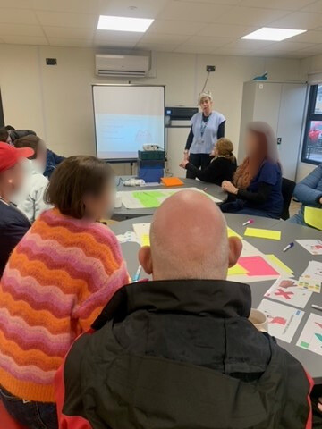
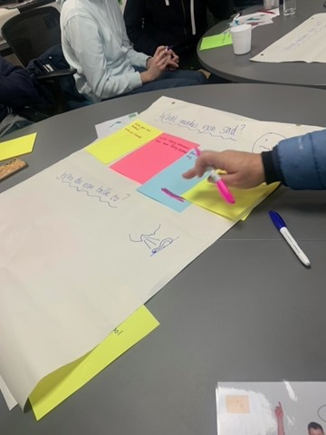

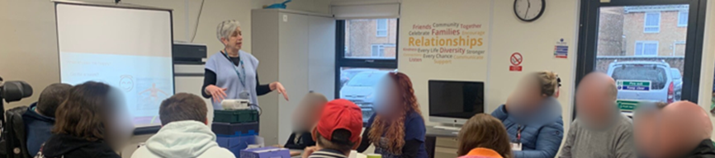

What did we find?
Only 38% of survey respondents felt the people they care for would recognise emotional distress in themselves. Similarly, the focus group attendees found talking about the things that made them happy easier than things that made them sad. When asked if emotional wellbeing was included in their annual health* check only a third (33%) felt it was.

We concluded that, across the board, more needs to be done to ensure that the mental health of those with learning disabilities is appropriately monitored, that those caring for them are facilitated and supported to intervene where necessary and that the support offered is appropriate and tailored to the specific needs of this community. We also recommended that annual health checks should routinely include discussion of emotional wellbeing to more effectively identify behaviour change and adverse life events.

*Annual health checks delivered through primary care play an important role in identifying the support needs of those with learning disabilities.

Our report and recommendations – available now on our website Making mental health inclusive: supporting people with learning disabilities - July 2025) - were shared widely with our system partners at Surrey Heartlands ICB, Frimley ICB and Surrey County Council (SCC).

What improvements will be implemented for those with learning disabilities?
Following our presentation of the report at the Learning Disabilities Partnership Board, the Learning Disabilities and Autism commissioning team are reviewing the Annual Health Check template for people with learning disabilities to ensure it better identifies emotional support needs.*

The SCC website has been reviewed and the information on the learning disabilities pages has been updated to include more information about mental health in an accessible format.

Mindworks Surrey are also looking at the service provision across Surrey and will review how reasonable adjustments can be made across the offer to ensure those with learning disabilities receive support they need.

* The research aligned with and augmented the findings and improvements being actioned through the Surrey Heartlands LeDeR (Learning from lives and deaths – people with a learning disability and autistic people) programme to improve the quality of annual health checks for people with learning disabilities.

Involvement of people: supporting system partners with their information provision

How will things change for patients?
Insights from Healthwatch Surrey are helping a trust to improve on health literacy by ensuring that their patient information materials are more accessible, easier to navigate and better aligned with patients’ and carers’ needs.

Frimley Health NHS Foundation Trust sought our support to review and obtain people’s feedback on the patient information leaflets provided to patients at Frimley Park Hospital.

We worked with them to develop a survey which we used to guide face to face discussions with patients on site and to distribute, digitally, more widely with the help of our VCSE partners. Our volunteer Reading Panel also reviewed the leaflets directly.

Our findings (which identified that some sections were difficult to follow and repetitive, with medical terminology which was not understood and that
people with impairments did not always receive the necessary adjustments and often had to rely on family members for support) were shared with the Patient Information Matron.

“The engagement work carried out by Healthwatch Surrey was extremely valuable in giving us an initial picture of some of the challenges patients and carers face, particularly around the lack of consistency in information and the need to better meet communication needs. Your findings have directly informed the work that myself and the website team are now progressing.”
Matteo Anfora, Patient Information Matron, Frimley Health NHS Foundation Trust

Social care and public health: myth busting sexual health services for the under 25s

What impact have we had?
Working with SCC’s public health team, who commission sexual health services, we have helped to demystify these services for young people across Surrey.

The latest Sexual Health Joint Strategic Needs Assessment (JSNA) for Surrey highlights a need to improve engagement and understanding of sexual health & contraception needs in younger people. Against this backdrop, and in discussion with Public Health, Healthwatch Surrey (who has been part of the Surrey Sexual Health Outreach Group since 2019) wanted to amplify the voice of under 25s in relation to sexual health services in Surrey.

We engaged with 9 colleges through in person visits and an online survey; a total of 594 young people shared their thoughts on this sensitive topic with us.

Our findings - Sexual health services for under 25s – looking at what students do and don’t know, where they get contraception from, the value of sexual health outreach in colleges and how services could be improved - were shared with the public health team at SCC. In response, SCC provided information and signposting to directly address some of the questions, concerns and misconceptions raised.

“And once again, thank you to you and your colleagues for this extremely helpful piece of work you have supported us with. The findings are so helpful and support the recommendations in the sexual health JSNA chapter. We are really grateful you took this on, so thank you!”
Rachael Taylor, Senior Public Health Lead, Surrey County Council

Primary care: encouraging uptake of sight tests for children across Surrey

How is our work helping?

A range of system partners are using the insight we shared – and our signposting - to guide their educational work with parents, helping to ensure information around sight tests is positioned appropriately. These partners include Surrey Adult Learning, school nurse teams, family learning tutors, Home School Link Workers and the Best Start Forum which has over 150 practitioners from across Surrey working with children 0-5, parents, carers and families.

We were aware that parents/carers may only take their children for eye tests if they are prompted by school, with many believing that the costs of sight tests and glasses are prohibitive.

We worked closely with Surrey Healthy Schools to talk to parents about their understanding of the need for sight tests and to gain a deeper insight into the barriers.

87 Surrey parents/carers responded to our survey or spoke to us at our community engagement events which took place in areas classified as deprived in some way in Guildford & Waverley, Farnham and Reigate & Banstead.

Our Out of sight, out of mind report has been shared with numerous system partners and the knowledge gaps we identified have formed the basis of our new signposting resource to support parents, particularly those with children who are neurodiverse.

“I will share this with family learning tutors who can integrate the knowledge into courses. It’s not something that we have ever discussed as a team so the report promoted some deeper thinking, in particular around our concentration workshops.”
Bekki Richens, Curriculum Manager, Family Learning, Healthy Living, Modern Foreign Languages & Humanities – Surrey Adult Learning
This resource is an important part of our commitment to do what we can locally to reduce poverty and improve the lives of those who are experiencing financial hardship (we’ve signed the End Poverty Pledge to confirm this commitment). We believe that costs shouldn’t be a barrier to eye health, and that people should be aware of their entitlements.



Making a difference at a system level
We ensure that decision makers in Surrey Heartlands and Frimley Health hear about the insights and experiences residents have shared with us, both positive and negative. We sit on a number of boards and committees and proactively challenge system partners over issues identified to us by local residents and share when things have gone well to help identify best practice.


Recognition from our system partners
Considering the plans to abolish Healthwatch, we were pleased that our work to hold our system partners to account was recognised by the Chair and Vice Chair of the Adults and Health Select Committee (AHSC).

“The Chairman…highlighted the role Healthwatch Surrey had in seeking assurance that the voices of vulnerable residents were being heard. The Vice-Chair noted Healthwatch Surrey’s work with Adult Social Care to ensure the complaints system is open and accessible to the most vulnerable, seeking that there was engagement with vulnerable groups for the new sexual health service and that the issue of digital exclusion was highlighted regarding the shift towards digital avenues to healthcare.

The Chairman also mentioned the self-funders project, which led to improvements to Surrey County Council’s “Planning for your future” programme. He emphasised that these examples reflected only a small part of Healthwatch Surrey’s valuable work.”
AHSC meeting papers, 8 October 2025

Maintaining momentum: checking in on long term impact
Real, lasting change takes time, which means often the full impact of our work can’t be felt immediately. That’s why we regularly re-visit our projects…

Self-funders: practical new support tool launching
As part of our 2024-25 quarter 4 report we highlighted how our insights into the journey self-funders may take to arrive in a residential care home setting helped to inform SCC’s ‘Planning for Your Future’ campaign and messaging.

This quarter we were pleased to see that a new ‘Care Cost Indicator’ is launching. The tool presents a sliding scale of local average care costs over weeks, months, and years, offering a clear and accessible way for individuals to visualise potential financial commitments. It also includes practical advice and signposting to further support and information.

How is the campaign helping Surrey residents?

Thanks in part to our research – which identified that future self-funders are looking for information on care home costs, and recommended that a ‘back to basics’ approach is adopted to address the fact that many didn’t realise that care wasn’t state funded like the NHS – self-funders, carers and care arrangers in Surrey will have access to a practical tool to help them better understand the long-term costs of care. It is hoped this will prompt early conversations about affordability and future planning.

Helping people to stay well while they wait
Back in 2022 we undertook a piece of work looking at residents’ experiences whilst waiting for treatment – Waiting for hospital care report. The insights gained fed in to a series of recommendations around ensuring patients were given the information, advice, contacts and signposting needed to stay well and prevent avoidable deterioration while waiting. We specifically recommended that patients were communicated with every 10 to 12 weeks to improve trust and reduce anxiety, stress and time wasted on repeated, and inbound queries.

What impact has our report had
In July of this year the Director of Operations and Strategic Commissioning at Surrey Heartlands ICB outlined what had changed for patients since the publication of this report:

- Patient portals and website content have improved patient communication and signposting.
- Patients on waiting lists are risk stratified and communicated with every 10 to 12 weeks to ensure their condition had not deteriorated.
- Waiting lists are also validated to understand what treatments patients are waiting for.

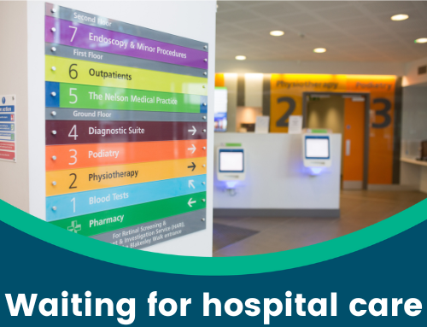

Involving local people in health and social care
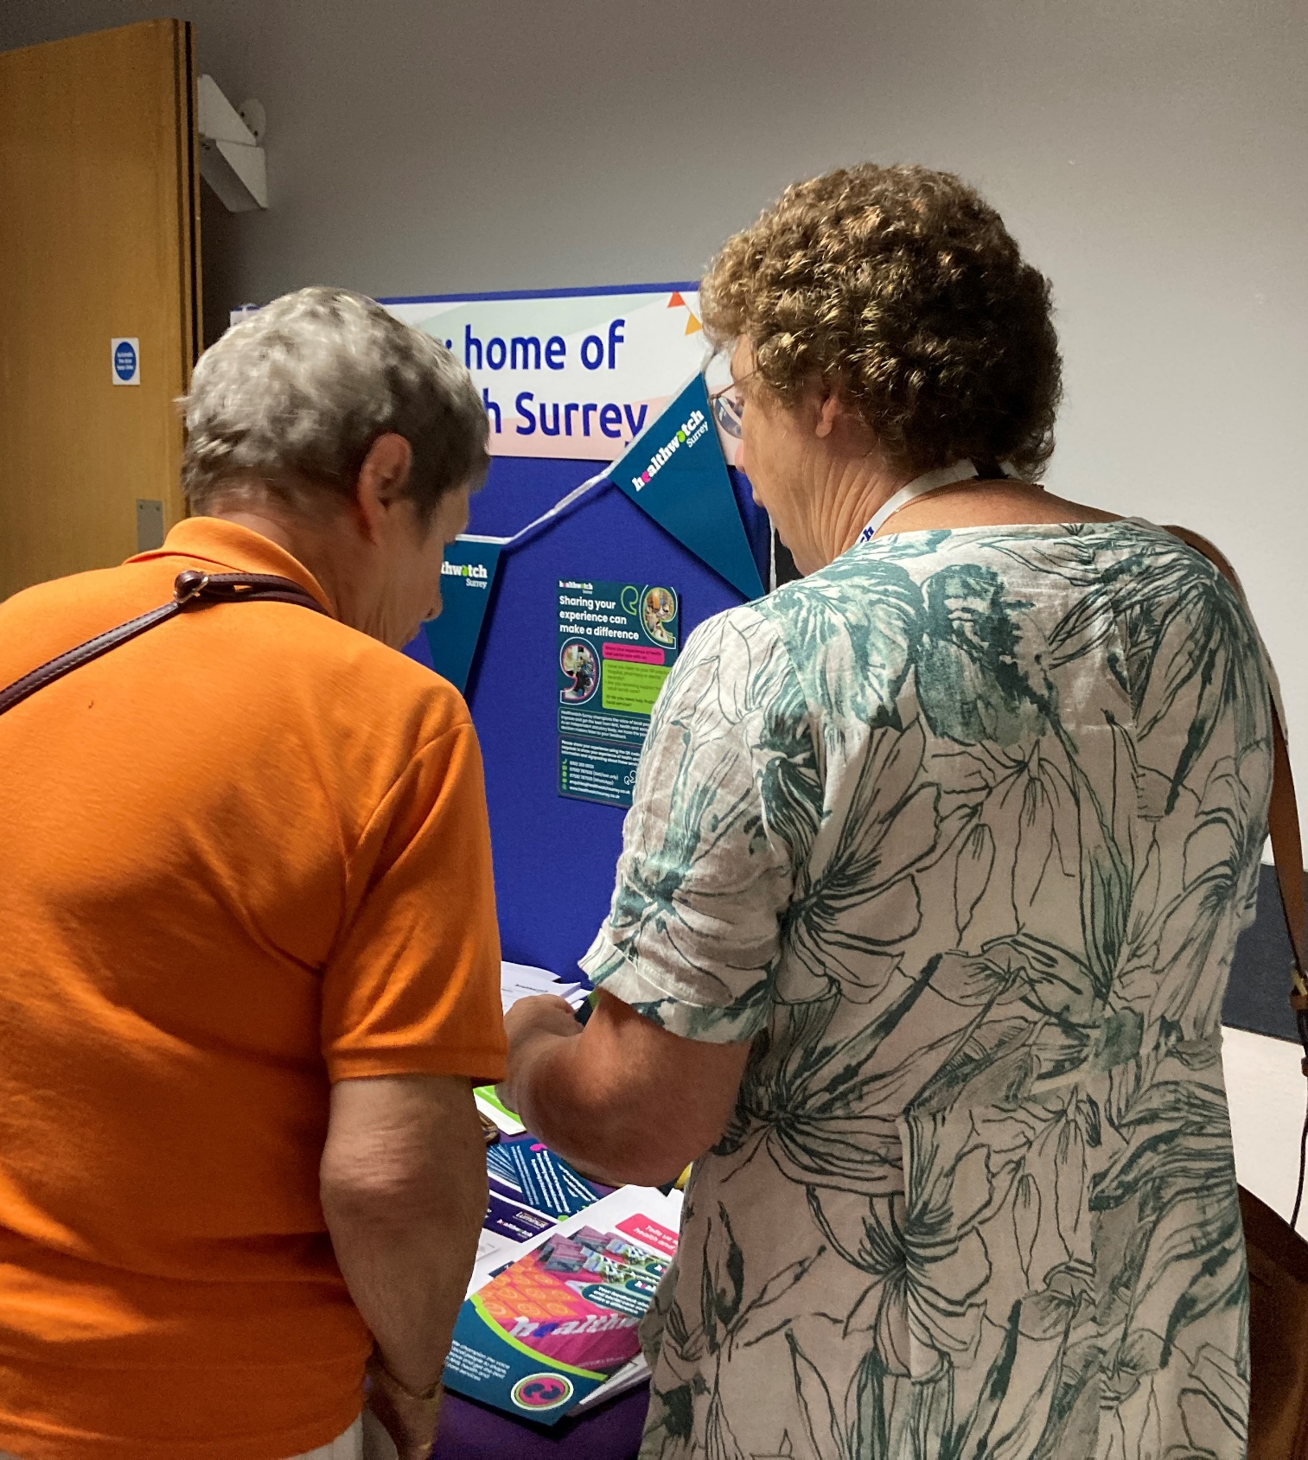
Our dedicated team of volunteers help us to ensure that local people have their say, and that we hold decision makers to account.
Our volunteers gifted us 233 hours of their valuable time since June!

Shining a light on student mental health
This quarter one of our volunteers set out to explore students’ understanding and awareness of mental health services. In this small, qualitative research project, student volunteer India Cleall spoke to 6 students at Royal Holloway, University of London.

As a student herself, India was able to garner the trust required for the students to talk openly about their thoughts and feelings, which were brought together in a powerful research report - Mental health on campus awareness.

What difference have we made?
The report was presented to SCC’s Public Health Team who have shared it with the Young People Suicide Prevention Lead to guide their activities and comms.

We would like to thank everyone who gave their time and shared their experiences with us this quarter.



Have your say! Upcoming projects

 | Involvement of People - we are looking at the NHS app - why people use it, why they don 't, and how it could be improved. We're also interested to know if residents the NHS app to provide feedback on NHS services and how they’d ideally like to provide this feedback.  https://www.smartsurvey.co.uk/s/HwSyNHSAppandfeedback2025/
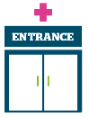 | Access to primary care - we are seeking to understand the barriers that may prevent people from black or Asian minoritised communities from accessing sight (eye) tests.  https://www.smartsurvey.co.uk/s/sightonequity/  We’re also looking at the adjustments (changes) a GP practice makes so you can use their services, and if they’re meeting your needs.  https://www.smartsurvey.co.uk/s/HwSyReasonableAdjustments2025/
 | Social care and public health - we are looking at NHS Health Checks. These checks are free for anyone between the ages of 40 and 74 (who doesn’t have one or more of a number of pre-existing conditions), but how much do residents know about them? Why are people not taking them up?  https://www.smartsurvey.co.uk/s/HwSyNHSHealthChecks2025/

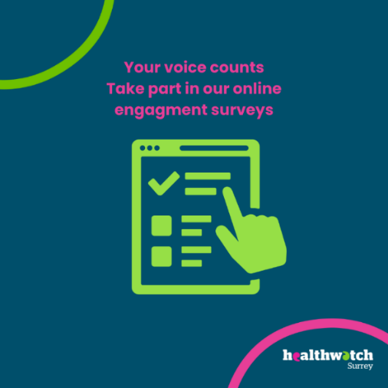

The more people we hear from, the more impactful our research will be, and the more likely we are to be able to bring about positive change.


Healthwatch Surrey – Contact us

Website: www.healthwatchsurrey.co.uk
Phone: 0303 303 0023
Text/SMS: 07592 787533
Email: enquiries@healthwatchsurrey.co.uk
Address: Freepost RSYX-ETRE-CXBY, Healthwatch Surrey, Astolat,
Coiners Way, Burpham, Guildford, Surrey, GU4 7HL

 Healthwatch Surrey
 Healthwatch_surrey
 Healthwatch Surrey



We are committed to the quality of our information.
Every 3 years we perform an audit so that we can be certain of this.

The Healthwatch Surrey service is run by Luminus Insight CIC
(known as Luminus).

