
Quarterly impact report
April - June 2026

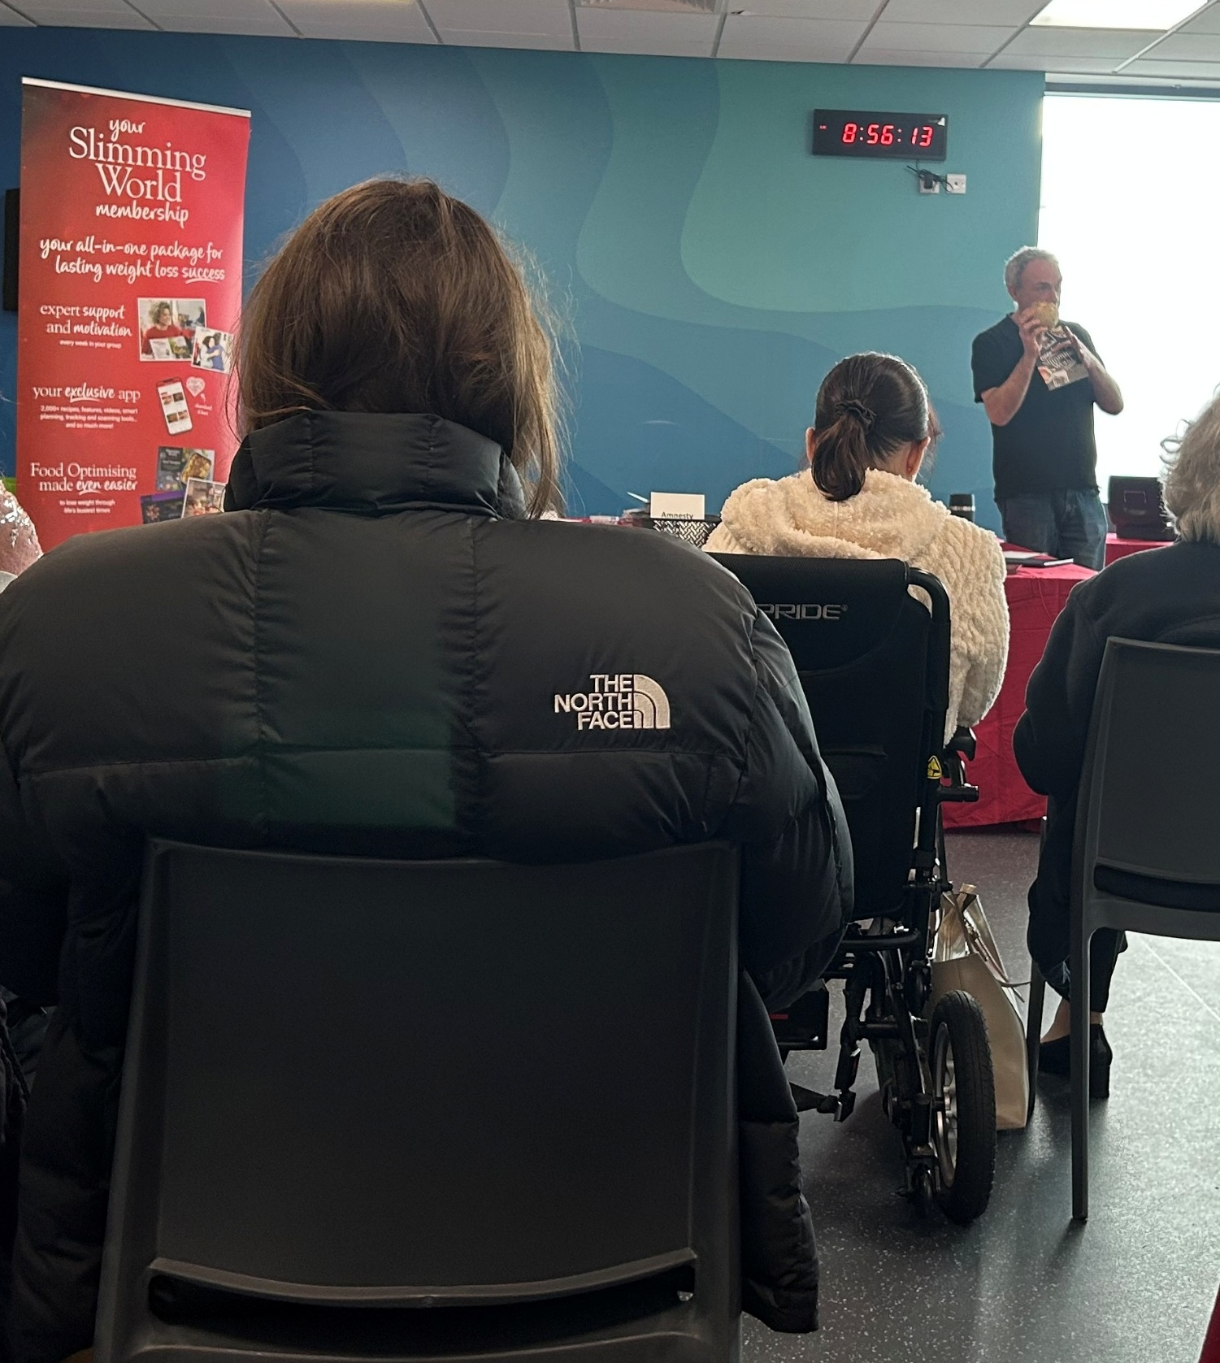

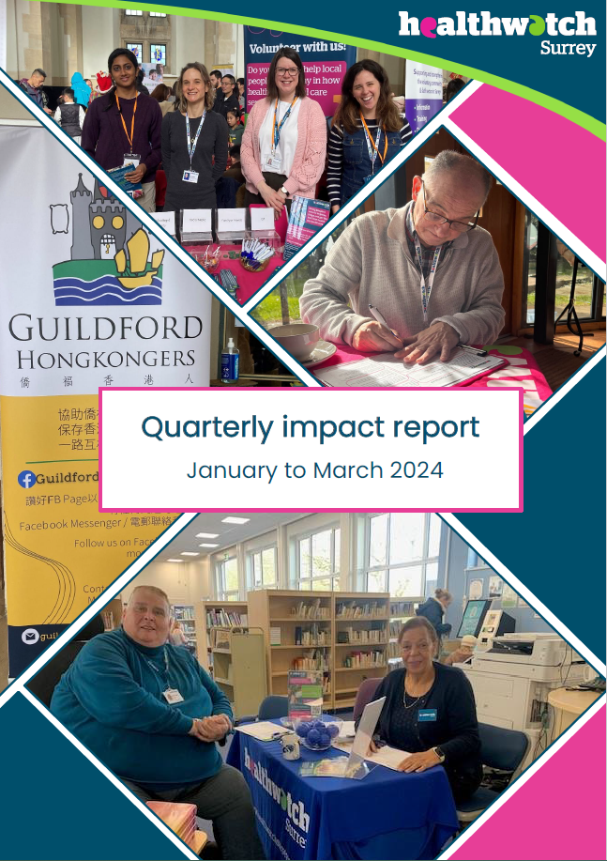

Contents
This quarter in numbers 3
Information and signposting 4
Supporting residents through our Helpdesk 5
Case study: Polly’s story* 7
Supporting residents in the community 8
NHS Advocacy & complaints 10
Delivering on our thematic priorities 11
Involvement of people: what’s working (and what’s not) in acute care 12
Public health and adult social care: supporting the prevention agenda 13
What other themes have we been exploring: additional publications 14
Making a difference at a system level 15
Using our voice to ensure equity of services 15
Sharing insights to inform system change 16
Ensuring Surrey voices are listened to nationally 18
Supporting the national consultation on the proposed NHS Online Trust 19
Involving local people in health and social care 20
Ensuring Quality Accounts are accessible 21
Have your say! Ongoing and upcoming projects 22
Contact us 23

If you would like a paper copy of this document or require it in an alternative format, please get in touch with us.

This quarter in numbers
 | 1684 Visits to our Information and advice website pages
 | 274 People have shared their experiences with us*
 | 119 People supported by our Helpdesk**
 | 112 People helped, supported or spoken with in the community
 | 24 People provided with Independent Health Complaints Advocacy support
 | 12 Events in the community attended
 | 4 Reports published

* People contacting our Helpdesk for information, advice or to share an experience, via email, telephone, text or WhatsApp, or via our website. Plus sharing their experiences via Smart Survey, our Enter and View visits or some other means including projects and Healthwatch England.
** People contacting our Helpdesk for information, advice or to share an experience, via email, telephone, text or WhatsApp, or via our website.

Information and signposting
One of our statutory functions is to provide non-clinical information and advice to the public about accessing health and social care services and the options available to them. We help people to identify the services and support they need and provide advice about how to navigate them. We can also escalate concerns to partners within the NHS and social care; providing resolutions to some individuals and ensuring an improved experience for others.
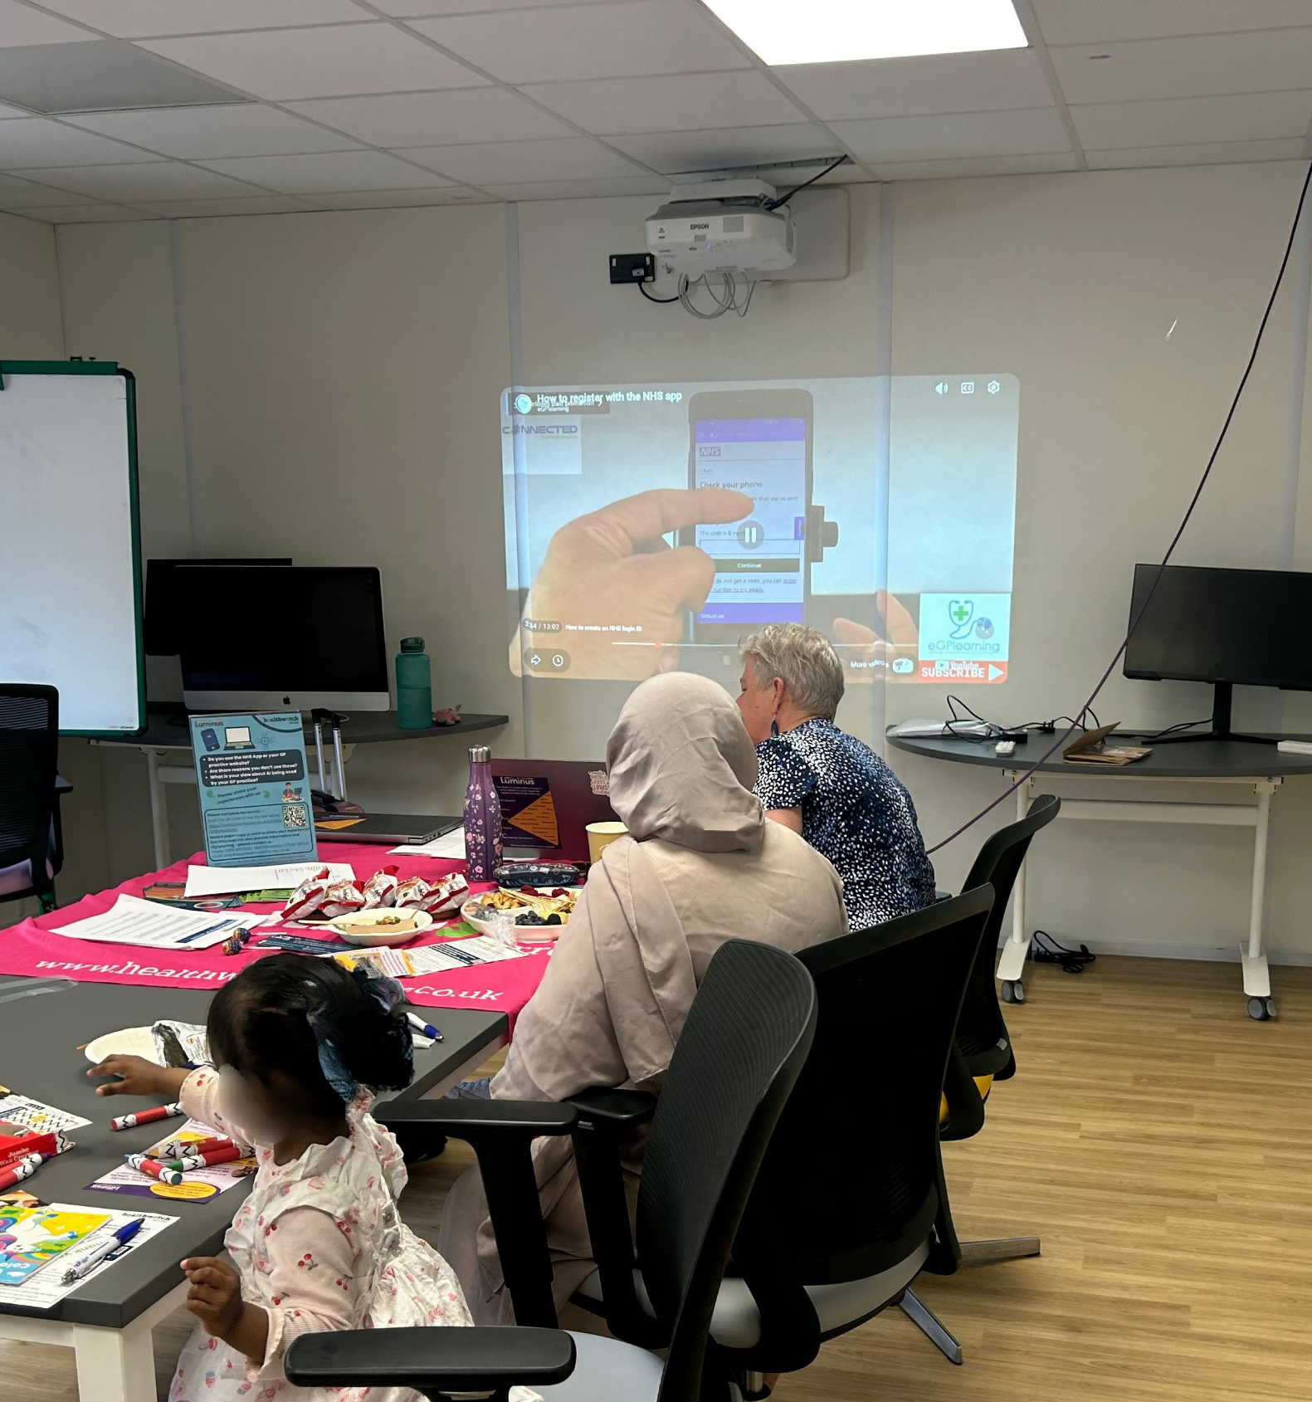

Supporting residents through our Helpdesk

We helped 119 people navigate health and social care services after they contacted our Helpdesk. Here are what some of them had to say about our service:

“At a time when I have been disabled it is all truly daunting, extremely stressful and absolutely overwhelming. My wife found you online and I'm so pleased she did. Oftentimes we just need direction.”

“I just want to say thank you for your compassion and kindness…I’m in awe and gobsmacked at the fact I have been listened to and helped today, thank you.”

“You have been amazing, absolutely amazing. Maybe this is what I needed. I can’t thank you enough, you have given me more information than I could have hoped for, thank you.”

People often come to our Helpdesk with a variety of complex concerns and issues. Our knowledgeable Helpdesk team are adept, not only at answering direct questions, but also at identifying where additional help and support could be useful as demonstrated in the following case studies.

Case study: Paul’s* story
Paul, who is neurodivergent and finds attending hospital challenging,
contacted the Helpdesk to request help with accessing hospital care following a rapid decline in his condition and concern about the impact it was having on his family.

Our Helpdesk advisor asked if Paul was receiving any support from his adult social care locality team. Paul told us that he had been advised to access direct payments but he didn’t know how to start the process and had not been given any accessible guidance from his social care team.

Our Helpdesk advisors put Paul in touch with the Independent Non-Statutory Discretionary Advocacy service and the hospital’s Autism and Learning Disability nurse. They also liaised with the adult social care team to request that Paul receive some information and support.

What impact have we had?

Paul now feels happier and more confident to attend his hospital appointments due to the support offered by an advocate and the reasonable adjustments which have been put in place following their intervention. He is also receiving help to understand direct payments so he can apply for these vital funds.

We have a useful guide to advocacy services on our website for those who need it.

Case study: George’s* story
We received a call from George who had recently lost his dentures and was unable to eat solid food as a result – he called the Helpdesk looking for support to find an NHS dentist. George - a pensioner and an unpaid carer for his wife and daughter, both of whom have terminal cancer - is unable to pay for private care or to travel far due to his caring responsibilities. It became clear during the conversation that the family were also struggling to cover the cost of living and were not receiving any carers’ support.

How did we make things better for George?

Our Helpdesk advisor liaised directly with George’s ICB to request support in finding him a new NHS dentist. We also signposted him to carers support and multiple benefit and welfare support services, to help ensure the family received the help they needed and were entitled to.

Case study: Polly’s story*

Polly’s mother was in a nursing home and had recently had her Continuing Health Care (CHC) funding removed. As a result she was referred back to adult social care, who told Polly that the family would have to pay a top up fee if they wished to keep their mum in the care home she loved.

Our Helpdesk team recognised that Polly’s mother may be entitled to NHS-funded nursing care.

What impact did we have?

We gave Polly information on how to appeal the CHC decision and request an assessment for funded nursing care, which would contribute to some of the nursing home fees and make Polly’s mum remaining in the same care home more viable.

*Names have been changed

Insights from our Helpdesk have also helped to support our system partners. Read more in our Making a difference at a system level section!

Supporting residents in the community

We visited 12 venues across Surrey and engaged with 112 people. Whilst out and about we have the opportunity to talk to people about the important issues we’re currently exploring (read more information on our thematic priorities later in this report). But we’re also able to listen, without prior agenda, to residents’ thoughts, concerns and questions about any aspect of health and social care and to offer information and signposting wherever we can.

The map below shows the venues we visited this quarter.

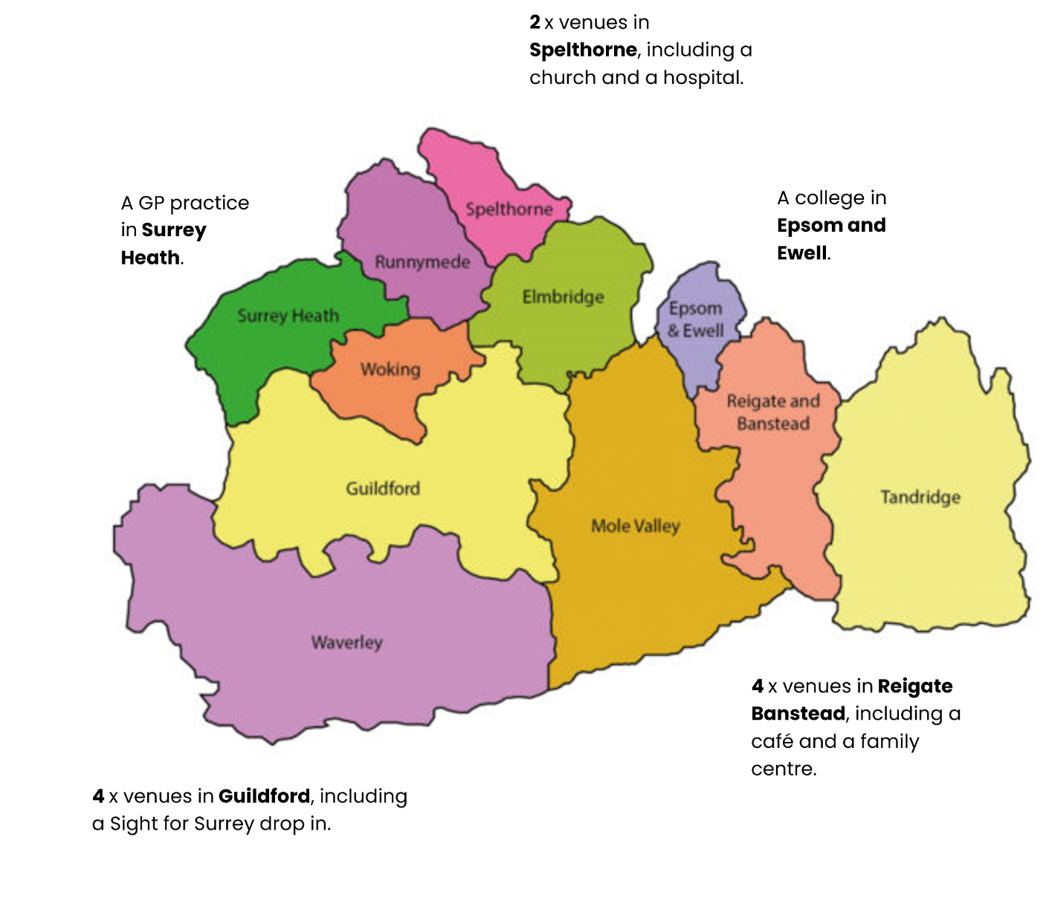

Engagement case study: weight management support
As part of a recent project investigating weight management support we had the opportunity to gain insights around people’s knowledge and understanding of the support available, but also to educate and inform. At several events across Surrey we facilitated discussions around how to manage weight and the options available via general practice and pharmacy. We also helped those who wanted to calculate their BMI (body mass index) to help inform their approach.
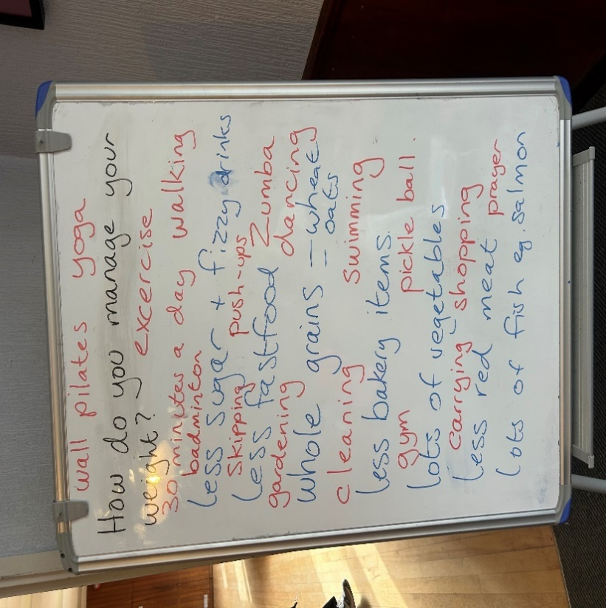

NHS Advocacy & complaints

This quarter 159 people contacted our Independent Health Complaints Advocacy service (IHCA) and were provided with information on how to pursue a complaint. 24 people needed specialist help from an advocate and were fully supported to submit and pursue their complaint. Run in partnership with Surrey Independent Living Charity, IHCA provides free, confidential and independent support.

Case study: Derek’s* story
Derek was struggling to access his GP practice’s online forms to book an appointment and had been told that he wasn’t able to do it over the phone. He had managed to submit a complaint online via the practice contact form with help from a family member but had not had a response from the practice for over a month. He therefore contacted the IHCA for advocacy support as he was not able to follow up online, not confident advocating for himself and unclear about the formal complaints process.

Derek’s advocate followed up with the practice on Derek’s behalf and was able to confirm with them that Derek had made a formal complaint, not simply offered feedback as the practice had thought. They continued to liaise with the practice manager to follow the complaint through, to confirm that no correspondence should be sent digitally and to work through the response once received.

Outcome for Derek
The practice’s response confirmed that it was acceptable for Derek to continue to make appointments over the phone. Derek was satisfied with the surgery’s response as they had acknowledged that the issue had happened and apologised, and had taken steps to ensure that it wouldn’t happen in the future.

Wider outcomes
Learnings around staff tone and patience, and the need to ensure patients feel supported when accessing appointments, were noted and shared with the reception team to reduce the risk of more patients having a negative experience.
* Names have been changed

Delivering on our thematic priorities
Along with our core priorities of agenda free listening, the provision of information and advice and amplifying the VCSE voice, we have 3 thematic priorities – access to primary care, public health and adult social care, and involvement of people – which have been designed based on what residents tell us matters to them.

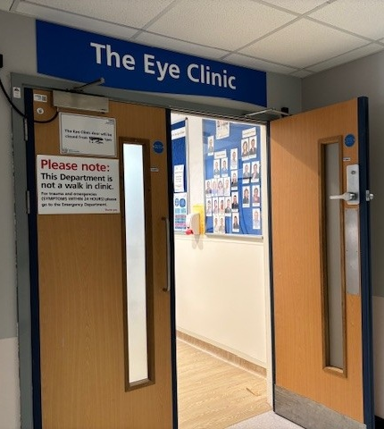

Involvement of people: what’s working (and what’s not) in acute care

Background and remit
Involving local people in decision making, and the design of and changes in, services helps to ensure that these services truly serve their local communities.

This year, under our involvement of people priority, we are focussing on people’s experiences of care delivered by Surrey’s acute hospitals.

Our approach
Our strategy involves a combination of agenda free listening (allowing people to talk to us about any aspect of their care) and more focussed activity, working with our acute trust colleagues to take a deep dive in to departments, therapeutic areas or patient populations where there is felt to be the greatest need to hear patient voice.

We have also adopted a combination approach with our engagement:
- Talking to people on site gives them an opportunity to share their experiences with an independent, impartial organisation, allowing us to capture feedback from those who are actively using services and can provide insights into current areas for praise or concern.
- Engagement in community settings gives us the opportunity to hear from people who may be using services but may also have access issues.
- When people contact our Helpdesk they are often doing so regarding a query, negative experience or complaint.

Case study: Royal Surrey County Hospital - ophthalmology
We supported the Trust to evaluate patient experience, accessibility, communication and service flow within the ophthalmology department.

We visited a Sight for Surrey drop in and a Macular Society support group, as well as talking to people on site in the ophthalmology department. We presented our findings to the nursing and patient experience teams.
How have we made things better for Surrey residents?

Based on the findings of our report the Trust are making a number of changes to improve the experience for patients, these include reviews of:
- Receptionist roles to ensure an allocated person answers the phone – ensuring patients receive a callback within a clearly defined timeframe - and an allocated person supports patients when they arrive in the department
- How patients can be better informed about waiting times
- Improved signage to refreshments
- Signposting to feedback mechanisms, to ensure patients are clear about how they can do this.

Public health and adult social care: supporting the prevention agenda

Background and remit
Prevention - specifically ‘Supporting people to lead healthy lives by preventing physical ill health and promoting physical wellbeing’ - is Priority 1 of the Surrey Health and Wellbeing Strategy. Prioritising prevention, moving from reactive to proactive care, is also one of the cornerstones of the NHS 10 Year Plan.

Our most recent project under our public health and adult social care priority looked at the attitudes of people in their 50s and 60s (those approaching the age range which, statistically, uses the NHS and social care the most) to their own health and wellbeing. Over 150 people contributed to the research, through community engagements, focus groups and a survey.

What difference have we made?

Our report ‘Living, coping, thriving: exploring preventative health behaviours of people aged 50-66 in Surrey’ was shared with our Public Health colleagues who, based on the findings, are progressing a programme of work focusing on prevention, the health mobility index, staff confidence in having health conversations and access to services. We’re pleased to have given a platform to both current and future service users.

What other themes have we been exploring: additional publications
Alongside these projects we have also published a number of additional reports this quarter.

Bridging the digital divide
Our Bridging the digital divide report revisits our previous work about digital access to GP services and the use of AI and looks at any changes in people's experiences or views.

Mental health services for young people - volunteer report
This small, qualitative study looking at mental health services for young people was undertaken by one of our volunteers.

Making every voice count: Healthwatch Surrey annual report 2025-26
We’ve also published our 2025-26 annual report, highlighting the impact we made throughout the year.

Making a difference at a system level
We ensure that decision makers in Surrey and Sussex hear about the insights and experiences residents have shared with us, both positive and negative. We sit on a number of boards and committees and proactively challenge system partners over issues identified to us by local residents and share when things have gone well to help to identify best practice.


Using our voice to ensure equity of services
Surrey County Council (SCC) operates several select committees that scrutinise council decisions, monitor performance and make recommendations on key policy areas. The Adults and Health Select Committee analyses all health and adult social care services commissioned or delivered within Surrey. We sit on this committee to ensure that residents’ voices are heard.

Reports suggested a significant improvement in the percentage of new social care assessments completed within acceptable timescales. At a recent meeting we sought more explanation on what lay behind these figures to surface any potential issues with complex care needs not being met.

How have we made a difference?

We are pleased that the Adults, Wellbeing and Health Partnerships Executive team are now exploring this further, ensuring better understanding – and safeguarding - of those waiting for care assessments.

Sharing insights to inform system change
This quarter we have used the insights shared with us, on our Helpdesk or out and about on engagement in the community, with our system partners to ensure that local voices are at the forefront when decisions are made.

- Helped to inform the Joint Strategic Needs Assessments (JSNAs) relating to people with disabilities and long term health conditions and end of life care (the latter based on our previous report for The Commission on Palliative and End-of-Life Care).
- Supported colleagues from Royal Surrey County Hospital as they were developing guidance for autistic people on how to submit a formal complaint, and for staff on how to support and interact with a person with autism.
- Shared insights around support services and organisations to assist the Surrey Safeguarding Adults Board with a project looking at carers.
- Provided a compilation of patient experiences of the NHS111 service with the provider and commissioner to help them understand the service from a patient perspective.

“The Healthwatch partnership provides us with an invaluable source of feedback from service users and the population we serve. Our meetings with Healthwatch colleagues are informative and collaborative. Without this relationship we would lose an invaluable source of feedback and triangulation which would significantly diminish the quality of our connection with our patients and their families."
Mark Roland, Chief Medical Officer, Ashford and St Peter’s NHS Foundation Trust

“Our joint collaborative working to address queries trends and feedback from patients across the patch has been invaluable and has supported the scope and design of services in primary care.”
Head of Primary Care Contracts, Surrey and Sussex ICB

Ensuring Surrey voices are listened to nationally

Through our Healthwatch network and our system contacts we are connected to changes, challenges and calls for insights at a national level; we often use what people tell us to ensure the Surrey story is told beyond the county boundaries.
Real, lasting change takes time, which often means the full impact of our work can’t be felt immediately. That’s why we regularly revisit our projects…

Supporting the national consultation on the proposed NHS Online Trust
In our last impact report we reported on the Department of Health and Social Care (DHSC) and NHS England’s plan to establish a new online service – NHS Online - to deliver online elective care. As part of the planning process DHSC and NHS England consulted with the local Healthwatch network.

Based on what local people tell us and our own knowledge and expertise we offered insights on people’s use and understanding of digital health services, required communication, access issues and capturing patient feedback.

What’s changed?

This quarter we received communication from the Department of Health and Social Care detailing what changes and updates to their plans will be made based on our feedback and that of other local Healthwatch. These include: the consideration of translation features to ensure access for those for whom English is not their first language; an increased focus on compliance with accessible information standards; consideration of the provision of hands on training and support to upskill patients to use the service and improved engagement with patients and stakeholders throughout the development process.

This quarter, having done our own local work on this topic, we have also been able to contribute to a National Institute for Health and Care Excellence (NICE) survey exploring how digital health technologies (such as apps and remote monitoring tools) may impact different groups, particularly people who could face barriers to accessing or using digital tools. Our feedback will help to ensure health inequalities and digital exclusion are properly considered in NICE’S guidance and decision making as well as to shape future work and recommendations in this area.

Involving local people in health and social care
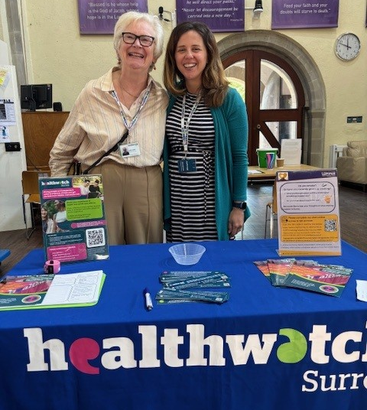
Our dedicated team of volunteers help us to ensure that local people have their say, and that we hold decision makers to account. Our volunteers gifted us 118 hours of their valuable time this quarter!

Ensuring Quality Accounts are accessible
We are committed to ensuring that system leaders and decision makers involve local people in health and care services. One way in which we do this is via our Reading Panel, who act as a vital sounding board for our system partners, scrutinising reports, strategies and other documents (written to provide details on decisions and services). Under the Health and Social Care Act 2012 many NHS organisations are required to produce Quality Accounts if they meet certain criteria. A Quality Account is a published report about the quality of services and improvements offered by an NHS healthcare provider.

What difference have we made?
This quarter, 5 of our Reading Panel dedicated approximately 35 hours to scrutinising the Quality Accounts of 8 different providers, suggesting changes and improvements to ensure better clarity and accessibility.

“Thank you very much for taking the time to review our 2025/26 Quality Account and for providing such positive and thoughtful feedback. We are incredibly grateful for the continued support and it was particularly encouraging to hear your positive comments regarding our continued focus on patient experience and the introduction of our digital patient story platform. We are excited about the opportunities this provides to strengthen the patient voice within SECAmb and ensure that lived experiences continue to inform service development and improvement. We greatly value the contribution of your volunteers and would be grateful if you could pass on our thanks to everyone involved in reviewing the Quality Account and providing feedback.”
Head of Patient Engagement, South East Coast Ambulance Service (SECAmb)

We would like to thank everyone who gave their time and shared their experiences with us this quarter.

Have your say! Ongoing and upcoming projects
We’re keen to hear from all Surrey residents about all aspects of health and social care, but we also have some specific subjects we’re interested in hearing about.

 | Involvement of People – we are looking at residents’ experiences of care delivered by Surrey acute hospitals, both in the hospital and the community.  https://www.smartsurvey.co.uk/t/HwSyHospitalFeedback2026
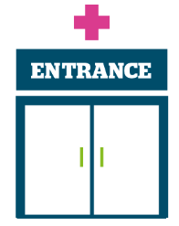 | Access to primary care – we’re working with our Giving Carers’ a Voice colleagues to hear about carers’ experiences of accessing primary care for the people they care for. Survey closes 30 September 2026.  https://www.smartsurvey.co.uk/t/CarersExperiencesGPPracticesHwSy2026/

The more people we hear from, the more impactful our research will be, and the more likely we are to be able to bring about positive change.





Contact us
Website: www.healthwatchsurrey.co.uk
Phone: 0303 303 0023
Text/SMS: 07592 787533
WhatsApp: 07592 787533
Email: enquiries@healthwatchsurrey.co.uk
Address: Freepost RSYX-ETRE-CXBY, Healthwatch Surrey, Astolat, Coniers Way, Burpham, Guildford, Surrey, GU4 7HL.
 healthwatchsurrey
 healthwatch_surrey
 Healthwatch Surrey


The Healthwatch Surrey service is run by Luminus Insight CIC, known as Luminus. Luminus is a Surrey based, independent, community interest company which exists to empower people to have their voices heard. We help organisations provide equity of access and the best services possible, through the inclusive involvement of local people.


We are proud to have signed up to the End Poverty Pledge.

Luminus Insight CIC trading as Luminus and Healthwatch Surrey
Registered office: GF21 Astolat, Coniers Way, Burpham, Surrey, GU4 7HL
Company number: 08737632. Registered in England and Wales.

