

Enter and View

Derby House, Epsom

  - September 2025

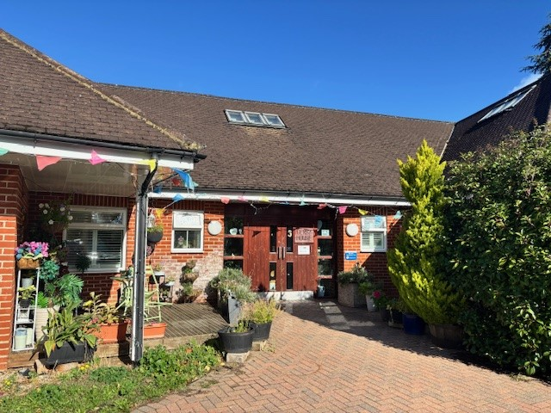

If you would like a paper copy of this document or require it in an alternative format, please get in touch with us.
Contents
Report overview 3
Why we visited 3
Who we heard from 3
Disclaimer 4
Recommendations 4
Observations about the service 5
Description of service 5
Environment 5
Facilities 5
What we heard in detail 7
Care 7
Staff 9
Visiting healthcare professionals 9
Food 9
Visiting 10
Staying in touch 10
Next steps 10
Acknowledgments 10
Appendix 11
What is Enter & View? 11
About Healthwatch Surrey 12
Healthwatch Surrey – Contact us 13

Report overview

Why we visited
Enter and View is one way in which Healthwatch Surrey can observe and report on how services are being run and collect the views of service users and their carers and relatives, as well as staff. You can read more about our policy here: Enter and View Policy - Healthwatch Surrey.

We were asked to carry out this Enter and View visit by the learning disability management team at Surrey and Borders NHS Foundation Trust (SABP). As well as giving people an opportunity to share their views of Derby House with an independent body, SABP were also keen to find out whether people are aware of the feedback mechanisms in place - an important way to ensure people with learning disabilities and their families have a say in how services are run.

Details of visit:
Service address | Derby House, St Ebba’s Way, Epsom, KT19 8QJ
Service provider | Surrey and Borders NHS Foundation Trust (SABP)
Date and time | Friday 12 September 2025, 10am - 12noon
Authorised  representatives | Hannah Gilmour, Linda Smullen (Healthwatch Surrey authorised Enter and View representative)
Contact details | Healthwatch Surrey GF21, Astolat, Coniers Way, Burpham, Surrey, GU4 7HL  Email: enquiries@healthwatchsurrey.co.uk  Phone: 0303 303 0023 (local rate number)  SMS (text only): 07592 787533  WhatsApp: 07592 787533

Who we heard from
We were shown around by the manager of the home, with input from staff that were on duty that morning. We also met family members of four of the people living at Derby House.

Disclaimer
This report relates to findings observed on the specific date we visited. It is designed to highlight the themes we heard about and includes quotes to provide context on these themes.

Executive summary
Based on findings from our visit and the people we spoke to, we observed
that the home is well maintained, the individuals are well cared for and
their families reported being happy with all aspects of care.

Observations about the service

Description of service
Derby House is a registered care home that supports 6 women who have a learning disability and autism.

Environment
Derby House is a single storey home situated at the old St. Ebba’s hospital site. There are a variety of community services and other residential homes in this complex. There are 6 female individuals living at Derby House, all with complex and differing needs. Ages of residents at the time of our visit were between 40-80.

There are large photos of the individuals in all of the corridors at Derby House and it has a warm and homely feel as you walk in.

There is a large garden that the people living there have free access to. The garden has a plum and apple tree and a vegetable patch that they help to maintain. Staff told us that one of the individuals uses a paddling pool in the summer, and one has her own trike that she can use both in the garden and on the wider site with support.

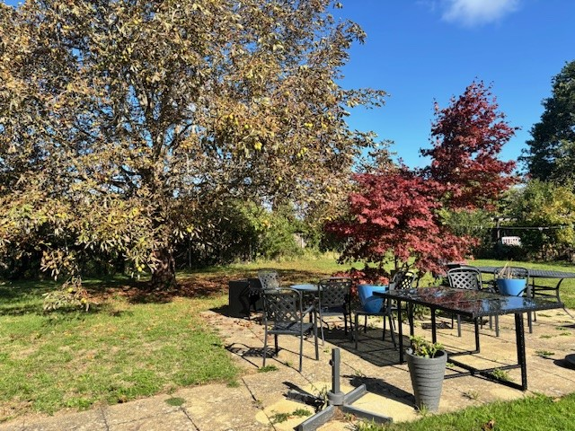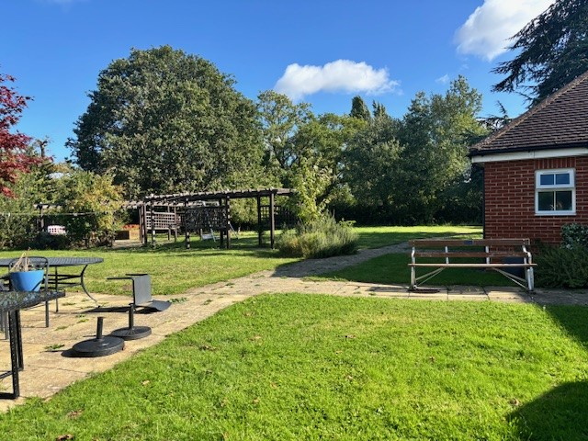

Facilities
All individuals have their own bedroom decorated to their tastes. Family and staff told us that each individual chose the colours painted on the walls. Photos of family and special occasions are framed and on display in the rooms

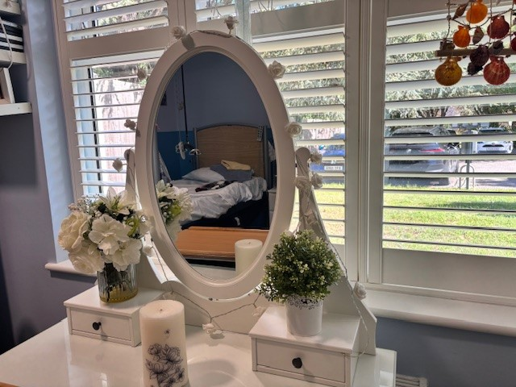

One of the individuals also has her own lounge to allow her some additional privacy away from the other people when she needs it.

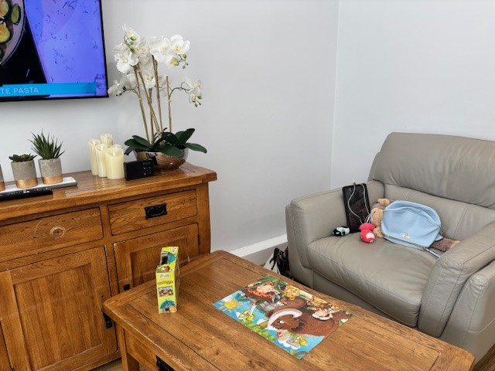

There are two bathrooms and two separate toilets that are shared. The bathrooms contain large walk-in baths that allow individuals to bathe in safety with support.

We were told that one of the old bedrooms no longer in use is about to be turned into a second staff room to allow some additional space for respite/night workers.

There is a laundry room that is used by individuals and a secure, dedicated medication room only accessible by staff.

What we heard - in detail

Daily life and care
All of the people we saw at the visit seemed happy and well cared for.
The families we met commented on their family member having a full social life. Three of the six ladies have friends in other units on the site – staff have facilitated days with them that include bowling and meals at local restaurants. One of the couples have holidayed together at Center Parcs. Two of the individuals holidayed together to Greece last year, another had a spa break and another has a holiday to Dorset to look forward to in the coming weeks.

There was an information board at the entrance with posters and leaflets advertising a variety of external activities that the individuals could go to, alongside information for staff and families. Lots of local activities are available, including visiting a social café that raises funds for the centres and a walk in aid of Mencap. The Surrey and Borders band also come on to the site to play for the different homes.

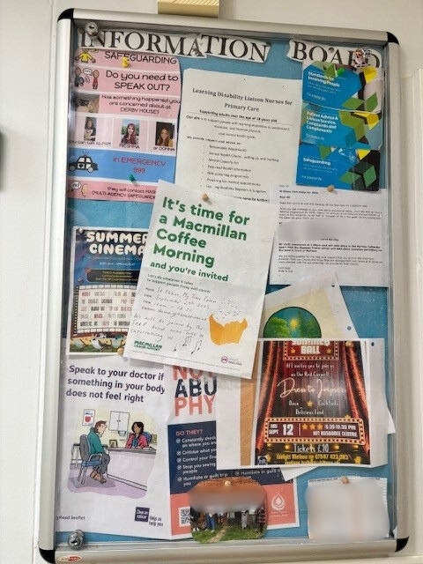
Derby House own a companion bike for cycling around the estate and they are hoping to buy a wheelchair companion bike for their individuals in wheelchairs.

Activities are not just confined to the daytime; three of the individuals were attending a local disco that evening. Each will be accompanied by their named carer.

One of the family members there on the day told us

“My aunt has a better social life than I do!”

All activities are planned with support staff according to the person’s needs and hobbies. Individuals can choose their own activity and they know on a week to week basis when things are happening. All people have a visual timetable they can refer to.

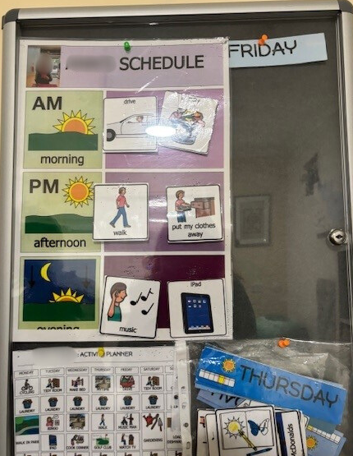

The staff try not to book activities that will clash with a visit from family or an appointment with a health professional.

Staff
At the time of the visit there were 18 staff on the rota in total. There were 5 staff on duty in the morning, 5 staff in the afternoon and 2 staff overnight. Bank staff are currently being used while a recruitment process takes place and current staff are offered overtime.

There is an activities co-ordinator who comes in on Mondays, Wednesdays and Fridays.

There are 4 staff at any time on at the weekend.

The family members we spoke to were very complimentary about the staff at Derby House.

“Every single member of staff at Derby House is incredible; they take time to listen to my sister and they provide high quality care and support at all times.”

Visiting healthcare professionals
External health professionals come in to see individuals on a weekly basis. These include a speech and language therapist and a physiotherapist. A chiropodist will come in every few weeks.

GPs will sometimes come out to the home, but more often than not the individuals will go to the practice. Appointments are given around a day in advance.

The people at Derby House visit a specialist dentist in Epsom every 6 months.

Food
Individuals are able to choose their own meals and some assist with the preparation of their own meals. The family members we spoke to were very complimentary about the choice of food on offer and those individuals that need specific dietary plans were well catered for.

Visiting
There were four different families visiting at the time of our visit – they all knew each other from previous visits and it was a very jovial atmosphere for both the individuals living at Derby House and the staff. There was a real sense of family and friendship among them all. Several of the family members had travelled a considerable distance to be there that day.

We were told that there were no set visiting hours and families were welcome to drop in whenever they liked, though most planned ahead to allow the individual time to acclimatise to the idea and to ensure they wouldn’t be otherwise engaged in another activity.

Staying in touch
The family members we spoke to appreciated the regular communication and FaceTime calls with their family member.

“Communication is very good.”

“I am contacted if anything needs discussing around decisions for my family member.”

Families told us that they are invited to the home regularly for special occasions such as birthdays, Easter and anniversaries. Some that were there on the day we visited were making arrangements to see each other again at the home for Halloween.

Next steps
This report and the response from the service provider will be shared with commissioners and regulators of the service and will be published on our website.

Acknowledgments
Healthwatch Surrey would like to thank the staff at Derby House for welcoming us, and the family members who spoke to us for this report. We would also like to thank our Healthwatch Surrey authorised representative, Linda, for her help.

Appendix

What is Enter & View?
Healthwatch have a legal power to visit health and social care services and see them in action. This power to ‘Enter and View’ services offers a way for Healthwatch to meet some of their statutory functions and allows them to identify what is working well with services and where they could be improved.

Healthwatch have a power under the Local Government and Public Involvement in Health Act 2007 and Part 4 of the Local Authorities Regulations 2013 to carry out Enter and View visits.

The legislation places a duty on health and social care providers to allow Authorised Representatives of Healthwatch to carry out an Enter and View visit on premises where health and social care is publicly funded and delivered.

The purpose of an Enter & View visit is to collect evidence-based feedback to highlight what’s working well and what could be improved to make people’s experiences better. Healthwatch can use this evidence to make recommendations and inform changes both for individual services as well as system wide.

Healthwatch Enter and Views are not intended to specifically identify safeguarding issues. However, if safeguarding concerns arise during a visit, they are reported in accordance with Healthwatch safeguarding policies. If at any time an Authorised Representative observes anything that they feel uncomfortable about they need to inform their lead who will inform the service manager, ending the visit.

In addition, if any member of staff wishes to raise a safeguarding issue about their employer, they will be directed to the CQC where they are protected by legislation if they raise a concern.

About Healthwatch Surrey
Healthwatch Surrey champions the voice of local people to shape, improve and get the best from NHS, health and social care services. We are independent and have statutory powers to make sure decision makers listen to the experiences of local people.

We passionately believe that listening and responding to local people's experiences is vital to create health and social care services that meet the needs of people in Surrey. We seek out people’s experiences of health and care services, particularly from people whose voices are seldom heard, who might be at risk of health inequalities and whose needs are not met by current services. We share our findings publicly and with service providers and commissioners to influence and challenge current provision and future plans.

We also provide reliable and trustworthy information and signposting about local health and social care services to help people get the support they need.


We are proud to be commended in the National Healthwatch Impact Awards, recognising our work helping to improve local NHS and social care. You can view our video highlighting how feedback has enabled us to make positive changes to health and social care services.


We are committed to the quality of our information.
Every 3 years we perform an audit so that we can be certain of this.

Healthwatch Surrey – Contact us

Website: www.healthwatchsurrey.co.uk
Phone: 0303 303 0023
Text/SMS: 07592 787533
WhatsApp: 07592 787533
Email: enquiries@healthwatchsurrey.co.uk
Address: Freepost RSYX-ETRE-CXBY, Healthwatch Surrey, Astolat,
Coniers Way, Burpham, Guildford, Surrey, GU4 7HL.

 /healthwatchsurrey
 @healthwatch_surrey
 Healthwatch Surrey


The Healthwatch Surrey service is run by Luminus Insight CIC, known as Luminus.
Registered office: GF21, Astolat, Coniers Way, Burpham, Surrey, GU4 7HL.

