As the independent consumer champion for health and social care, Healthwatch Surrey is committed to ensuring the people of Surrey have a voice to improve, shape and get the best from their health and social care services by empowering local people and communities.
For several years now, local Healthwatch across the country have been asked to read and comment on Quality Accounts produced by NHS providers, as required by the legislation. In Surrey this involves at least nine Quality Accounts working to similar deadlines, often to tight timescales. Each document is lengthy and involves many hours work by our staff and volunteers to digest and comment in a meaningful way. Last year we attempted, with the help of volunteers, to comment on the Quality Accounts and to provide a perspective based on the evidence we collect from the public, however we are not convinced that it was a good use of our resources. We do not believe that this process is an effective way of getting our information out to the public; nor an effective way of using our evidence to improve services.
This year our Board has decided that we will not to get involved in commenting on the Quality Accounts. With limited resources we do not believe this is the best way to use our time to make a difference for the people of Surrey. We know that this issue is under discussion at a national level and that other local Healthwatch are adopting a similar approach. We have chosen to concentrate this year on ensuring we feed back what we’ve heard on NHS and social care services to commissioners on a regular basis; and that we have the processes and relationships in place to escalate any cases of particular concern to the providers involved and seek outcomes.

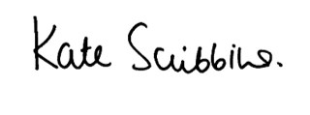
Kate Scribbins
Chief Executive
Healthwatch Surrey 2017

