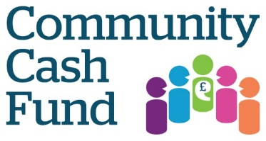
Grant application form for Healthwatch Surrey
Community Cash Fund 2017-18

Date of Application Name of the individual, community/voluntary group or organisation making this
application:

Name of main contact:

Address: (including postcode)

Telephone Number:

Email:

Charity number (if applicable)

If you are applying on behalf of a group or organisation, what is its status e.g. constituted club, co-operative, charity or another ?

1.How much is the total grant you are applying for? £_________(Max £1000)

Please give a detailed breakdown of how you would spend the Community Cash Fund allocation (eg. equipment, staff, resources etc.)

2. What is the name of your project

3.Please provide a brief description of your Community Cash Fund project: what you want to do and how you plan to achieve it … (max 150 words)

4. Who is your project aimed at?
Community Cash Fund are particularly looking to receive applications from local groups and voluntary sector organisations who work with or support people from groups with protected characteristics, carers, socio-economically deprived communities and the working population. For more details see healthwatchsurrey.co.uk/communitycashfund

5. How will you capture the views and experiences from your project about health and social care services and how will you record this information? E.g. Written report, short film, audio recordings, questionnaire

6. How will your project improve the wellbeing of communities through involvement and engagement? E.g. it will help with accessing services, raise awareness of services available, raise awareness of issues in the community….

7. Are you happy for the members of the Healthwatch Surrey team to attend events within your project.

Please send your Community Cash Fund application to: enquiries@healthwatchsurrey.co.uk

Alternatively please post your application to Healthwatch Surrey, The Annexe, Lockwood Day Centre, Westfield Road, Guildford Surrey GU1 1RR before Friday 8th September.

