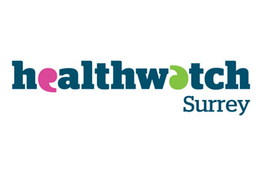
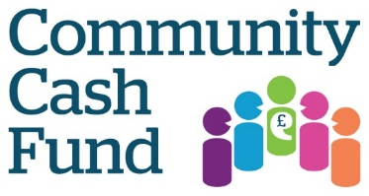
Information and Application Guidance
Welcome to the Community Cash Fund 2017-2018 sponsored by Healthwatch Surrey. We have put together a FAQs section to help you apply for a Community Cash Fund Grant.

- What is Healthwatch Surrey?
Healthwatch Surrey is the local independent health watchdog, we gather experiences from people accessing the NHS and social care in Surrey, when speaking to NHS health and social care decision makers we amplify the voice of the seldom heard groups of people.

- Who is the Community Cash Fund open to?
Individuals, community and voluntary groups or organisations in Surrey, sorry but this fund is not available to statutory organisations.

- How much is the Community Cash Fund?
Healthwatch Surrey will award up to £1000 for the entire project/event.

- To be successful, what will be expected in the application for the Community cash Fund?
The Community Cash Fund applicant must be able to demonstrate that through a project programme or event it will increase and improve the health and well-being of its participants.
The Community Cash Fund applicant must be able to demonstrate ability to actively gather, accurately record and explore people’s experiences of local health care services in their community.

- Are there any preference groups?
Yes, we are particularly keen to receive applications that will reflect the views and experiences from groups of people that rarely speak out which may include, the working population, socio-economically deprived communities, unpaid carers, people from groups with protected characteristics.

- If I am successful, what commitments are we making to Healthwatch Surrey?
Healthwatch Surrey will expect successful Community cash Fund grant winners to share all information arising from the project or event.
The project will include:
- a set of specific, evidence informed outcomes that can be shared with service providers and commissioners
- Use of Healthwatch Surrey branding on all publicity material relating to the Community Cash Fund project.
- Promotion of Healthwatch Surrey during events and communications connected to the project.
- Participation in a celebration event and present the success of the project.

- Must the project be new?
Yes, the project/event must be new. Please note the Community Cash Fund Grant is not available to existing/ongoing or extended projects. There must be a clear indication that this is a new concept, which may not be possible without the grant. We cannot accept applications from our 2016/17 winners.

- What am I agreeing to by filling in the application form?
In making this application and as part of the decision making process we may need to share your application with other people or organisations.

- If I am successful, what support can we expect from Healthwatch?
We will invite all the winners to a Community Cash Fund workshop on the 19th October 2017, 10-12pm, in order to provide everyone with the opportunity to expand and map out their projects.

- When do I receive the funding?
Grants awarded below £500 will receive 100% of their funding after attendance at the Winners Workshop. Grants in excess of £500 will receive 75% of their funding after attendance at the Winners Workshop.
The remaining balance will be payable when the project is completed and final evidence submitted at the end of April 2018.

CHECK LIST FOR COMPLETING THE COMMUNITY CASH FUND APPLICATION FORM
- Please answer all the questions on the application form
- Only use the Community Cash Fund application form
- Check your proposal meets the Community Cash Fund criteria
- Submit your application by FRIDAY 8TH SEPTEMBER to
Email: enquiries@healthwatchsurrey.co.uk
Post to Healthwatch Surrey, The Annexe, The Lockwood Centre Westfield Road, Guildford, GU1 1RR

For help with your application or if you have any questions….
Email: enquiries@healthwatchsurrey.co.uk

